

Citizenship, Economics and Society
(Secondary 1-3)
Support Resources
Secondary 2

Module 2.2:

Governance of the HKSAR
Personal, Social and Humanities Education Section
Curriculum Development Institute
Education Bureau
Introduction

- The “Citizenship, Economics and Society (Secondary1-3) Support Resources” covers the essential learning contents of Strands 1, 5 and 6 in the Personal, Social and Humanities Education Key Learning Area. It is designed to support the implementation of the Citizenship, Economics and Society curriculum.
- The support resources provide diversified learning activities to help
students acquire knowledge and understand concepts, develop skills
and nurture positive values and attitudes. In addition, they offer
teaching guidelines and suggestions on learning and teaching activities for teachers’ reference. Further, they provide reading materials to enhance students’ interest in reading.
- “Module 2.2: Governance of the HKSAR” for Secondary 2 was developed by the Personal, Social and Humanities Education Section, Curriculum Development Institute of the Education Bureau.

Module 2.2: Governance of the HKSAR

Contents

 | Pages
Introduction | 6
Teaching Design | 8
Lesson 1: The Constitution and the Basic Law jointly form the constitutional basis of the HKSAR | 9
Lesson 2: Hong Kong affairs which are the responsibility of the Central Authorities | 10
Lesson 3: Aspects of HKSAR’s high degree of autonomy | 11
Lesson 4: Interpretation and amendment of the Basic Law | 12
Lesson 5: Understand the relationship between the Central Authorities and the HKSAR through relevant foreign and external affairs | 13
Lesson 6: Political structure of the HKSAR (1) | 14
Lesson 7: Political structure of the HKSAR (2) | 15
Lesson 8: Political structure of the HKSAR (3) | 16
Lesson 9: Political structure of the HKSAR (4) | 17
Lesson 10: Political structure of the HKSAR (5) | 18
Lesson 11: Political structure of the HKSAR (6) | 19
Lesson 12: HKSAR’s duty to safeguard national security (1) | 20
Lesson 13: HKSAR’s duty to safeguard national security (2) | 22
Lesson 14: HKSAR’s duty to safeguard national security (3) | 23
Lesson 15: HKSAR’s duty to safeguard national security (4) | 24
Learning and Teaching Activities
Pre-lesson Preparation | 25
Worksheet 1: Constitutional Basis of the HKSAR | 33
Worksheet 2: Basic Law is a national law | 39
Worksheet 3: The Central Authorities are responsible for the defence of the HKSAR | 52
Worksheet 4: The CPG exercises power of appointment over the HKSAR | 56
Worksheet 5: The HKSAR enjoys executive power | 63
Worksheet 6: The HKSAR enjoys legislative power | 66
Worksheet 7: The HKSAR enjoys independent judicial power, including that of final adjudication | 70
Worksheet 8: Interpretation of the Basic Law | 75
Worksheet 9: Amendment to the Basic Law | 79
Worksheet 10: CPG is responsible for the foreign affairs relating to the HKSAR and assisting the HKSAR to conduct relevant external affairs on its own | 81
Worksheet 11: Relevant external affairs conducted by the HKSAR on its own | 87
Worksheet 12: Appointment, dual capacity and dual responsibility of the Chief Executive | 93
Worksheet 13: Method of formation as well as major roles and functions of the Executive Council | 97
Worksheet 14: Powers and functions of the executive authorities as well as the appointment and removal of principal officials | 100
Worksheet 15: Law-making process of the HKSAR | 105
Worksheet 16: HKSAR Government is accountable to the LegCo | 111
Worksheet 17: Judicial independence in the HKSAR | 116
Worksheet 18: Appintment and removal of HKSAR judges | 119
Worksheet 19: Election Committee | 129
Worksheet 20: Candidate Eligibility Review Committee, measures against acts of manipulating or undermining election, and amendment to Annex I and Annex II to the Basic Law | 135
Worksheet 21: Method for selecting the CE | 141
Worksheet 22: Method for forming the LegCo and the voting procedures of the LegCo | 143
Worksheet 23: The ultimate goal of election by universal suffrage of the Chief Executive and all members of the Legislative Council is stipulated by the Basic Law | 152
Worksheet 24: The HKSAR’s constitutional duty and legislative obligation to safeguard national security | 159
Worksheet 25: Background and legal basis of the Decision of the National People’s Congress on Establishing and Improving the Legal System and Enforcement Mechanisms for the Hong Kong Special Administrative Region to Safeguard National Security and that the NPCSC is authorised by the NPC to enact the law | 163
Worksheet 26: CPG’s responsibility for national security affairs relating to the HKSAR | 171
Worksheet 27 HKSAR’s duty to safeguard national security | 173
Worksheet 28: NSL safeguards human rights and the rule of law | 186
Worksheet 29: NSL stipulates four types of offences that endanger national security | 192
Worksheet 30: Related bodies for safeguarding national security in the HKSAR | 202
Worksheet 31: Jurisdiction, applicable law and procedure as stipulated in the NSL | 211
Extended Reading Worksheet 1: “Four Musts” | 216
Extended Reading Worksheet 2: “Four Proposals” | 220
References | 225

Introduction

As Hong Kong residents, students should learn from an early age that the Constitution and the Basic Law jointly form the constitutional basis of the HKSAR. Through the primary school curriculum, especially General Studies/ Primary Humanities and cross-curricular mode (such as class teacher lessons, values education activities, etc.), students understood that the National People’s Congress formulated the Basic Law in accordance with the Constitution, and the Basic Law is the constitutional document of the HKSAR. The Basic Law prescribes the systems to be practised in the HKSAR, and ensure the implementation of the basic policies of the People’s Republic of China regarding Hong Kong, including the implementation of “one country, two systems”, “Hong Kong people administering Hong Kong” and a high degree of autonomy. Students should understand that the HKSAR is an inalienable part of the People’s Republic of China and has been authorised by the National People’s Congress to exercise a high degree of autonomy in accordance with the Basic Law. The HKSAR is a local administrative region of the People’s Republic of China, which shall enjoy a high degree of autonomy and come directly under the Central People’s Government.

This module consists of three parts. In the first part, students shall study in greater depth that: (1) the Constitution and the Basic Law jointly form the constitutional basis of the HKSAR; (2) the Constitution and the Basic Law entrust the Central Authorities to exercise overall jurisdiction over the HKSAR; (3) the powers directly exercised by the Central Authorities and the power of supervision over the high degree of autonomy of the HKSAR are stipulated in the Basic Law; and (4) the HKSAR is authorized by the National People’s Congress to exercise a high degree of autonomy in accordance with the provisions of the Basic Law.

In the second part, students will learn the constitutional order of the HKSAR as established by the Constitution and the Basic Law. They will also learn as stipulated by the Basic Law, the political structure of the HKSAR is an executive-led system, in which the Chief Executive is vested with dual role and has dual accountability. Under the executive-led system, the executive authorities, the legislature and the judiciary perform their respective functions and complement each other in accordance with the Basic Law. At the same time, the student will learn the direction of development for the methods for selecting the Chief Executive and forming the legislature, including improving the electoral system of the HKSAR and ensuring the implementation of the principle of “patriots administering Hong Kong”.

In the third part, students will understand the provisions of the Constitution on safeguarding national security and that national security is a matter within the purview of the Central Authorities. Students will also understand that the Central People’s Government has an overarching responsibility for national security affairs relating to the HKSAR, and the HKSAR has the constitutional duty to safeguard national security.

Students will recognize the “holistic view of national security” and four types of crimes that endanger national security as regulated by the National Security Law and understand the importance of the National Security Law for safeguarding national security (homeland security, political security), and put the idea of “National security is our shared responsibility and everyone has a role to play” into practice.

Teaching Design:
Topic: | Governance of the HKSAR
Duration: | 15 lessons
Learning  Objectives: | - understand that the Constitution comes first before the Basic Law and the Constitution is the “parent law” while the Basic Law is the “branch law”; and that the Constitution and the Basic Law jointly form the constitutional basis of the HKSAR;  - understand that “one country” is the foundation and prerequisite of “two systems”; and that the Constitution and the Basic Law entrust the Central Authorities to exercise overall jurisdiction over the HKSAR;  - understand the powers directly exercised by the Central Authorities and the power of supervision over the high degree of autonomy of the HKSAR as stipulated by the Basic Law;  - understand that the HKSAR is authorized by the National People’s Congress to exercise a high degree of autonomy in accordance with the provisions of the Basic Law;  - understand that the constitutional order of the HKSAR is established by the Constitution and the Basic Law, and that the Basic Law stipulates that the political structure of the HKSAR is an executive-led system;  - understand the direction of development for the methods of selecting the Chief Executive and forming the legislature, including improving the electoral system of the HKSAR and ensuring the implementation of the principle of “patriots administering Hong Kong” with patriots as the main body;  - understand that the Central People’s Government has an overarching responsibility for national security affairs relating to the HKSAR, and the HKSAR has the constitutional duty to safeguard national security;  - understand the “holistic view of national security”;  - understand the importance of the National Security Law for safeguarding national security (homeland security, political security);  - put the idea of “National security is our shared responsibility and everyone has a role to play” into practice; and  - develop a sense of national identity and support the implementation of the principle of “one country, two systems”.
Note: Teachers do not need to ask students to memorize the contents of the Constitution and the Basic Law. Students only need to understand the meaning behind the contents of the relevant provisions and their application in daily life.

Lesson 1 (The Constitution and the Basic Law jointly form the constitutional basis of the HKSAR)
 |  | Suggested lesson time
Enquiry  Process: | - Set:  - Through checking answers to Pre-lesson Preparation: Hong Kong’s return to China, the teacher leads students to review the relevant major historical moments.  - The teacher asks students to complete Questions 1-3 in Activity 1 so that students can have an initial understanding that the Constitution and the Basic Law jointly form the constitutional basis of the HKSAR. | 12 minutes
Enquiry  Process: | - Interactive teaching:  - The teacher asks students to read and complete Questions 1-4 in Worksheet 1 so that students can understand the constitutional basis of the HKSAR and the functions and powers of related state institutions. | 12 minutes
Enquiry  Process: | - Further reading:  - Students read Appendix 1 “Know more: The People’s Congress System” and Appendix 2 “Know more: National People’s Congress (NPC) and its Standing Committee (NPCSC)”. | 4 minutes
Enquiry  Process: | - Interactive teaching:  - The teacher asks students to read and complete Questions 1-2 in Worksheet 2 so that students can understand that the Basic Law is a national law. | 12 minutes
Learning and  Teaching  Resources: | Pre-lesson preparation; Activity 1; Worksheets 1-2; Appendices 1-2

Lesson 2 (Hong Kong affairs which are the responsibility of the Central Authorities)
 |  | Suggested lesson time
Enquiry  Process: | - Set:  - The teacher asks students to complete Activity 2 so that students can have initial understanding that the Central Authorities exercise overall jurisdiction over the HKSAR and also the related functions and powers of state institutions as stipulated in the Basic Law. | 8 minutes
Enquiry  Process: | - Interactive teaching:  - The teacher asks students to read and complete Questions 1-3 in Worksheet 3 so that students can understand that the Central Authorities are responsible for the foreign affairs relating to the HKSAR, and the related functions and powers of the Central People’s Government (CPG) and the Central Military Commission. | 16 minutes
Enquiry  Process: | - Interactive teaching:  - The teacher asks students to read and complete Questions 1-2 in Worksheet 4 so that students can understand that the CPG exercises power of appointment over the HKSAR. | 16 minutes
Homework: | After completing Homework 1: reporting for the record, authorization, approval, special permission, students will understand matters that the HKSAR have to report to the Central Authorities for the record and matters that require the authorization, approval or special permission by the Central Authorities.
Learning and  Teaching  Resources: | Activity 2; Worksheets 3-4; Homework 1

Lesson 3 (Aspects of HKSAR’s high degree of autonomy)
 |  | Suggested lesson time
Enquiry  Process: | - Set:  - The teacher asks students to complete Activity 3 so that students can have an initial understanding of the aspects of HKSAR’s high degree of autonomy as prescribed in the Basic Law. | 6 minutes
Enquiry  Process: | - Interactive teaching:  - The teacher asks students to read and complete Questions 1-2 in Worksheet 5 so that students can understand that the HKSAR enjoys executive power. | 10 minutes
Enquiry  Process: | - Interactive teaching:  - The teacher asks students to read and complete Questions 1-2 in Worksheet 6 so that students can understand that the HKSAR enjoys legislative power. | 12 minutes
Enquiry  Process: | - Interactive teaching:  - The teacher asks students to read and complete Questions 1-3 in Worksheet 7 so that students can understand that the HKSAR enjoys independent judicial power, including that of final adjudication. | 12 minutes
Homework: | After watching the video clip “Origin of the Basic Law” and completing Homework 2, students can understand the power of interpretation of the Basic Law is vested in the NPCSC.
Learning and  Teaching  Resources: | Activity 3; Worksheets 5-7; Homework 2

Lesson 4 (Interpretation and amendment of the Basic Law)
 |  | Suggested lesson time
Enquiry  Process: | - Set:  - The teacher asks students to complete Activity 4 so that students can have an initial understanding of the interpretations of the Basic Law adopted by the NPCSC since Hong Kong’s return to China. | 6 minutes
 | - Interactive teaching:  - The teacher asks students to read and complete Questions 1-3 in Worksheet 8 so that students can understand that the NPCSC’s power of interpretation over the Basic Law originates from the Contitution and the Basic Law, and that there are different ways to request for an interpretation. | 22 minutes
 | - Interactive teaching:  - The teacher asks students to watch the video clip “Amendment to the Basic Law” and complete Worksheet 9. The students can understand that the power of amendment of the Basic Law is vested in the NPC and that the power to propose bills for amendments to the Basic Law is vested in the NPCSC, the State Council and the HKSAR. | 12 minutes
Learning and  Teaching  Resources: | Activity 4; Worksheets 8-9

Lesson 5 (Understand the relationship between the Central Authorities and the HKSAR through relevant foreign and external affairs)
 |  | Suggested lesson time
Enquiry  Process: | - Set:  - The teacher asks students to complete Activity 5 so that students can have an initial understanding of the principles of our country’s foreign policy. | 6 minutes
Enquiry  Process: | - Interactive teaching:  - The teacher asks students to read and complete Questions 1-8 in Worksheet 10 so that students can understand that the CPG is responsible for the foreign affairs relating to the HKSAR and assisting the HKSAR to conduct relevant external affairs on its own. | 24 minutes
Enquiry  Process: | - Interactive teaching:  - The teacher asks students to read and complete Questions 1-2 in Worksheet 11 so that students can understand the relevant external affairs conducted by the HKSAR on its own. | 10 minutes
Learning and  Teaching  Resources: | Activity 6; Worksheets 10-11

Lesson 6 (Political structure of the HKSAR (1))
 |  | Suggested lesson time
Enquiry  Process: | - Set:  - The teacher asks students to complete Activity 6 so that students can understand the qualifications of being the Chief Executive. | 8 minutes
Enquiry  Process: | - Interactive teaching:  - The teacher asks students to read and complete Questions 1-3 in Worksheet 12 so that students can understand the appointment, dual capacity and dual responsibility of the Chief Executive. | 14 minutes
Enquiry  Process: | - Interactive teaching:  - The teacher asks students to read and complete Questions 1-2 in Worksheet 13, so that students can understand the method of formation as well as major roles and functions of the Executive Council. | 8 minutes
Enquiry  Process: | - Interactive teaching:  - The teacher asks students to read and complete Questions 1-2 in Worksheet 14 so that students can understand the powers and functions of the executive authorities as well as the appointment and removal of principal officials. | 10 minutes
Learning and  Teaching  Resources: | Activity 6; Worksheets 12-14

Lesson 7 (Political structure of the HKSAR (2))
 |  | Suggested lesson time
Enquiry  Process: | - Set:  - The teacher asks students to complete Activity 7 so that stuendents can understand the three main roles of the LegCo. | 6 minutes
Enquiry  Process: | - Interactive teaching:  - The teacher asks students to read and complete Questions 1-4 in Worksheet 15 so that students can understand the law-making process in the HKSAR. | 24 minutes
Enquiry  Process: | - Interactive teaching:  - The teacher asks students to read and complete Question 1 in Worksheet 16 so that students can understand that the HKSAR Government is accountable to the LegCo. | 10 minutes
Learning and  Teaching  Resources: | Activity 7; Worksheets 15-16

Lesson 8 (Political structure of the HKSAR (3))
 |  | Suggested lesson time
Enquiry  Process: | - Set:  - The teacher asks students to complete Activity 8 so that students can have an initial understanding of the judicial power, including that of final adjudication, in the HKSAR. | 8 minutes
Enquiry  Process: | - Interactive teaching:  - The teacher asks students to read and complete Questions 1-3 in Worksheet 17 so that they can understand the judicial independence in the HKSAR. | 12 minutes
Enquiry  Process: | - Interactive teaching:  - The teacher asks students to read and complete Question 1-3 in Worksheet 18 so that they can understand the appointment and removal of judges in the HKSAR. | 15 minutes
Enquiry  Process: | - Conclusion:  - By concluding Lessons 6–8, students will understand that our political structure is an executive-led system headed by the Chief Executive. The executive authorities, the legislature and the judiciary perform their respective functions under the executive-led system in accordance with the Basic Law and complement each other with a view to upholding national unity and territorial integrity, maintaining the prosperity and stability of Hong Kong. | 5 minutes
Learning and  Teaching  Resources: | Activity 8; Worksheets 17-18

Lesson 9 (Political structure of the HKSAR (4))
 |  | Suggested lesson time
Enquiry  Process: | - Set:  - The teacher asks students to complete Activity 9 so that students can have an initial understanding of the Decision of the National People’s Congress on Improving the Electoral System of the Hong Kong Special Administrative Region. | 4 minutes
Enquiry  Process: | - Interactive teaching:  - The teacher asks students to read and complete Questions 1-2 in Worksheet 19 so that they can understand the size, composition and methods for returning members of the Election Committee. | 16 minutes
Enquiry  Process: | - Further reading:  - Students read Appendix 3 “Know more: State leaders”. | 4 minutes
Enquiry  Process: | - Interactive teaching:  - The teacher asks students to read and complete Questions 1-3 in Worksheet 20 so that students can understand the powers and functions of the Candidate Eligibility Review Committee, the importance of the measures against acts of manipulating or undermining election, and that the NPCSC exercises in accordance with the law the power to amend Annex I and Annex II to the Basic Law. | 16 minutes
Learning and  Teaching  Resources: | Activity 9; Worksheets 19-20; Appendix 3

Lesson 10 (Political structure of the HKSAR (5))
 |  | Suggested lesson time
Enquiry  Process: | - Set:  - The teacher asks students to complete Activity 10 so that students can review the relationship between the CPG and the Chief Executive of the HKSAR. | 6 minutes
Enquiry  Process: | - Interactive teaching:  - The teacher asks students to read and complete Questions 1-2 in Worksheet 21, so that students can understand the method for selecting the Chief Exeuctive. | 12 minutes
Enquiry  Process: | - Interactive teaching:  - The teacher asks students to read and complete Questions 1-3 in Worksheet 22 so that students can understand the method for forming the LegCo and the voting procedures of the LegCo. | 18 minutes
Enquiry  Process: | - Further reading:  - Students read Appendix 4 “Know more: Composition, seats allocation and electorates of 28 Functional Constituencies”. | 4 minutes
Learning and  Teaching  Resources: | Activity 10; Worksheets 21-22; Appendix 4

Lesson 11 (Political structure of the HKSAR (6))
 |  | Suggested lesson time
Enquiry  Process: | - Set:  - The teacher asks students to complete Activity 11 so that students can understand that the Constitution and the Basic Law jointly form the constitutional basis of the HKSAR. | 15 minutes
Enquiry  Process: | - Interactive teaching:  - The teacher asks students to read and complete Question 1 in Worksheet 23 so that students can understand that the ultimate goal of election by universal suffrage of the Chief Executive and all members of the Legislative Council is stipulated by the Basic Law. | 25 minutes
Learning and  Teaching  Resources: | Activity 11; Worksheet 23

Lesson 12 (HKSAR’s duty to safeguard national security (1))
 |  | Suggested lesson time
Enquiry  Process: | - Set:  - The teacher asks students to complete Activity 12 so that students can have an initial understanding of the requirements on safeguarding national security in the Constitution and the Bais Law. | 4 minutes
Enquiry  Process: | - Interactive teaching:  - The teacher asks students to read and complete Questions 1-5 in Worksheet 24 so that students can understand the provisions of the Constitution on safeguarding national security; that national security falls under the purview of the Central Authorities; and that Article 23 of the Basic Law stipulates that Hong Kong “shall enact laws on its own” to prohibit seven types of acts and activities that endanger national security, which is an obligatory provision rather than a clause on delegation of power. | 13 minutes
Enquiry  Process: | - Interactive teaching:  - The teacher asks students to read and complete Questions 1-3 in Worksheet 25 so that students can understand the legal basis as stipulated in the Constitution through the Decision of the NPC, the functions and powers of relevant state institutions, and that the NPCSC added the NSL to Annex III to the Basic Law in accordance with Article 18 of the Basic Law and the NSL was gazetted and implemented by the HKSAR. | 13 minutes
Enquiry  Process: | - Further reading:  - Students read Appendix 5 “Know more: Implementation of the National Security Law in the HKSAR by way of promulgation after its addition to Annex III to the Basic Law”. | 10 minutes
Homework: | The students complete Homework 3: Implementation of the National Security Law by way of promulgation so that they can understand the legislative process of the NSL and that the power of interpretation of the NSL is vested in the NPCSC.
Learning and  Teaching  Resources: | Activity 12; Worksheets 24-25; Homework 3; Appendix 5

Lesson 13 (HKSAR’s duty to safeguard national security (2))
 |  | Suggested lesson time
Enquiry  Process: | - Interactive teaching:  - The teacher asks students to read and complete Questions 1-3 in Worksheet 26 so that students can understand CPG’s responsibility for national security affairs relating to the HKSAR. | 14 minutes
Enquiry  Process: | - Interactive teaching:  - The teacher asks students to read and complete Questions 1-4 in Worksheet 27 so that students can understand HKSAR’s duty to safeguard national security and that it is everyone’s duty to safeguard national security. | 18 minutes
Enquiry  Process: | - Concept map:  - The teacher asks students to complete the Concept map so that students can have a holistic understanding of the legal basis of the NSL. | 8 minutes
Learning and  Teaching  Resources: | Worksheets 26-27; Concept map

Lesson 14 (HKSAR’s duty to safeguard national security (3))
 |  | Suggested lesson time
Enquiry  Process: | - Interactive teaching:  - The teacher asks students to read and complete Questions 1-2 in Worksheet 28 so that students can understand how the NSL protects human rights and the rule of law. | 10 minutes
Enquiry  Process: | - Interactive teaching:  - The teacher asks students to read and complete Questions 1-4 in Worksheet 29 so that students can understand the specific contents of the four types of offences regulated by the NSL and their importance to homeland security and political security. | 20 minutes
Enquiry  Process: | - Further reading:  - Students read Appendix 6 “Know more: HKSAR and the enactment of local legislation on Article 23 of the Basic Law”. | 10 minutes
Homework: | The students complete Homework 4: The Committee for Safeguarding National Security of HKSAR and the Office for Safeguarding National Security of the Central People’s Government in the HKSAR so that they can have an initial understanding of the Committee for safeguarding National Security of the HKSAR and the Office for Safeguarding National Security of the Central People’s Government in the Hong Kong Special Administrative Region (CPG Office on National Security).
Learning and  Teaching  Resources: | Worksheets 28-29; Homework 4; Appendix 6

Lesson 15 (HKSAR’s duty to safeguard national security (4))
 |  | Suggested lesson time
Enquiry  Process: | - Interactive teaching:  - The teacher asks students to read and complete Questions 1-4 in Worksheet 30 so that students can understand the work carried out by the relevant bodies in the HKSAR to safeguard national security, so as to let them understand the respective responsibilities of the CPG and the HKSAR. | 14 minutes
Enquiry  Process: | - Further reading:  - Students read Appendix 7 “Know more: commissions of supervision”. | 3 minutes
Enquiry  Process: | - Interactive teaching:  - The teacher asks students to read and complete Questions 1-2 in Worksheet 31 so that students can understand the jurisdiction, applicable law and procedure of the NSL; the powers of the Supreme People’s Procuratorate and that the Supreme People’s Court will be involved in certain circumstances. | 14 minutes
Enquiry  Process: | - Concept map:  - Ask students to complete the concept map so that they can have a holistic understanding of the provisions of the NSL on bodies safeguarding national security and its jurisdiction. | 9 minutes
Extended Activity: | Students conduct group discussion and finish the Extended Reading Worksheet 1: “Four Musts” and Extended Reading Worksheet 2: “Four Proposals”
Learning and  Teaching  Resources: | Worksheets 30-31; Concept map; Appendix 7, Extended worksheets 1-2

Module 2.2: Governance of the HKSAR
(Lesson 1)
Learning and Teaching Materials

Pre-lesson Preparation: Hong Kong’s return to China

Please refer to the wall-chart resource on the theme of “Event Book on Hong Kong’s Return to China” (Chinese version only):
https://www.edb.gov.hk/tc/curriculum-development/kla/pshe/basic-law-education/cble_wallcharts/index.html

Source 1  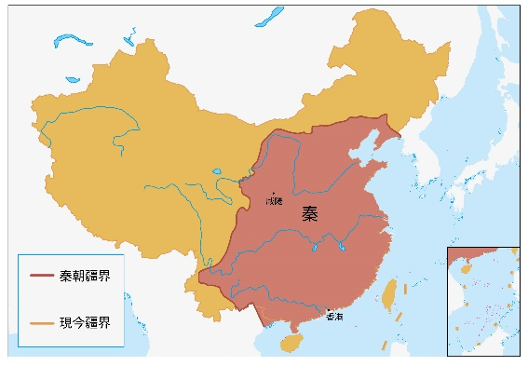 | - How does the picture in Source 1 demonstrate that, as stated in the Preamble of the Basic Law, “Hong Kong has been part of the territory of China since ancient times”?
  Hong Kong has been part of the
  territory of China since the Qin
  Dynasty (221 to 207 BC).
Source 2  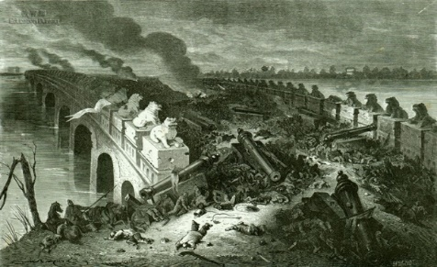  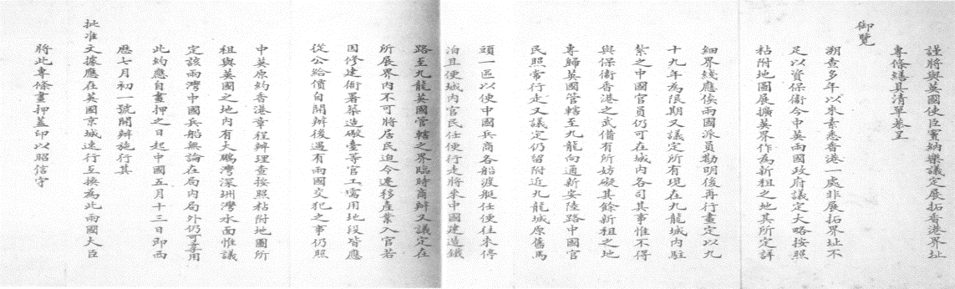 | - (a) Which event mentioned in the Preamble of the Basic Law are the pictures in Source 2 related to?  (b) What unequal treaties are the pictures in Source 2 related to?
  Hong Kong was occupied by
  Britain after the Opium War in
  1840.
  Treaty of Nanking, Convention
  of Peking, Convention between
  the United Kingdom and
  China, Respecting an
  Extension of Hong Kong’s
  Territory.

Source 3  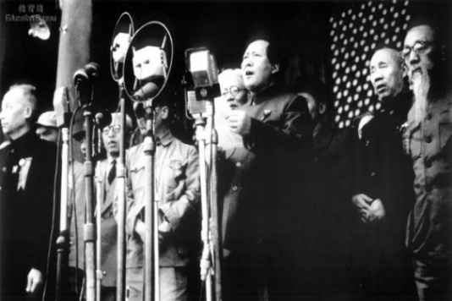  1971  United Nations  General Assembly  Twenty-sixth Session  Resolution 2758 (XXVI)  United Nations General Assembly Twenty-Seventh Session Resolution 2908(XXVII) on 2 November 1972: Approves the report of the Special Committee on Decolonization  1972 | - (a) What important historical event does the photo in Source 3 show?  (b) What is the importance of the resolution of the United Nations (UN) General Assembly in 1971 shown in Source 3 to the People’s Republic of China (PRC)?  (c) What is the importance of the report approved in the UN General Assembly in 1972 shown in Source 3 to Hong Kong?
  The establishment of the
  People’s Republic of China in
  1949.
  Restoration of the lawful rights
  of the PRC in the UN.
  Hong Kong was removed from
  the list of colonial territories.
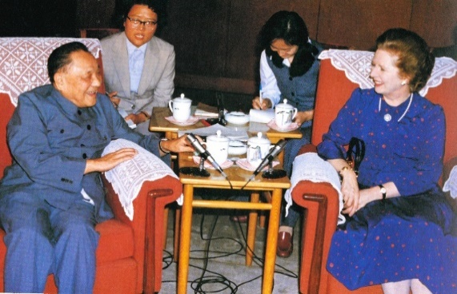  Source 4 | - What important historical event does the photo in Source 4 show?
  Sino-British negotiations on the
  future of Hong Kong began.
Source 5 | - Which important document does the provision in Source 5 come from?
  The state may establish special administrative regions when necessary. The systems instituted in special administrative regions shall, in light of specific circumstances, be prescribed by laws enacted by the National People’s Congress.
  Constitution.

Source 6 | - Which document does the content in Source 6 come from?
  The Government of the People’s Republic of China declares that to recover the Hong Kong area (including Hong Kong Island, Kowloon and the New Territories, hereinafter referred to as Hong Kong) is the common aspiration of the entire Chinese people, and that it has decided to resume the exercise of sovereignty over Hong Kong with effect from 1 July 1997.
  Sino-British Joint Declaration.
Source 7  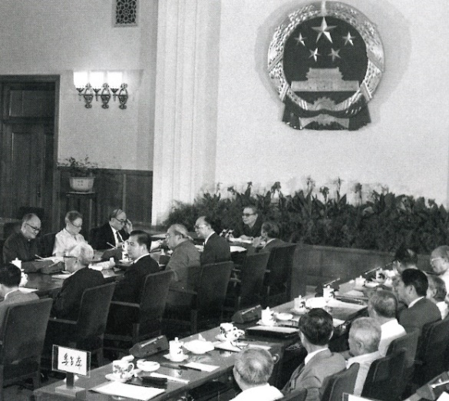 | - (a) Which organisation was holding the meeting as shown in the photo in Source 7?  (b) Which organisation established the Committee in the answer to 7.(a)?
  Drafting Committee for the
  Basic Law of the Hong Kong
  Special Administrative Region.
  National People’s Congress.
Source 8  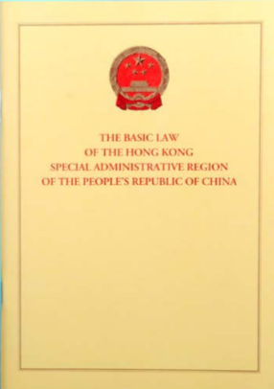 | - (a) Which organisation was responsible for adopting the legal document shown in Source 8?  (b) Who was responsible for promulgating this legal document?
  National People’s Congress.
  President of the PRC.

Source 9  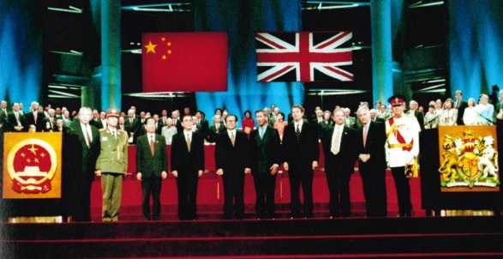 | - What important historical event does the photo in Source 9 show?
  Establishment of the Hong Kong
  Special Administrative Region
  on 1 July 1997.

The Constitution and the Basic Law jointly form the constitutional basis of the HKSAR

Activity 1
Part I
Source 1
Today (13 September 2000), Mr LAM Woon-kwong, Secretary for Home Affairs, witnessed the solemn flag-raising ceremony in Sydney Olympic Village. He watched the regional flag of the Hong Kong Special Administrative Region (HKSAR) rise in the Olympic Village for the first time, sharing the joy and excitement with the Hong Kong Olympic delegation.
After seeing that the regional flag of the HKSAR was raised along with the playing of the national anthem, Mr LAM Woon-kwong said to the media, “This ceremony is of special significance to us. It is the first time that the HKSAR has participated in the Olympic Games in the name of Hong Kong, China.” ...

Source of information: Translated from 香港特別行政區政府新聞公報網頁（2000年9月13日）。《奧運村內升起香港特別行政區區旗》，https://www.info.gov.hk/gia/general/200009/13/0913169.htm

- (i) What flag was used and (ii) what song was played and sung in the ceremony mentioned in Source 1?
(i) Regional Flag.
(ii) National Anthem.

[Complete the following questions in accordance with the brochure of the “The Constitution and the Basic Law” or the electronic version of the Basic Law on the web page of the Basic Law (https://www.basiclaw.gov.hk/en/basiclaw/index.html).]

- (a) How does Article 10(1) of the Basic Law stipulate the use of the national flag and the regional flag?
Apart from displaying the national flag of the PRC, the HKSAR may also
use a regional flag.

(b) Apart from Article 10(1), is there any other provision in the 160 articles of the Basic Law make mention of the national flag and the national anthem?
No.

Part II

Paragraph 3 of the Basic Law’s Preamble states that “In accordance with the Constitution of the People’s Republic of China, the National People’s Congress hereby enacts the Basic Law of the Hong Kong Special Administrative Region of the People’s Republic of China”.

Since there is no other provision under which the national flag and the national anthem are stipulated in the Basic Law, naturally, we have to refer to relevant provisions in the Constitution:

Source 2
Constitution
Chapter IV - The National Flag, National Anthem, National Emblem and the Capital
Article 141
The national flag of the People’s Republic of China is a red flag with five stars.
The national anthem of the People's Republic of China is the March of the Volunteers.
Article 142
The national emblem of the People’s Republic of China consists of an image of Tiananmen Gate in the center illuminated by five stars and encircled by spikes of grain and a cogwheel.
Article 143
The capital of the People’s Republic of China is Beijing.

Source of information: Basic Law website>Full Text of the Constitution>, https://www.basiclaw.gov.hk/en/constitution/chapter4.html

In short, the Constitution has stipulated on the national flag, national anthem, national emblem and the Capital in Chapter IV which is applicable to the whole country. Therefore, it is not necessary for the Basic Law to stipulate on them again in different articles. On the other hand, Article 10(1) of the Basic Law stipulates a special provision, “Apart from displaying the national flag and national emblem of the People’s Republic of China, the Hong Kong Special Administrative Region may also use a regional flag and regional emblem.” Stipulations on the regional flag and regional emblem are specified in Article 10(2) and (3).



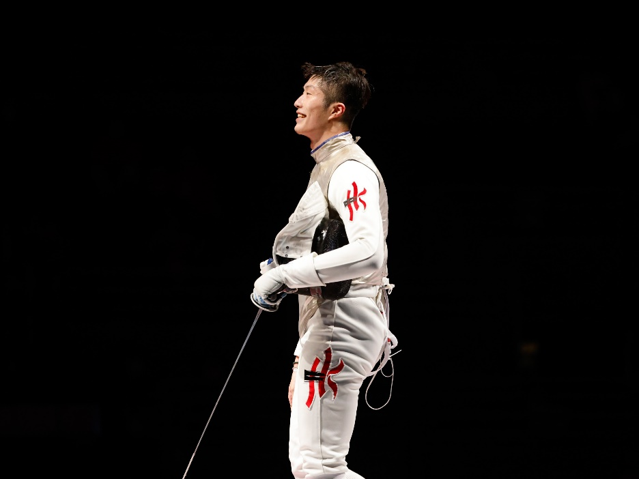

Copyright © SPORTS FEDERATION & OLYMPIC COMMITTEE OF HONG
KONG, CHINA (SF&OC)

- In 2021, fencer Edgar Cheung of the Hong Kong, China delegation won the gold medal in the Men’s Foil Individual competition at the Tokyo Olympic Games. During the Medal Ceremony, (i) which flag was hoisted? (ii) which song was played?
(i) Regional Flag.
(ii) National Anthem.
Summary

Paragraph 13 of the Preamble of the Constitution states that, “This Constitution affirms, in legal form, the achievements of the struggles of the Chinese people of all ethnic groups and stipulates the fundamental system and task of the state. It is the fundamental law of the state and has supreme legal force. The people of all ethnic groups, all state organs and armed forces, all political parties and social organizations, and all enterprises and public institutions in the country must treat the Constitution as the fundamental standard of conduct; they have a duty to uphold the sanctity of the Constitution and ensure its compliance.”

The National People’s Congress (NPC) decided to establish the HKSAR in accordance with Article 31 and Article 62(14) of the Constitution and enacted the Basic Law in accordance with the Constitution. It is a common practice in countries around the world that each state has its own sovereignty and has one constitution. The HKSAR is part of the territory of our country, so the national Constitution is the Constitution of the Special Administrative Region. The Constitution is the “mother law” and the Basic Law is the “infra-law”. The Constitution is the legislative basis of the Basic Law. The national Constitution is the constitutional basis of the Basic Law of the HKSAR.

Worksheet 1: Constitutional Basis of the HKSAR

Source 1
Constitution
Chapter I - General Principles
Article 31
The state may establish special administrative regions when necessary. The systems instituted in special administrative regions shall, in light of specific circumstances, be prescribed by laws enacted by the National People’s Congress.
Chapter III - State Institutions Section 1 National People’s Congress
Article 57
The National People’s Congress of the People’s Republic of China is the highest state organ of power. Its permanent organ is the National People’s Congress Standing Committee.
Article 62(1) (14)
[The National People’s Congress shall exercise the following functions and powers:]
14. deciding on the establishment of special administrative regions and the systems to be instituted there;²

Source of information: Basic Law homepage > Constitution, https://www.basiclaw.gov.hk/en/constitution/index.html

Source 2
Decision of the National People’s Congress on the Establishment of the
Hong Kong Special Administrative Region
(Adopted at the Third Session of the Seventh National People’s Congress on 4 April 1990)
In accordance with the provisions of Article 31 and sub-paragraph 13³ of Article 62 of the Constitution of the People’s Republic of China, the Third Session of the Seventh National People’s Congress decides:
1. The Hong Kong Special Administrative Region is to be established on July 1, 1997.
2. The area of the Hong Kong Special Administrative Region covers the Hong Kong Island, the Kowloon Peninsula, and the islands and adjacent waters under its jurisdiction. The map of the administrative division of the Hong Kong Special Administrative Region will be published by the State Council separately.

Source of information: Basic Law website > Basic Law > Annex & Instrument, https://www.basiclaw.gov.hk/filemanager/content/en/files/basiclawtext/basiclawtext_doc12.pdf
2 In the amendments to the Constitution adopted in 2018, a new sub-paragraph is added to Article 62 as sub-paragraph 7 and the original sub-paragraph 13 is accordingly changed to sub-paragraph 14.
3 Ditto.
Source 3
Basic Law
Preamble [Paragraphs 2 and 3]
Upholding national unity and territory integrity, maintaining the prosperity and stability of Hong Kong, and taking account of its history and realities, the People’s Republic of China has decided that upon China’s resumption of the exercise of sovereignty over Hong Kong, a Hong Kong Special Administrative Region will be established in accordance with the provisions of Article 31 of the Constitution of the People’s Republic of China, and that under the principle of “one country, two systems”, the socialist system and policies will not be practised in Hong Kong. The basic policies of the People’s Republic of China regarding Hong Kong have been elaborated by the Chinese Government in the Sino-British Joint Declaration.
In accordance with the Constitution of the People’s Republic of China, the National People’s Congress hereby enacts the Basic Law the Hong Kong Special Administrative Region of the People’s Republic of China, prescribing the systems to be practised in the Hong Kong Special Administrative Region, in order to ensure the implementation of the basic policies of the People’s Republic of China regarding Hong Kong.
Chapter I - General Principles
Article 11(1)
In accordance with Article 31 of the Constitution of the People’s Republic of China, the systems and policies practised in the Hong Kong Special Administrative Region, including the social and economic systems, the system for safeguarding the fundamental rights and freedoms of its residents, the executive, legislative and judicial systems, and the relevant policies, shall be based on the provisions of this Law.

Source of information: Basic Law website > Basic Law,
https://www.basiclaw.gov.hk/en/basiclaw/index.html

Source 4
Basic Law
Chapter I - General Principles
Article 2
The National People’s Congress authorizes the Hong Kong Special Administrative Region to exercise a high degree of autonomy and enjoy executive, legislative and independent judicial power, including that of final adjudication, in accordance with the provisions of this Law.

Source of information: Basic Law website > Basic Law> Chapter I,
https://www.basiclaw.gov.hk/en/basiclaw/chapter1.html
Source 5
Constitution
Chapter III - State Institutions Section 3 The State Council
Article 85
The State Council of the People’s Republic of China, namely, the Central People’s Government, is the executive organ of the highest state organ of power; it is the highest state administrative organ.

Source of information: Basic Law website > Constitution > Chapter III, https://www.basiclaw.gov.hk/en/constitution/chapter3.html

Source 6
Basic Law
Chapter II - Relationship between the Central Authorities and the Hong Kong Special Administrative Region
Article 12
The Hong Kong Special Administrative Region shall be a local administrative region of the People’s Republic of China, which shall enjoy a high degree of autonomy and come directly under the Central People’s Government.

Source of information: Basic Law website > Basic Law> Chapter II, https://www.basiclaw.gov.hk/en/basiclaw/chapter2.html

- (a) According to Source 1, when shall the state establish special administrative regions as stipulated in Article 31 of the Constitution?
When necessary.

(b) Following the above question and according to paragraph 2 of the Basic Law’s Preamble in Source 3, why shall the state establish the HKSAR?
Upholding national unity and territory integrity, maintaining the
prosperity and stability of Hong Kong, and taking account of its history
and realities.

(c) According to Article 31 of the Constitution, as mentioned in Source 3, the provisions of which law shall the systems and policies practised in the HKSAR based on?
Basic Law.

- (a) According to Article 31 of the Constitution in Source 1, which organisation shall, in light of specific circumstances, enact laws prescribing the systems instituted in special administrative regions?
National People’s Congress.

(b) According to Source 2, under which two articles of the Constitution did the NPC establish the HKSAR?
Article 31 and Article 62(13).

(c) According to Source 3, what are prescribed and ensured by the NPC’s enactment of the Basic Law in accordance with the Constitution?
To prescribe the systems to be practised in the HKSAR and to ensure the
implementation of the basic policies of the PRC regarding Hong Kong.

- (a) According to Source 4, by what means does the NPC allow the HKSAR to exercise a high degree of autonomy in accordance with the provisions of the Basic Law?
Authorization.

(b) Try to find out relevant information from Source 1 and explain why it was the NPC which decided to adopt the means as mentioned in the answer to 3.(a) to allow the HKSAR to exercise a high degree of autonomy in accordance with the Basic Law?
The NPC is the highest state organ of power.

- (a) According to Source 5, the Central People’s Government (CPG) is the highest state organ in what aspect?
Administrative.

(b) According to Source 6, what is special about the HKSAR as a local administrative region of the PRC? What is its relationship with the CPG?
The HKSAR is a local administrative region of the PRC, which enjoys a
high degree of autonomy and comes directly under the CPG.



Appendix 1

Know more: The People’s Congress System

All power in China belongs to the people. The organs through which the people exercise state power are the NPC and the local people’s congresses. Therefore, the people’s congress system is China’s fundamental political system. Its basic characteristics are: It has extensive representation, and is the basic form for the people to administer the country. It follows the principle of democratic centralism, i.e., it guarantees that the people enjoy extensive democracy and rights, at the same time guaranteeing that state power is exercised in a centralized and unified way. Under the premise that the people’s congresses exercise the state power in a unified way, the state’s administrative power, judicial authority, procuratorial authority and the leadership over the armed forces are clearly divided to ensure that the organs of state power and administrative, judicial, procuratorial and other state organs work in a coordinated way.

Deputies to the people’s congresses at all levels are elected, and are responsible to and accept supervision by the people. The deputies are broadly representative; they include people from all ethnic groups, all walks of life, and all regions, classes and strata. As they come from the people, they maintain close ties with their respective constituencies and the electorates, and earnestly listen to their views and demands. When the congresses meet to discuss issues concerning major policies and principles, they can air their views fully and carry out the decisions after they have been made. Hence, the people’s views can be collected and the people can administer state affairs through the people’s congresses.

Each NPC shall have a term of five years and a session of the NPC shall be held once every year. The session will be held in the first quarter of each year and shall be convened by the National People’s Congress Standing Committee (NPCSC). If the NPCSC deems it necessary, or one-fifth or more of NPC deputies so propose, a session of the NPC may be convened in the interim. When the NPC holds a session, it shall elect a presidium to conduct that session. Local people’s congresses at all levels shall have a term of five years and shall meet in session at least once a year. A session of a local people’s congress may be convened at any time upon the proposal of one-fifth of its deputies. Sessions of local people’s congresses at or above the county level shall be convened by their standing committees. People’s congresses of townships, nationality townships and towns shall be convened by the presidia of the previous session. A presidium shall be elected by each local people’s congress at all levels when the latter holds a session. The presidium shall preside over the session.

Sources of information: Constitution, Organic Law of the Local People’s Congresses and Local People’s Governments of the People’s Republic of China, and Ministry of Foreign Affairs of the People’s Republic of China website> About China>China Briefing, https://www.fmprc.gov.cn/mfa_eng/ljzg_665465/zgjk_665467/

Appendix 2
Know more: National People’s Congress (NPC) and its Standing Committee (NPCSC)

Article 57 of the Constitution stipulates that “The National People’s Congress of the People’s Republic of China is the highest state organ of power. Its permanent organ is the National People’s Congress Standing Committee.”

The decision to establish the NPCSC was made according to the national conditions of our country. There are close to 3,000 deputies to the NPC. (Article 15 of the Electoral Law of the National People’s Congress and Local People’s Congresses of the People’s Republic of China stipulates that “The number of deputies to the National People’s Congress shall not exceed 3,000.”) Since the number of deputies to the NPC is fairly large, it is inconvenient to hold frequent meetings to exercise NPC’s functions and powers as many of the deputies have their own jobs. Therefore, a session of the NPC shall be held once every year and usually lasts 15 days.

In order to solve related issues of the NPC, including that of a fairly large number of deputies, the inconvenience to hold frequent meetings and a relatively short meeting period, the NPC elects the NPCSC which is an organ with fewer number of people. The NPCSC can meet more frequently to exercise its functions and powers, and to discuss and decide on relevant matters. Currently, the NPCSC has about 170 members and normally meets once every two months that usually lasts 7 days. As a result, there are more than 40 meeting days per year. When the NPC is not in session, the NPCSC can decide upon major state issues and exercise the powers and functions of the highest state organ of power more effectively.

Source of information: Translated from 中國人大網，http://www.npc.gov.cn/

Worksheet 2: Basic Law is a national law

Source 1
Constitution
Chapter III - State Institutions Section 1 National People’s Congress
Article 58
The National People’s Congress and the National People’s Congress Standing Committee exercise the legislative power of the state.
Article 62(1) (3)
[The National People’s Congress shall exercise the following functions and powers:]
3. enacting and amending criminal, civil, state institutional and other basic laws;

Source of information: Basic Law website>Constitution>Chapter III, https://www.basiclaw.gov.hk/en/constitution/chapter3.html

Source 2
Which laws need to be enacted by the NPC?

Criminal, civil, state institutional and other basic laws need to be enacted by the NPC. The name of “basic laws” suggests that they are laws of overall importance in regulating state politics, economy and social life. … The Basic Law of the Hong Kong Special Administrative Region and the Basic Law of the Macao Special Administrative Region etc. are also basic laws. …

Source of information: Translated from 中國人大網 (2000), http://www.npc.gov.cn/zgrdw/npc/rdgl/rdzd/2000-11/01/content_8829.htm

Text record of press conference by the General Office of the NPCSC [LI Fei, deputy secretary general of the NPCSC cum Chairman of the HKSAR Basic Law Committee]

… The NPC is the highest state organ of power. Its permanent organ is the NPCSC. The Basic Law of the HKSAR is a basic law enacted by the NPC. … The Basic Law of the HKSAR is a national law and is most important to the implementation of “one country, two systems” in the SAR. …

Source of information: Translated from 中國人大網 (2016), http://www.npc.gov.cn/zgrdw/npc/zhibo/zzzb39/node_363.htm

Source 3
Constitution
Chapter I - General Principles
Article 5(3)
No law, administrative regulation or local regulation shall be in conflict with the Constitution.

Source of information: Basic Law website>Constitution>Chapter I, https://www.basiclaw.gov.hk/en/constitution/chapter1.html

Legislation Law of the People’s Republic of China
Article 98
The Constitution has the highest authority. No laws, administrative regulations, local regulations, autonomous regulations, separate regulations, or rules may contravene the Constitution.

Article 103
Where special provisions are inconsistent with general provisions in the laws, administrative regulations, local regulations, autonomous regulations, separate regulations, or rules formulated by the same authority, the special provisions shall prevail. Where new provisions are inconsistent with old provisions, the new provisions shall prevail.

Source of information: Legislation Law of the People’s Republic of China, the National People's Congress of the People's Republic of China,
http://en.npc.gov.cn.cdurl.cn/2023-03/13/c_938674.htm
(Accessed_15 May 2026)

Source 4
Decision of the National People’s Congress on the Basic Law of the Hong Kong Special Administrative Region of the People’s Republic of China
(Adopted at the Third Session of the Seventh National People’s Congress on 4 April 1990)
The Third Session of the Seventh National People’s Congress adopts the Basic Law of the Hong Kong Special Administrative Region of the People’s Republic of China, including Annex I: Method for the Selection of the Chief Executive of the Hong Kong Special Administrative Region, Annex II: Method for the Formation of the Legislative Council of the Hong Kong Special Administrative Region and Its Voting Procedures, Annex III: National Laws to be Applied in the Hong Kong Special Administrative Region, and the designs of the regional flag and regional emblem of the Hong Kong Special Administrative Region. Article 31 of the Constitution of the People’s Republic of China provides: “The State may establish special administrative regions when necessary. The systems to be instituted in special administrative regions shall be prescribed by law enacted by the National People’s Congress in the light of the specific conditions.” The Basic Law of the Hong Kong Special Administrative Region is constitutional as it is enacted in accordance with the Constitution of the People’s Republic of China and in the light of the specific conditions of Hong Kong. The systems, policies and laws to be instituted after the establishment of the Hong Kong Special Administrative Region shall be based on the Basic Law of the Hong Kong Special Administrative Region.
The Basic Law of the Hong Kong Special Administrative Region of the People’s Republic of China shall be put into effect as of July 1, 1997.

Source of information: Basic Law website>Basic Law>Annex & Instrument, https://www.basiclaw.gov.hk/en/basiclaw/annex-instrument.html

Source 5
Constitution
Chapter III - State Institutions
Section 2 The President of the People’s Republic of China
Article 80
The president of the People’s Republic of China, pursuant to decisions of the National People’s Congress and the National People’s Congress Standing Committee, promulgates laws....

Source of information: Basic Law website>Constitution>Chapter III, https://www.basiclaw.gov.hk/en/constitution/chapter3.html

Source 6

Decree of the President of the People’s Republic of China

No. 26

I hereby promulgate the Basic Law of the Hong Kong Special Administrative Region of the People’s Republic of China, including Annex I, “Method for the Selection of the Chief Executive of the Hong Kong Special Administrative Region”, Annex II, “Method for the Formation of the Legislative Council of the Hong Kong Special Administrative Region and Its Voting Procedures”, Annex III, “National Laws to be Applied in the Hong Kong Special Administrative Region”, and the designs of the regional flag and regional emblem of the Hong Kong Special Administrative Region, which was adopted by the Seventh National People’s Congress of the People’s Republic of China at its Third Session on 4 April 1990 and shall be put into effect as of 1 July 1997.

Yang Shangkun
Preisdent of
the People’s Republic of China

4 April 1990

Source of information: Basic Law website>Basic Law> Decree of the President of the People's Republic of China, https://www.basiclaw.gov.hk/en/basiclaw/decree.html

- (a) According to Source 1, the NPC exercises the legislative power of the state. With reference to its functions and powers, what national laws are enacted and amended by the NPC?
Criminal, civil, state institutional and other basic laws.

(b) According to Source 2, what is the importance of the national laws mentioned in the answer to 1.(a)?
They are laws of overall importance in regulating state politics, economy
and social life.

(c) According to Source 2, the Basic Law is a basic law enacted by the NPC. What is its legal status?
A national law.

- (a) According to Source 3, the legal effect of the Constitution is the highest. How are laws, administrative regulations, local regulations, autonomous regulations, separate regulations or rules related to the Constitution?
None of them may contradict the Constitution.

(b) Both the Constitution and the Basic Law were enacted by the NPC. Which provision of Article 92 of the Legislation Law of the People’s Republic of China in Source 3 does this comply with?

Formulated by one and same organ.

Think about it

What is the relationship among Decision of the National People’s Congress on the Basic Law of the Hong Kong Special Administrative Region of the People’s Republic of China (Sources 4), the Constitution (Source 5 ) and Decree of the President of the People’s Republic of China, No. 26 (Source 6)?

Source 4 is about the decision of the NPC on enacting the Basic Law in
accordance with the Constitution. Source 5 is about the Constitution’s stipulation that the President of the PRC, pursuant to decisions of the NPC, promulgates laws. Accordingly, Source 6 is about Yang Shangkun, then President of the PRC, promulgating the Basic Law, pursuant to the decision of the NPC in 1990.

Module 2.2: Governance of the HKSAR
(Lesson 2)
Learning and Teaching Materials

Introduction

The Central Authorities exercising overall jurisdiction over the HKSAR

As prescribed in the Constitution of the PRC and the Basic Law of the HKSAR, the organs of power by which the central leadership directly exercises jurisdiction over the HKSAR are the NPC and its Standing Committee, the president of the state, the Central People’s Government, and the Central Military Commission. The NPC decided on the establishment of the HKSAR, formulated the Basic Law of the HKSAR to prescribe the system to be instituted in the HKSAR, and has the power of amendment to the Basic Law. The NPC Standing Committee has the power of interpretation regarding the Basic Law of the HKSAR, the power of decision on revising the selection methods of the chief executive and the Legislative Council of the HKSAR, the power of supervision over the laws formulated by the legislative organs of the HKSAR, the power of decision on the HKSAR entering a state of emergency, and the power of making new authorization for the HKSAR. The HKSAR comes directly under the Central People’s Government, and its chief executive is accountable to the Central People’s Government. The Central People’s Government appoints the chief executive and the principal officials, is responsible for foreign affairs relating to the HKSAR in accordance with the law, and issues directives to the chief executive. The Central Military Commission is the leading body of the Hong Kong garrison, and performs defense and other duties. The central authorities perform overall jurisdiction and constitutional duties as prescribed in the Constitution of the People’s Republic of China and in the Basic Law of the HKSAR, and exercise effective administration over the HKSAR.

The Constitution and the Basic Law together create the constitutional foundations underpinning the HKSAR. They grant the central authorities overall jurisdiction over the region, detail the powers directly exercised by the central authorities, empower the HKSAR to exercise a high degree of autonomy, and confirm the central authorities’ right to supervise the exercise of this autonomy. The direct powers of the central authorities are to establish the HKSAR, decide on its systems, organize its government, manage foreign affairs and defense affairs related to the HKSAR, appoint the Chief Executive and principal officials, archive and review legislation of the HKSAR, and amend and interpret the Basic Law. The central authorities also exercise the power to decide on the system of democracy in the region.

Hong Kong affairs which are the responsibility of the Central Authorities:
Activity 2:

Stipulations of the Basic Law that are related to the functions and powers of central state institutions can be roughly divided into 7 aspects:

No. | Stipulations of the Basic Law that are related to the functions and powers of central state institutions | Relevant articles of the Basic Law (Examples)
1. | Foreign affairs | Article 13(1), (2)  The Central People’s Government shall be responsible for the foreign affairs relating to the Hong Kong Special Administrative Region.  The Ministry of Foreign Affairs of the People’s Republic of China shall establish an office in Hong Kong to deal with foreign affairs.
2. | Defence | Article 14(1), (3)  The Central People’s Government shall be responsible for the defence of the Hong Kong Special Administrative Region.  Military forces stationed by the Central People’s Government in the Hong Kong Special Administrative Region for defence shall not interfere in the local affairs of the Region. …
3. | Appointment | Article 45(1)  The Chief Executive of the Hong Kong Special Administrative Region shall be selected by election or through consultations held locally and be appointed by the Central People’s Government.
4. | Matters that the HKSAR shall report to the Central Authorities for the record | Article 90(2)  In the case of the appointment or removal of judges of the Court of Final Appeal and the Chief Judge of the High Court of the Hong Kong Special Administrative Region, the Chief Executive shall, in addition to following the procedures prescribed in Articles 88 and 89 of this Law, obtain the endorsement of the Legislative Council and report such appointment or removal to the Standing Committee of the National People’s Congress for the record.
5. | Matters that can be implemented by the Government of the HKSAR with the authorization, approval or special permission by the Central Authorities
5. | (i) Authorization | Article 13(3)  The Central People’s Government authorizes the Hong Kong Special Administrative Region to conduct relevant external affairs on its own in accordance with this Law.
5. | (ii) Approval | Article 157(1)  The establishment of foreign consular and other official or semi-official missions in the Hong Kong Special Administrative Region shall require the approval of the Central People’s Government.
5. | (iii) Special permission | Article 126  With the exception of foreign warships, access for which requires the special permission of the Central People’s Government, ships shall enjoy access to the ports of the Hong Kong Special Administrative Region in accordance with the laws of the Region.
6. | Interpretation and Amendment of the Basic Law | Article 158(1)  The power of interpretation of this Law shall be vested in the Standing Committee of the National People’s Congress.  Article 159(1)  The power of amendment of this Law shall be vested in the National People’s Congress.
7. | Application of national laws in the HKSAR | Article 18(2), (3)  National laws shall not be applied in the Hong Kong Special Administrative Region except for those listed in Annex III to this Law. The laws listed therein shall be applied locally by way of promulgation or legislation by the Region.  The Standing Committee of the National People’s Congress may add to or delete from the list of laws in Annex III after consulting its Committee for the Basic Law of the Hong Kong Special Administrative Region and the government of the Region. Laws listed in Annex III to this Law shall be confined to those relating to defence and foreign affairs as well as other matters outside the limits of the autonomy of the Region as specified by this Law.

Please fill in the number of the most relevant functions and powers of central state institutions next to each of the following photos or materials.
 | No. of functions and powers
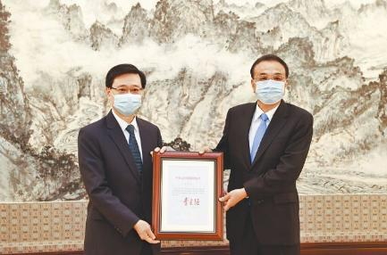  30 May 2022 at Ziguang Pavilion of Zhongnanhai, Beijing | 3
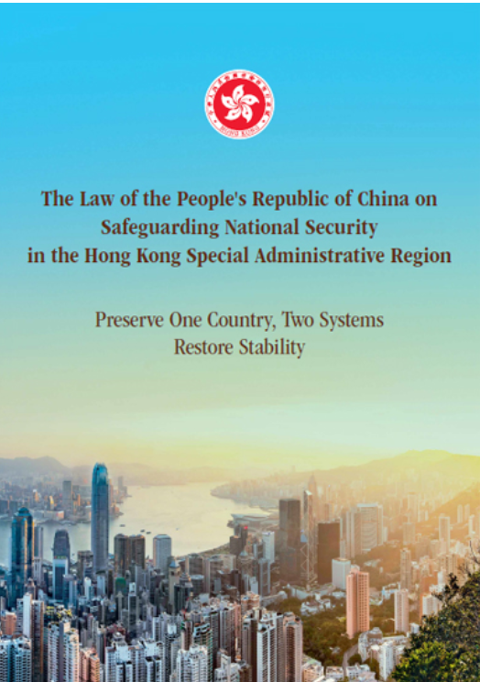 | 7

 | No. of functions and powers
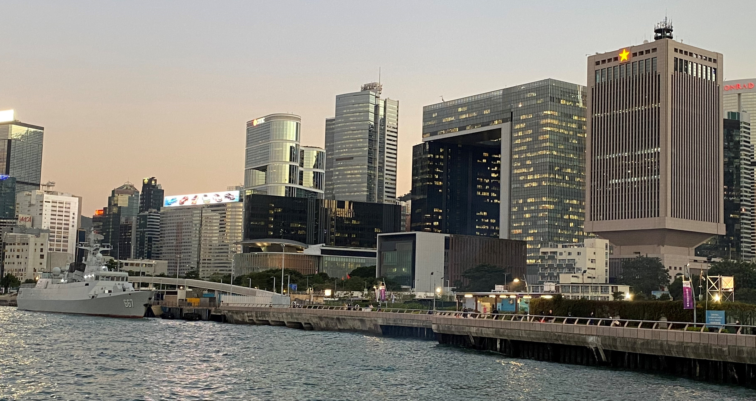  On the right side is the Chinese People’s Liberation Army Forces Hong Kong Building. On the left side a People’s Liberation Army warship berthed at the Central Military Dock. | 2
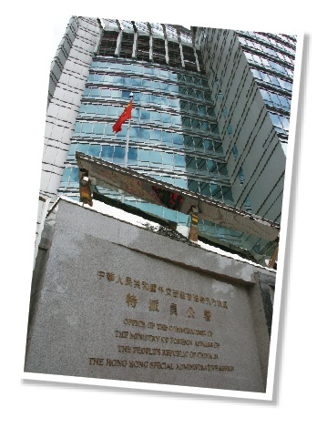  Office of the Commissioner of the Ministry of Foreign Affairs of the People’s Republic of China in the Hong Kong Special Administrative Region | 1

 | No. of functions and powers
The Chief Executive, Mrs Carrie Lam, today (June 24) signed the instrument of appointment of the Honourable Mr Justice Andrew Cheung Kui-nung as the Chief Justice of the Court of Final Appeal with effect from January 11, 2021, and reported the appointment to the Standing Committee of the National People's Congress (NPCSC) for the record, completing the relevant legal procedures for the appointment of the Chief Justice of the Court of Final Appeal. …  Source of information: CE appoints Chief Justice of the Court of Final Appeal, 24 June 2020, Press Releases, HKSAR Government,  https://www.info.gov.hk/gia/general/202006/24/P2020062400849.htm?fontSize=1 | 4
The applications for warships of the United States to enter Hong Kong are directly lodged by the American Consulate General with the Office of the Commissioner of the Ministry of Foreign Affairs of the People’s Republic of China in the Hong Kong Special Administrative Region (MFA Office). Before the CPG decided to reject access of warships of the United States to Hong Kong waters between May and August, the Government of the HKSAR (HKSARG) had not presented any views to the MFA Office. In refusing access of warships of the United States to Hong Kong, the MFA indicated that in view of the circumstances at that time, the visit by those warships to Hong Kong was not appropriate. According to our records, permissions have been given to warships of Italy, Australia and the United States to visit Hong Kong since July and a total of three warships of the United States had been granted permission to enter Hong Kong by the CPG since mid-August.  Source of information: LCQ6: CPG responsible for foreign affairs relating to HKSAR, 13 October 1999, Press Releases, HKSAR Government, https://www.info.gov.hk/gia/general/199910/13/1013139.htm | 5. (iii)

Worksheet 3: The Central Authorities are responsible for the defence of the HKSAR

Source 1
According to reports, more than 600,000 Hong Kong citizens have visited the barracks on the Hong Kong Garrison’s Open Days up to July last year. They have indicated that there are not many opportunities for them to be in touch with the People’s Liberation Army. Through visiting the barracks, they can have a glimpse of the glamorous Hong Kong Garrison at close quarters and first hand experience of the latest military development of the country.
…
Visits to the living facilities have also been arranged during the Open Days so that citizens can get a fuller picture of the Garrison. In sleeping quarters, citizens can have a look at the quilts being folded like “tofu cubes” and personal experience of the conditions of officers’ and soldiers’ daily life. The Hong Kong Garrison’s Open Days become the bridge that facilitate the understanding of the Hong Kong Garrison by different sectors of the community and reinforce mutual communication and exchange.

資料來源：人民日報海外版（2016年6月24日），《港人熱盼駐港部隊開放日》，載於中

Source of information: Translated from 人民日報海外版（2016年6月24日），《港人熱盼駐港部隊開放日》，載於中華人民共和國外交部駐香港特別行政區特派員公署網頁, https://www.fmprc.gov.cn/ce/cohk/chn/xwdt/xjlc/t1375107.htm

Source 2
Basic Law
Chapter II - Relationship between the Central Authorities and the Hong Kong Special Administrative Region
Article 14
The Central People’s Government shall be responsible for the defence of the Hong Kong Special Administrative Region.
The Government of the Hong Kong Special Administrative Region shall be responsible for the maintenance of public order in the Region.
Military forces stationed by the Central People’s Government in the Hong Kong Special Administrative Region for defence shall not interfere in the local affairs of the Region. The Government of the Hong Kong Special Administrative Region may, when necessary, ask the Central People’s Government for assistance from the garrison in the maintenance of public order and in disaster relief.
In addition to abiding by national laws, members of the garrison shall abide by the laws of the Hong Kong Special Administrative Region.
Expenditure for the garrison shall be borne by the Central People’s Government.

Source of information: Basic Law website>Basic Law>Chapter II, https://www.basiclaw.gov.hk/en/basiclaw/chapter2.html
Source 3
Law of the People’s Republic of China on Garrisoning the Hong Kong Special Administrative Region
Article 2
The military forces stationed by the Central People’s Government in the Hong Kong Special Administrative Region for defence shall be composed of forces from the Army, the Navy and the Air Force of the Chinese People’s Liberation Army, and be designated as the Hong Kong Garrison of the Chinese People’s Liberation Army (hereinafter referred to as the Hong Kong Garrison).
Article 3(1)
The Hong Kong Garrison shall be subject to the direction of the Central Military Commission of the People’s Republic of China. The number of its members shall be determined according to the need for the defence of the Hong Kong Special Administrative Region.
Article 14(2)
Where the request of the Government of the Hong Kong Special Administrative Region is approved by the Central People’s Government, the Hong Kong Garrison shall call out troops in accordance with the order of the Central Military Commission to carry out tasks of assistance in the maintenance of public order or in disaster relief, and upon completion of the tasks, the troops shall return to their barracks immediately.

Source of information: National People’s Congress of the People’s Republic of China>Database of Laws and Regulations>, http://www.npc.gov.cn/zgrdw/englishnpc/Law/2007-12/11/content_1383602.htm
------------------------------------------------------------------------------------------------------------
Supplementary information:
Law of the People’s Republic of China on Garrisoning the Hong Kong Special Administrative Region was adopted at the 23rd Meeting of the Standing Committee of the Eighth National People’s Congress on December 30, 1996 on 30 December 1996.
On 1 July 1997, the “Decision of the Standing Committee of the National People’s Congress on Adding to and Deleting from the List of the National Laws in Annex III to the Basic Law of the Hong Kong Special Administrative Region of the People’s Republic of China” was adopted at the 26th Meeting of the Standing Committee of the Eighth National People’s Congress, which included the addition of the Law of the People’s Republic of China on Garrisoning the Hong Kong Special Administrative Region. It applied locally by way of promulgation on 1 July 1997.

Source 4
Constitution
Chapter III - State Institutions Section 4 The Central Military Commission
Article 93(1)
The Central Military Commission of the People’s Republic of China shall lead the country’s armed forces.

Source of information: Basic Law website>Constitution> Chapter III, https://www.basiclaw.gov.hk/en/constitution/chapter3.html

- (a) According to Source 1, what is the daily relationship between the Hong Kong citizens and the Hong Kong Garrison?
There are not many opportunities for the Hong Kong citizens to be in
touch with the Hong Kong Garrison.

(b) Which provision of the Basic Law in Source 2 can explain the relationship mentioned in the answer to 1.(a)?
Military forces stationed by the CPG in the HKSAR for defence shall not
interfere in the local affairs of the Region.

- (a) According to sources 2 and 3, which organization is responsible for the defence of the HKSAR?
CPG.

(b) According to sources 2 and 3, which organization is responsible for stationing the Hong Kong Garrison?
CPG.

- (a) According to source 2, when may the Government of the HKSAR ask the CPG for assistance from the garrison in the maintenance of public order and in disaster relief?
When necessary.

(b) Following the above question and according to source 3, after the request of the Government of the HKSAR is approved by the CPG, the Hong Kong Garrison shall call out troops in accordance with the order of which organization to carry out tasks of assistance in the maintenance of public order or in disaster relief, and upon completion of the tasks, the troops shall return to their barracks immediately?
Central Military Commission.

(c) According to the Law of the People’s Republic of China on Garrisoning the Hong Kong Special Administrative Region in source 3, why should the Hong Kong Garrison comply with the orders of the organisation mentioned in the answer to 3.(b)?
It is because the Hong Kong Garrison is subject to the direction of the
Central Military Commission.

(d) According to source 4, why is the provision mentioned in the answer to 3.(c) stipulated in the Law of the People’s Republic of China on Garrisoning the Hong Kong Special Administrative Region?
It is because the Central Military Commission leads the country’s armed
forces.

Worksheet 4: The CPG exercises power of appointment over the HKSAR

Source 1
Basic Law
Chapter IV - Political Structure Section 1 The Chief Executive
Article 43
The Chief Executive of the Hong Kong Special Administrative Region shall be the head of the Hong Kong Special Administrative Region and shall represent the Region.
The Chief Executive of the Hong Kong Special Administrative Region shall be accountable to the Central People’s Government and the Hong Kong Special Administrative Region in accordance with the provisions of this Law.
Article 45(1)
The Chief Executive of the Hong Kong Special Administrative Region shall be selected by election or through consultations held locally and be appointed by the Central People’s Government.
Article 48(1) (5)
[The Chief Executive of the Hong Kong Special Administrative Region shall exercise the following powers and functions:]
(5) To nominate and to report to the Central People’s Government for appointment the following principal officials: Secretaries and Deputy Secretaries of Departments, Directors of Bureaux, Commissioner Against Corruption, Director of Audit, Commissioner of Police, Director of Immigration and Commissioner of Customs and Excise; and to recommend to the Central People’s Government the removal of the above-mentioned officials;
Section 2 The Executive Authorities
Article 59
The Government of the Hong Kong Special Administrative Region shall be the executive authorities of the Region.
Article 60(1)
The head of the Government of the Hong Kong Special Administrative Region shall be the Chief Executive of the Region.

Source of information: Basic Law website>Basic Law>Chapter II, https://www.basiclaw.gov.hk/en/basiclaw/chapter4.html

- (a) According to Article 43 of the Basic Law in Source 1, what are the special status of the Chief Executive (CE) in the HKSAR?
The CE of the HKSAR shall be the head of the HKSAR and shall
represent the Region.

(b) According to Source 1, which organisation is responsible for appointing the CE?
CPG.

(c) Referring to Source 6 of “Worksheet 1: Constitutional Basis of the HKSAR”, why should the organisation mentioned in the answer to 1.(b) be responsible for appointing the CE?
The HKSAR comes directly under the CPG.

- (a) According to Source 1, which organisation is responsible for appointing principal officials of the Government of the HKSAR?
CPG.

(b) According to Source 1, what is the relevant procedure before the organisation mentioned in the answer to 2.(a) appoints principal officials of the Government of the HKSAR?
The CE of the HKSAR nominates and reports to the CPG for appointment
of the principal officials.

(c) Following the above question and according to Source 1, why is it necessary to appoint principal officials of the Government of the HKSAR through the procedure mentioned in the answer to 2.(b)?
The head of the Government of the HKSAR is the CE of the HKSAR and
is accountable to the CPG and the HKSAR in accordance with the
provisions of the Basic Law.

Homework 1: reporting for the record, authorization, approval, special permission

Part 1: Matters that the HKSAR shall report to the Central Authoritie for the record
The left column in the following table lists the provisions of the Basic Law on matters that the HKSAR shall report to the Central Authorities for the record. Please put a “” in the appropriate boxes.

 | Standing Committee of the National People’s Congress | Central People’s Government
Article 17 (2)
Laws enacted by the legislature of the Hong Kong Special Administrative Region must be reported to the __________ for the record. The reporting for record shall not affect the entry into force of such laws.
Article 48(1) (3) (2)
[The Chief Executive] To sign budgets passed by the Legislative Council and report the budgets and final accounts to the __________ for the record
Article 90 (2)
In the case of the appointment or removal of judges of the Court of Final Appeal and the Chief Judge of the High Court of the Hong Kong Special Administrative Region, the Chief Executive shall, in addition to following the procedures prescribed in Articles 88 and 89 of this Law, obtain the endorsement of the Legislative Council and report such appointment or removal to the __________ for the record.
Article 156
The Hong Kong Special Administrative Region may, as necessary, establish official or semi-official economic and trade missions in foreign countries and shall report the establishment of such missions to the __________ for the record.

Part 2: Matters that require the authorization, approval or special permission by the Central Authorities before the implementation by the HKSAR

The left column in the following table lists matters that require the authorization, approval or special permission by the Central Authorities before the implementation by the HKSAR. Please put a “” in the appropriate boxes.

 | Authorize(d) | Approval | Special permission
Article 48(1) (9)
[The Chief Executive] To conduct, on behalf of the Government of the Hong Kong Special Administrative Region, external affairs and other affairs as __________ by the Central Authorities
Article 126
… With the exception of foreign warships, access for which requires the __________ of the Central People’s Government, …
Article 129(2)
Access of foreign state aircraft to the Hong Kong Special Administrative Region shall require the __________ of the Central People’s Government.
Article 155
The Central People’s Government shall assist or __________ the Government of the Hong Kong Special Administrative Region to conclude visa abolition agreements with foreign states or regions.
Article 157(1)
The establishment of foreign consular and other official or semi-official missions in the Hong Kong Special Administrative Region shall require the __________ of the Central People’s Government.

Module 2.2: Governance of the HKSAR
(Lesson 3)
Learning and Teaching Materials

Aspects of HKSAR’s high degree of autonomy
Activity 3

There are roughly 5 aspects regarding the high degree of autonomy of the HKSAR in the Basic Law:

No. | Aspects regarding the high degree of autonomy of the HKSAR in the Basic Law | Relevant articles of the Basic Law (Examples)
1. | Executive power (including the authorization for the HKSAR to conduct some “external affairs” in the Basic Law) | Article 2  The National People’s Congress authorizes the Hong Kong Special Administrative Region to exercise a high degree of autonomy and enjoy executive, legislative and independent judicial power, including that of final adjudication, in accordance with the provisions of this Law.
2. | Legislative power | Article 73(1) item 1  [The Legislative Council of the Hong Kong Special Administrative Region shall exercise the following powers and functions:]  1. To enact, amend or repeal laws in accordance with the provisions of this Law and legal procedures;
3. | Independent judicial power, including that of final adjudication | Article 82  The power of final adjudication of the Hong Kong Special Administrative Region shall be vested in the Court of Final Appeal of the Region, which may as required invite judges from other common law jurisdictions to sit on the Court of Final Appeal.  Article 85  The courts of the Hong Kong Special Administrative Region shall exercise judicial power independently, free from any interference. Members of the judiciary shall be immune from legal action in the performance of their judicial functions.
4. | HKSAR may enjoy other powers granted to it by the Central Authorities (e.g. HKSAR has the power to propose bills for amendments to the Basic Law) | Article 159(2)  The power to propose bills for amendments to this Law shall be vested in the Standing Committee of the National People’s Congress, the State Council and the Hong Kong Special Administrative Region. Amendment bills from the Hong Kong Special Administrative Region shall be submitted to the National People's Congress by the delegation of the Region to the National People’s Congress after obtaining the consent of two-thirds of the deputies of the Region to the National People’s Congress, two-thirds of all the members of the Legislative Council of the Region, and the Chief Executive of the Region.
5. | Other powers related to the high degree of autonomy | Article 10(1)  Apart from displaying the national flag and national emblem of the People’s Republic of China, the Hong Kong Special Administrative Region may also use a regional flag and regional emblem.

Please fill in the number of the most relevant aspect of the high degree of autonomy of the HKSAR next to each of the following photos or materials.
 | No. of the aspects of the high degree of autonomy
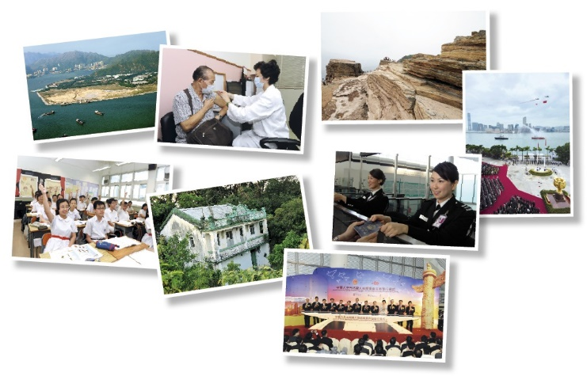 | 1
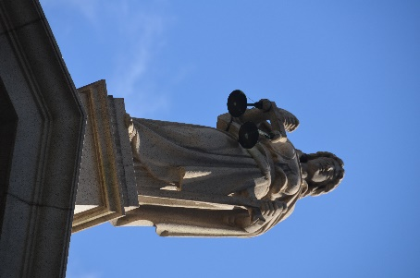 | 3
 | 2
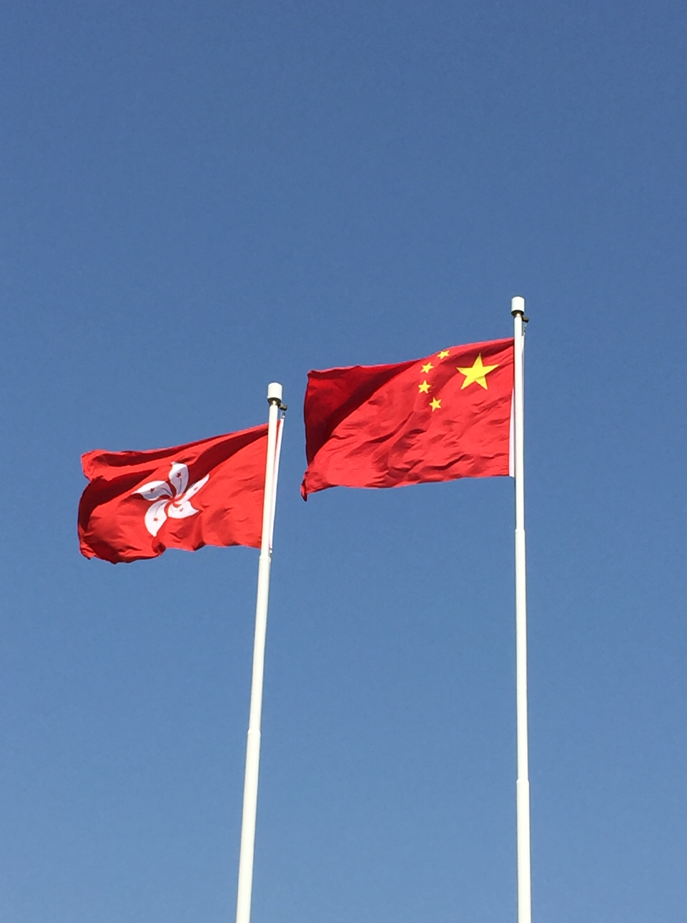 | 5
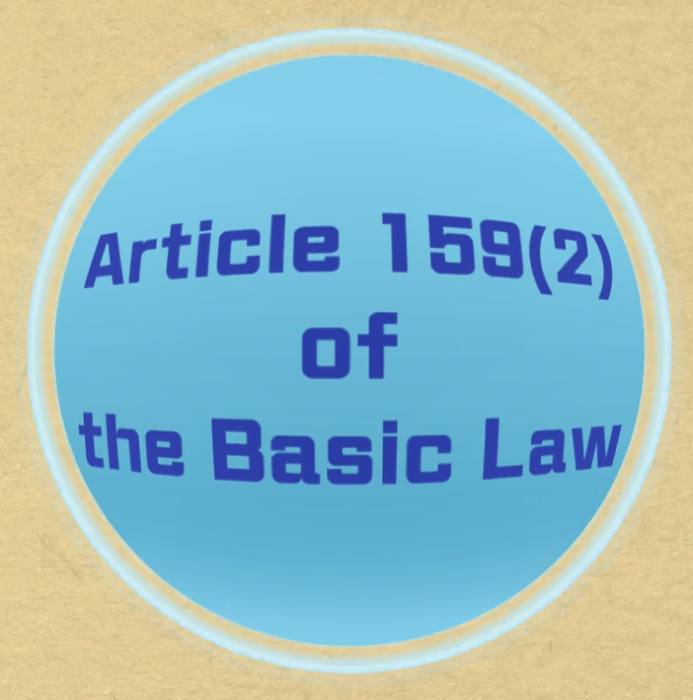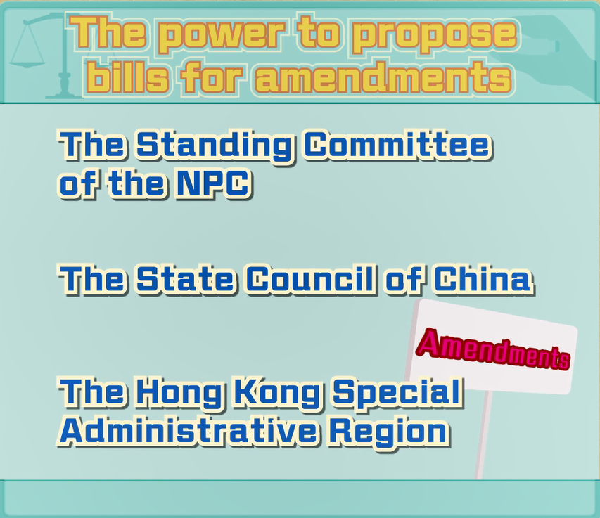 | 4
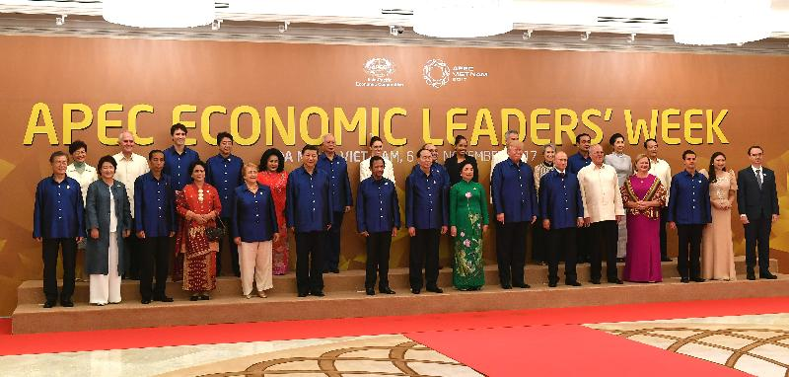  Source of photo: Chief Executive’s Office | 1

Worksheet 5: The HKSAR enjoys executive power

Source 1
Basic Law
Chapter I - General Principles
Article 2
The National People’s Congress authorizes the Hong Kong Special Administrative Region to exercise a high degree of autonomy and enjoy executive, legislative and independent judicial power, including that of final adjudication, in accordance with the provisions of this Law.
Chapter II - Relationship between the Central Authorities and the Hong Kong Special Administrative Region
Article 16
The Hong Kong Special Administrative Region shall be vested with executive power. It shall, on its own, conduct the administrative affairs of the Region in accordance with the relevant provisions of this Law.

Source of information: Basic Law website>Basic Law, https://www.basiclaw.gov.hk/en/basiclaw/index.html

Source 2
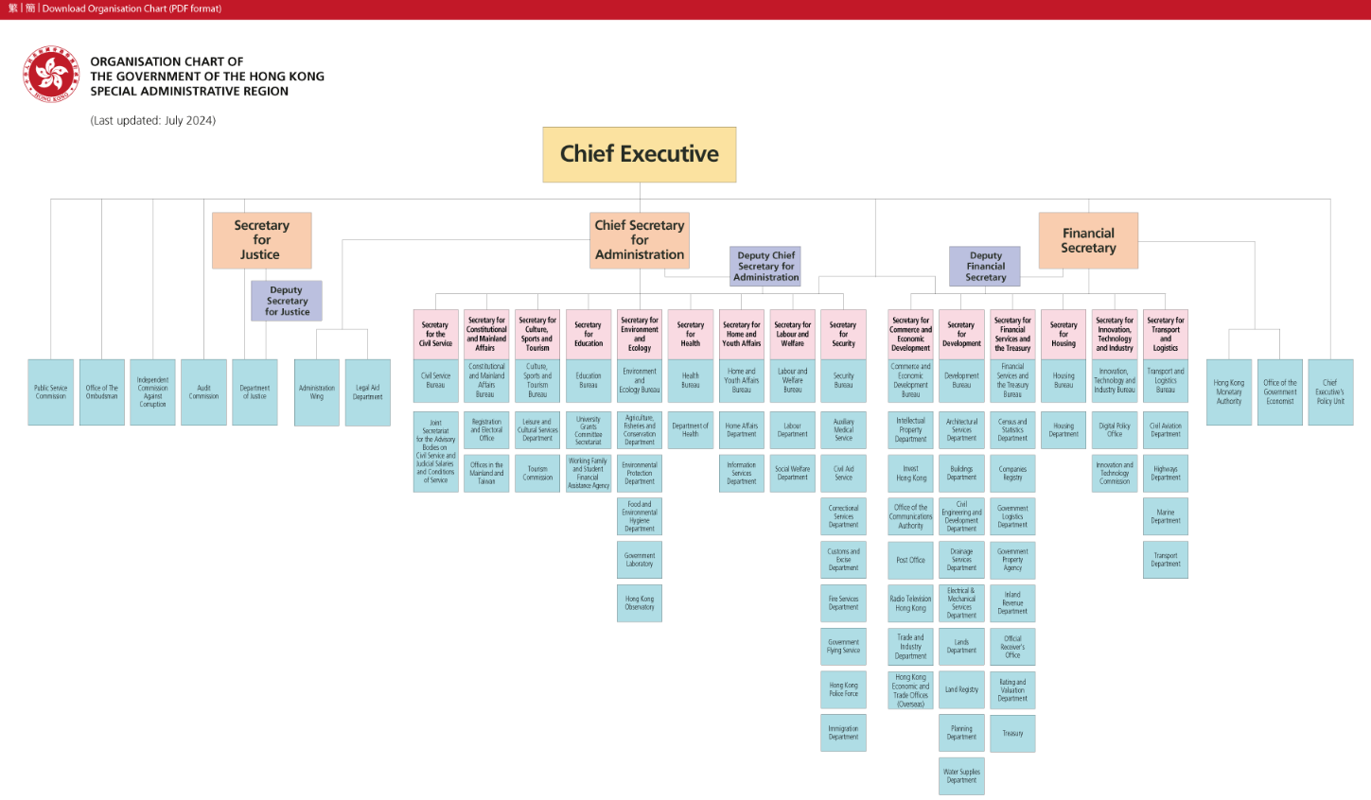
Source of information: GovHK-one-stop portal of the Hong Kong SAR Government (July 2024) > Organisational Chart of the Government,
https://www.gov.hk/en/about/govdirectory/govchart/index.htm

- (a) According to Source 1, by what means does the NPC allow the HKSAR to exercise a high degree of autonomy in accordance with the provisions of the Basic Law?
Authorization.

(b) Following the above question, what are covered under the high degree of autonomy practised in the HKSAR?
Executive, legislative and independent judicial power, including that of
final adjudication.

(c) According to Source 1, how does the HKSAR enjoy “executive power”?
The HKSAR shall, on its own, conduct the administrative affairs of the
HKSAR in accordance with the relevant provisions of the Basic Law.

- Referring to Source 2, try to name three government departments and point out the administrative affairs of the HKSAR that the respective departments can handle on their own?

 | Name of the Department | Administrative Affairs
Example | Post Office | Postal affairs
(a) | Immigration Department | Immigration control
(b) | The Land Registry | Land registration
(c) | Social Welfare Department | Social welfare

Worksheet 6: The HKSAR enjoys legislative power

Source 1
Basic Law

Chapter II - Relationship between the Central Authorities and the Hong Kong Special Administrative Region

Article 17
The Hong Kong Special Administrative Region shall be vested with legislative power.
Laws enacted by the legislature of the Hong Kong Special Administrative Region must be reported to the Standing Committee of the National People's Congress for the record. The reporting for record shall not affect the entry into force of such laws.
If the Standing Committee of the National People's Congress, after consulting the Committee for the Basic Law of the Hong Kong Special Administrative Region under it, considers that any law enacted by the legislature of the Region is not in conformity with the provisions of this Law regarding affairs within the responsibility of the Central Authorities or regarding the relationship between the Central Authorities and the Region, the Standing Committee may return the law in question but shall not amend it. Any law returned by the Standing Committee of the National People's Congress shall immediately be invalidated. This invalidation shall not have retroactive effect, unless otherwise provided for in the laws of the Region.

Chapter IV - Political Structure Section 3 The Legislature

Article 66
The Legislative Council of the Hong Kong Special Administrative Region shall be the legislature of the Region.

Source of information: Basic Law website> Basic Law, https://www.basiclaw.gov.hk/en/basiclaw/index.html

Source 2
Legislation Law of the People’s Republic of China
(Adopted at the Third Session of the Ninth National People's Congress on March 15, 2000; amended for the first time in accordance with the Decision on Amending the Legislation Law of the People's Republic of China adopted at the Third Session of the Twelfth National People’s Congress on March 15, 2015; and amended for the second time in accordance with the Decision on Amending the Legislation Law of the People's Republic of China adopted at the First Session of the Fourteenth National People’s Congress on March 13, 2023 )

Article 108
[The allocation of authority to modify or annul laws, administrative regulations, local regulations, autonomous regulations, separate regulations or rules is as follows:]
(2) that the Standing Committee of the National People’s Congress has the authority to annul any administrative regulation that contravenes the Constitution or laws, to annul any local regulation that contravenes the Constitution, laws or administrative regulations, and to annul any autonomous regulation or separate regulation approved by the standing committees of the people’s congresses of the relevant provinces, autonomous regions or municipalities directly under the Central Government that contravenes the Constitution or the provisions of the second paragraph of Article 85 of this Law

Source of information: Legislation Law of the People’s Republic of China, the National People's Congress of the People's Republic of China,
http://en.npc.gov.cn.cdurl.cn/2023-03/13/c_938674.htm (Accessed_15 May 2026)

- (a) According to Source 1, which organisation is responsible for enacting the laws of the HKSAR?
LegCo.

(b) Apart from the enactment of laws by the legislature of the HKSAR, there are some steps in the relevant procedure need to be completed. Please fill in the blanks of the following flow chart according to Source 1:

bills considered and enacted by the LegCo
laws signed by the CE and promulgated by gazette
- reports the laws to the NPCSC for the record
- shall not affect the entry into force of such laws

(c) According to source 1, under what conditions will the NPCSC return the law enacted by the legislature of the HKSAR but shall not amend it?
If the NPCSC considers that the law is not in conformity with the
provisions of the Basic Law regarding affairs within the responsibility of
the Central Authorities or regarding the relationship between the Central
Authorities and the HKSAR.

(d) Following the above questions, what will happen to a law when it is returned by the NPCSC?
It shall immediately be invalidated.

- (a) According to source 2, under what conditions will the NPCSC annul laws, administrative regulations, local regulations, autonomous reguations and separate regulations?
When they contradict the Constitution, relevant laws and regulations.

(b) Following the above question, the NPCSC will only return a law enacted by the legislature of the HKSAR under specified circumstances but shall not amend it. It is different from the practice mentioned in 2.(a). What does this show?
Under the principle of “one country, two systems”, the HKSAR enjoys a
high degree of autonomy.

Worksheet 7: The HKSAR enjoys independent judicial power, including that of final adjudication

Source 1
Basic Law
Chapter II - Relationship between the Central Authorities and the Hong Kong Special Administrative Region
Article 19
The Hong Kong Special Administrative Region shall be vested with independent judicial power, including that of final adjudication.
The courts of the Hong Kong Special Administrative Region shall have jurisdiction over all cases in the Region, except that the restrictions on their jurisdiction imposed by the legal system and principles previously in force in Hong Kong shall be maintained.
The courts of the Hong Kong Special Administrative Region shall have no jurisdiction over acts of state such as defence and foreign affairs. The courts of the Region shall obtain a certificate from the Chief Executive on questions of fact concerning acts of state such as defence and foreign affairs whenever such questions arise in the adjudication of cases. This certificate shall be binding on the courts. Before issuing such a certificate, the Chief Executive shall obtain a certifying document from the Central People’s Government.
Chapter IV - Political Structure Section 4 The Judiciary
Article 80
The courts of the Hong Kong Special Administrative Region at all levels shall be the judiciary of the Region, exercising the judicial power of the Region.
Article 81(2)
The judicial system previously practised in Hong Kong shall be maintained except for those changes consequent upon the establishment of the Court of Final Appeal of the Hong Kong Special Administrative Region.
Article 82
The power of final adjudication of the Hong Kong Special Administrative Region shall be vested in the Court of Final Appeal of the Region, which may as required invite judges from other common law jurisdictions to sit on the Court of Final Appeal.
Article 85
The courts of the Hong Kong Special Administrative Region shall exercise judicial power independently, free from any interference. Members of the judiciary shall be immune from legal action in the performance of their judicial functions.

Source of information: Basic Law website>Basic Law, https://www.basiclaw.gov.hk/en/basiclaw/index.html

Source 2
The Supreme People’s Court is the highest judicial organ and the Supreme People’s Procuratorate is the highest legal oversight organ. According to the stipulations of the Basic Laws of the Special Administrative Regions (SARs), SARs shall be vested with independent judicial power, including that of final adjudication. Therefore, judiciaries and legal departments in the SARs have no affiliation with state judicial and legal oversight organs. …
According to the Basic Laws of the SARs, the judicial systems previously practised in the SARs shall be maintained and are not influenced by the judicial system on the mainland. Each SAR has its own Court of Final Appeal and the final adjudication of cases is not exercised by the Supreme People’s Court. There is no higher adjudicatory organ above the Courts of Final Appeal of the SARs and the Supreme People’s Court. So “one country, two judicial systems” has taken shape in China.

Source of information: Translated from 王振民（2017年），《 “一國兩制” 與基本法：歷史、現實與未來》，三聯書店（香港）有限公司, p.97 and p.128.

- (a) According to Source 1, how does the Basic Law guarantee that the HKSAR enjoys the independent judicial power?
The courts of the HKSAR shall exercise judicial power independently,
free from any interference. Members of the judiciary shall be immune
from legal action in the performance of their judicial functions.

(b) According to Source 1, what do the courts of the HKSAR have no jurisdiction over?
Acts of state such as defence and foreign affairs.

- (a) According to Source 1, what changes took place in the judicial system previously practised in Hong Kong at the time of Hong Kong’s return to China?
The establishment of the Court of Final Appeal of the HKSAR.

(b) Following the above question, what power is the organisation mentioned in the answer to 2.(a) responsible for exercising?
The power of final adjudication of the HKSAR.

- (a) According to Source 2, why do the judiciaries and legal departments in the SARs have no affiliation with state judicial and legal oversight organs?
It is because SARs shall be vested with independent judicial power,
including that of final adjudication.

(b) Following the above question, how does the author of Source 2 summarise the relationship between judicial systems on the mainland and in Hong Kong?
“One country, two judicial systems”.

Homework 2: The power of interpretation of the Basic Law is vested in the NPCSC

Watch the video clip Origin of the Basic Law (Chinese only)

Watch the following video clip about the Origin of the Basic Law (Chinese only), and then answer the questions.

Origin of the Basic Law (Chinese only) [Duration: 4 minutes]
[Web link: Basic Law website>Promotion Activities>30th Anniversary of the Promulgation of the Basic Law>Origin of the Basic Law (Chinese only)
https://www.basiclaw.gov.hk/en/promotion/anniversary30/video.html]

- Where does the NPCSC’s power to interpret laws originate from?
Constitution.

- The power of interpretation of the Basic Law is vested in which organization?
NPCSC.

- The power of amendment of the Basic Law is vested in which organization?
NPC.

Module 2.2: Governance of the HKSAR
(Lesson 4)
Learning and Teaching Materials

Interpretation and amendment of the Basic Law
Activity 4

The following table shows the information about the five interpretations of the Basic Law that have been adopted by the NPCSC since Hong Kong’s return to China (as of May 2026):

Date | NPC Standing Committee |  | No. of Basic Law articles | Ways to request for an interpretation
Date | Term | Session | No. of Basic Law articles | Ways to request for an interpretation
26 June 1999 | 9th | 10th | Articles 22(4) and 24(2) (3) | the State Council submitted a motion upon the report furnished by the Chief Executive of the HKSAR
6 April 2004 | 10th | 8th | Article 7 of Annex I and Article 3 of Annex II | the NPCSC Council of Chairmen submitted the motion
27 April 2005 | 10th | 15th | Article 53(2) | the State Council submitted a motion upon the report furnished by the Chief Executive of the HKSAR
26 August 2011 | 11th | 22nd | Articles 13(1) and 19 | the Court of Final Appeal of the HKSAR sought an interpretation from the NPCSC
7 November 2016 | 12th | 24th | Article 104 | the NPCSC Council of Chairmen submitted the motion

- According to the above table, how many ways are there to request for an interpretation of the Basic Law by the NPCSC?
Three.

- Following the above question, how many of these ways start from the HKSAR?
Two.

Worksheet 8: Interpretation of the Basic Law

Source 1
Constitution
Chapter III - State Institutions Section 1 The National People’s Congress
Article 67(1) (4)
[The National People’s Congress Standing Committee shall exercise the following functions and powers:]
(4) interpreting laws

Source of information: Basic Law website>Constitution>Chapter III, https://www.basiclaw.gov.hk/en/constitution/chapter3.html

Source 2
Legislation Law of the People’s Republic of China
(Adopted at the Third Session of the Ninth National People's Congress on March 15, 2000; amended for the first time in accordance with the Decision on Amending the Legislation Law of the People's Republic of China adopted at the Third Session of the Twelfth National People’s Congress on March 15, 2015; and amended for the second time in accordance with the Decision on Amending the Legislation Law of the People's Republic of China adopted at the First Session of the Fourteenth National People’s Congress on March 13, 2023 )
Article 48
The power of legal interpretation belongs to the Standing Committee of the National People’s Congress.
A law shall be interpreted by the Standing Committee of the National People’s Congress if:
(1) the specific meaning of a provision needs to be further defined; or
(2) after its enactment, new developments make it necessary to define the basis on which to apply the law.
Article 49
The State Council, Central Military Commission, National Commission of Supervision, Supreme People’s Court, Supreme People’s Procuratorate, and special committees of the National People’s Congress may submit requests for legal interpretation or submit relevant legislative bills to the Standing Committee of the National People's Congress.
The standing committees of the people's congresses of provinces, autonomous regions or municipalities directly under the Central Government may submit requests for legal interpretation to the Standing Committee of the National People’s Congress.

Source of information: Legislation Law of the People’s Republic of China, the National People's Congress of the People's Republic of China,
http://en.npc.gov.cn.cdurl.cn/2023-03/13/c_938674.htm (Accessed_15 May 2026)
Source 3
Basic Law
Chapter VIII - Interpretation and Amendment of the Basic Law
Article 158
The power of interpretation of this Law shall be vested in the Standing Committee of the National People’s Congress.
The Standing Committee of the National People’s Congress shall authorize the courts of the Hong Kong Special Administrative Region to interpret on their own, in adjudicating cases, the provisions of this Law which are within the limits of the autonomy of the Region.
The courts of the Hong Kong Special Administrative Region may also interpret other provisions of this Law in adjudicating cases. However, if the courts of the Region, in adjudicating cases, need to interpret the provisions of this Law concerning affairs which are the responsibility of the Central People’s Government, or concerning the relationship between the Central Authorities and the Region, and if such interpretation will affect the judgments on the cases, the courts of the Region shall, before making their final judgments which are not appealable, seek an interpretation of the relevant provisions from the Standing Committee of the National People’s Congress through the Court of Final Appeal of the Region. When the Standing Committee makes an interpretation of the provisions concerned, the courts of the Region, in applying those provisions, shall follow the interpretation of the Standing Committee. However, judgments previously rendered shall not be affected.
The Standing Committee of the National People’s Congress shall consult its Committee for the Basic Law of the Hong Kong Special Administrative Region before giving an interpretation of this Law.

Source of information: Basic Law website>Basic Law>Chapter VIII, https://www.basiclaw.gov.hk/en/basiclaw/chapter8.html

Source 4
Thus, certain basic propositions are authoritatively established. Under the constitutional framework of the Hong Kong Special Administrative Region, the Basic Law is a national law of the PRC, having been enacted by the National People’s Congress pursuant to Article 31 of the Constitution of the PRC. The NPCSC’s power to interpret the Basic Law derives from Article 67 (4) of the Constitution of the PRC and is provided for expressly in the Basic Law itself in BL158 (1) and is in general and unqualified terms. The exercise of interpretation of the Basic Law under PRC law is one conducted under a different system of law to the common law system in force in the Hong Kong Special Administrative Region, and includes legislative interpretation which can clarify or supplement laws. An interpretation of the Basic Law issued by the NPCSC is binding on the courts of the Hong Kong Special Administrative Region. It declares what the law is and has always been since the coming into effect of the Basic Law on 1 July 1997.

Source of information: Reasons for Determination of the Appeal Committee of the Court of Final Appeal on the Application for Leave to Appeal by Sixtus LEUNG Chung-hang and YAU Wai-ching, https://legalref.judiciary.hk/lrs/common/ju/ju_frame.jsp?DIS=111120&currpage=T
- (a) According to Source 1, what function and power does the NPCSC exercise?
Interpreting laws.

(b) According to Source 2, under which two circumstances will the NPCSC exercise the function and power mentioned in the answer to 1.(a)?
(i) the specific meaning of a provision needs to be further defined
(ii) after its enactment, new developments make it necessary to define
the basis on which to apply the law

- (a) According to Source 3, how does the Basic Law correspond to the function and power of the NPCSC mentioned in the answer to 1.(a)?
The power of interpretation of the Basic Law shall be vested in the
NPCSC.

(b) Following the above question and according to Source 4, how is the legal basis for the relevant function and power of the NPCSC described by the Court of Final Appeal?
The NPCSC’s power to interpret the Basic Law derives from Article 67(4)
of the Constitution of the PRC and is provided for expressly in the Basic
Law itself in BL158(1) and is in general and unqualified terms.

(c) According to Source 4, it is pointed out by the Court of Final Appeal that the exercise of the relevant function and power of the NPCSC is conducting interpretation “under a different system of law to the common law system in force in the Hong Kong Special Administrative Region”. What is this called by the Court of Final Appeal?
Legislative interpretation.

(d) According to the answers to 2.(a) and (b), which “way to request for an interpretation” mentioned in “Activity 4” is indicated?
The NPCSC Council of Chairmen submitted the motion.

- According to Article 158(3) of the Basic Law in Source 3 and with reference to “the Court of Final Appeal of the HKSAR sought an interpretation from the NPCSC” as mentioned in “Activity 4”, please fill in the blanks of the following flow chart according to relevant information.

NPCSC exercises the functions and powers of interpreting law
Court of Final Appeal of the HKSAR should seek an interpretation of the relevant provisions from the NPCSC
before making their final judgments which are not appealable
if the interpretation of the relevant provisions will affect the judgments on the cases
If the courts of the HKSAR, in adjudicating cases, need to interpret the provisions of the Basic Law concerning affairs which are the
responsibility of the CPG , or concerning the relationship between the Central Authorities and the HKSAR

Worksheet 9: Amendment to the Basic Law

Watch the following video clip about the Amendment to the Basic Law, and then answer the questions.
Amendment to the Basic Law [Duration: 3 minutes 21 seconds]
[Web link: 教育局網頁>課程發展>學習領域>個人、社會及人文教育>基本法教育>憲法與《基本法》>
https://www.edb.gov.hk/tc/curriculum-development/kla/pshe/basic-law-education/constitution-basiclaw/index.html，
Download the PowePoint file (II. 學與教資源 - 3.《基本法》的解釋和修改)，然後播放投影片25「《基本法》的修改」視像片段。】

Please fill in the blanks of the following flow chart according to the information provided in the video clip.
The power of amendment of the Basic Law shall be vested in the NPC
【Before a bill for amendment to the Basic Law is put on the agenda of the NPC, the Committee for the Basic Law of the HKSAR shall study it and submit its views; no amendments to the Basic Law shall contravene the established basic policies of the PRC regaring Hong Kong】
Submitted by the delegation of the HKSAR to the NPC
Power to propose amend-ment bills is vested in……
Amendment bills from the NPCSC
Amendment bills from the HKSAR
Consent of the
CE
of the HKSAR
Consent of two-thirds of all the members of the LegCo of the HKSAR
Consent of two-thirds of the deputies of the HKSAR to the NPC
Amendment bills from the State Council

Module 2.2: Governance of the HKSAR
(Lesson 5)
Learning and Teaching Materials

Understand the relationship between the Central Authorities and the HKSAR through relevant foreign and external affairs
Activity 5

Source 1
Constitution
Preamble [Paragraph 12]
The achievements of China’s revolution, development and reform would have been impossible without the support of the world’s people. The future of China is closely bound up with the future of the world. China pursues an independent foreign policy, observes the five principles of mutual respect for sovereignty and territorial integrity, mutual nonaggression, mutual noninterference in internal affairs, equality and mutual benefit, and peaceful coexistence, keeps to a path of peaceful development, follows a mutually beneficial strategy of opening up, works to develop diplomatic relations and economic and cultural exchanges with other countries, and promotes the building of a human community with a shared future. China consistently opposes imperialism, hegemonism and colonialism, works to strengthen its solidarity with the people of all other countries, supports oppressed peoples and other developing countries in their just struggles to win and safeguard their independence and develop their economies, and strives to safeguard world peace and promote the cause of human progress.

Source of information: Basic Law website>Constitution, https://www.basiclaw.gov.hk/en/constitution/index.html

- According to Source 1, what are the five principles of China’s foreign policy?
Mutual respect for sovereignty and territorial integrity, mutual nonaggression,
mutual non-interference in internal affairs, equality and mutual benefit, and
peaceful coexistence.

- Following the above question, what does China aim at by keeping to a path of peaceful development and following a mutually beneficial strategy of opening up?
To develop diplomatic relations and economic and cultural exchanges with
other countries, and promote the building of a human community with a shared
future.

Worksheet 10: CPG is responsible for the foreign affairs relating to the HKSAR and assisting the HKSAR to conduct relevant external affairs on its own

Source 1
Basic Law
Chapter II - Relationship between the Central Authorities and the Hong Kong Special Administrative Region
Article 13
The Central People’s Government shall be responsible for the foreign affairs relating to the Hong Kong Special Administrative Region.
The Ministry of Foreign Affairs of the People’s Republic of China shall establish an office in Hong Kong to deal with foreign affairs.
The Central People’s Government authorizes the Hong Kong Special Administrative Region to conduct relevant external affairs on its own in accordance with this Law.

Source of information: Basic Law website>Basic Law>Chapter II, https://www.basiclaw.gov.hk/en/basiclaw/chapter2.html

Source 2
Main Functions (2016/07/22)
The Office was established by the Ministry of Foreign Affairs of the People’s Republic of China in accordance with the Basic Law. It is responsible for handling foreign affairs concerning the Hong Kong Special Administrative Region.
According to the Basic Law, the function of the Office include: handling foreign affairs concerning the HKSAR; assisting the SAR Government in dealing with external affairs in accordance with the Basic Law or with authorization; processing other matters as instructed by the Central Government and the Foreign Ministry. To be more specific, we
I. Coordinate HKSAR’s participation in relevant international organizations and conferences; coordinate establishment of offices by international organizations and institutions in HKSAR; coordinate convening of inter-governmental conferences in the HKSAR. II. Handle applicability of international conventions in HKSAR; assist in dealing with matters concerning conclusion of bilateral agreements between HKSAR and foreign governments with authorization of the Central Government. III. Coordinate establishment of consular posts or other official and semi-official institutions by foreign governments in HKSAR. IV. Process applications of foreign state aircrafts and warships for access to HKSAR.

Source of information: Office of the Commissioner of the Ministry of Foreign Affairs of the People’s Republic of China in the Hong Kong Special Administrative Region website>About Us>Main Functions, http://www.fmcoprc.gov.hk/eng/zjgs/zygy/t944912.htm

- According to Source 1, which organization is responsible for foreign affairs related to the HKSAR?
CPG.

- According to Source 1, why can the HKSAR handle relevant foreign affairs on its own in accordance with the Basic Law?
It is authorized by the CPG.

- According to Sources 1 and 2, the establishment of the Office of the Commissioner of the Ministry of Foreign Affairs of the People’s Republic of China in the Hong Kong Special Administrative Region (Office of the Commissioner of the Ministry of Foreign Affairs in the HKSAR) by the Ministry corresponds to which paragraph of Article 13 of the Basic Law?
Paragraph 2.

- According to Source 2, how does the functions of the Office of the Commissioner of the Ministry of Foreign Affairs in the HKSAR correspond to Article 13 (1) and (3) of the Basic Law respectively?

Basic Law  Article 13 | Functions of the Office of the Commissioner of the Ministry of Foreign Affairs in the HKSAR
(1) The Central People’s Government shall be responsible for the foreign affairs relating to the Hong Kong Special Administrative Region. | handling foreign affairs concerning the HKSAR that are the responsibility of the Central People’s Government
(3) The Central People’s Government authorizes the Hong Kong Special Administrative Region to conduct relevant external affairs on its own in accordance with this Law. | assisting the SAR Government in dealing with external affairs in accordance with the Basic Law or with authorization

- It is mentioned in Main Functions I in Source 2 that the Office of the Commissioner of the Ministry of Foreign Affairs in the HKSAR “coordinates HKSAR’s participation in relevant international organizations and conferences”, and this corresponds to Article 152 of the Basic Law. Try to complete the following table accordingly.

The nature and membership of international organizations are mainly of two types, namely: state membership and non-state membership.

Government of the HKSAR
- May send representatives as members of delegations of the PRC or may attend in such other capacity as may be permitted by the CPG and the international organization or conference concerned
- May express their views, using the name “Hong Kong, China”
HKSAR
- May using the name “Hong Kong, China”, participate
Not limited to states
In appropriate fields limited to states and affecting the HKSAR

If Hong Kong has participated in an international organization in one capacity or another, of which the PRC

The CPG shall take the necessary steps to ensure that the HKSAR shall continue to retain its status in an appropriate capacity in the international organization

The CPG shall, where necessary, facilitate the continued participation of the HKSAR in an appropriate capacity in the international organization

is already a member
is not yet a member

- It is mentioned in Main Function II in Source 2 that the Office of the Commissioner of the Ministry of Foreign Affairs in the HKSAR “handles applicability of international conventions in HKSAR”, and this corresponds to Article 153 of the Basic Law. Try to complete the following table accordingly.

Different situations
Actions

The application to the HKSAR of these international agreements shall be decided by the CPG, in accordance with the circumstances and needs of the HKSAR, and after seeking the views of the Government of the HKSAR
International agreements to which the PRC is or becomes a party

These international agreements may continue to be implemented in the HKSAR. The CPG shall, as necessary, authorize or assist the Government of the HKSAR to make appropriate arrangements for the application to the HKSAR of other relevant international agreements.
International agreements to which the PRC is not a party but which are implemented in Hong Kong
- It is mentioned in Main Function III in Source 2 that the Office of the Commissioner of the Ministry of Foreign Affairs in the HKSAR “coordinates establishment of consular posts or other official and semi-official institutions by foreign governments in HKSAR”, and this corresponds to Article 157(1) of the Basic Law that “The establishment of foreign consular and other official or semi-official missions in the Hong Kong Special Administrative Region shall require the approval of the Central People’s Government”; based on their different relations with China, different countries can set up institutions of different nature in Hong Kong. Try to fill in appropriate figures in the table below referring to Article 157(2) - (4) of the Basic Law.


According to the circumstances of each case, consular and other official missions established in Hong Kong may be permitted either to remain or be changed to semi-official missions
May only establish non-governmental institutions in the HKSAR
Consular and other official missions established in Hong Kong may be maintained

States’ relationship with the PRC
Have formal diplomatic relations with the PRC
Have no formal diplomatic relations with the PRC
Not recognized by the PRC

- It is mentioned in Main Function IV in Source 2 that the Office of the Commissioner of the Ministry of Foreign Affairs in the HKSAR “processes applications of foreign state aircrafts and warships for access to HKSAR”, and this corresponds to Article 129(2) and Article 126 of the Basic Law. What is the procedure for foreign state aircrafts and warships for access to the HKSAR as stipulated in the relevant Articles?
Requring the special permission of the CPG.

Worksheet 11: Relevant external affairs conducted by the HKSAR on its own

Source 1
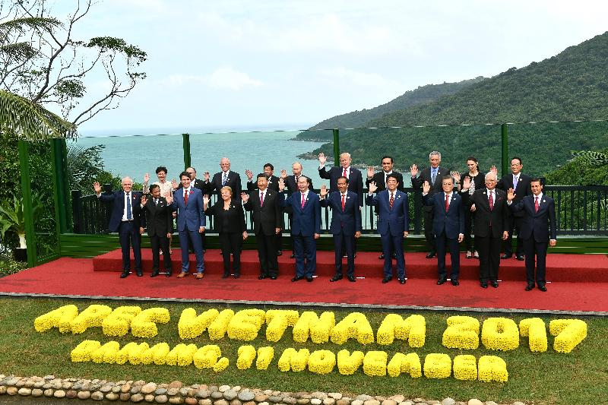
The President of our country and the Chief Executive of the HKSAR attended the Asia-Pacific Economic Cooperation Economic Leaders’ Meeting
Source of photos: Chief Executive’s Office

Source 2
Asia-Pacific Economic Cooperation (APEC) has 21 members. The word ‘economies’ is used to describe APEC members because the APEC cooperative process is predominantly concerned with trade and economic issues, with members engaging with one another as economic entities.

Source of information: Asia-Pacific Economic Cooperation website>About APEC, 30 Apr 2026, https://www.apec.org/who-we-are/our-members

Source 3

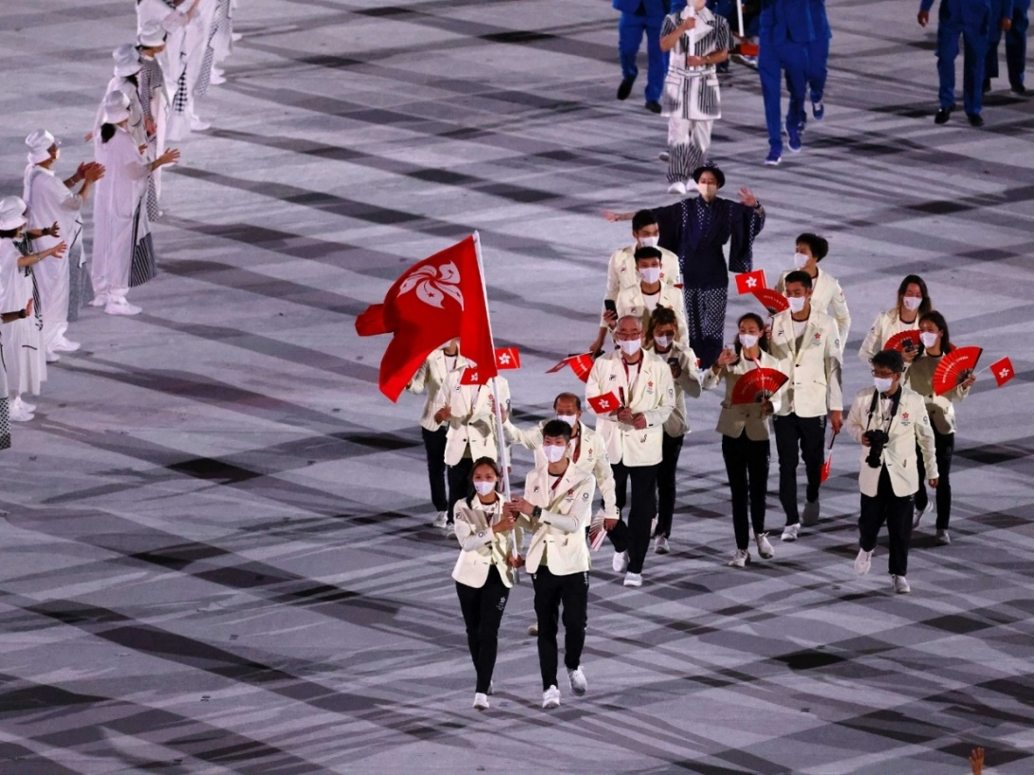
[2
Copyright © SPORTS FEDERATION & OLYMPIC COMMITTEE OF HONG KONG, CHINA (SF&OC)
On 24 July 2021, the Hong Kong, China delegation entered the Olympic Stadium at the Opening Ceremony of the 2020 Olympic Games in Tokyo.

- (a) Referring to the photos in Sources 1 and 2, the attending of the APEC Economic Leaders’ Meeting by the Chief Executive of the HKSAR is relevant to which fields as mentioned in Article 151 of the Basic Law?
Economic and trade.

(b) According to Source 2, why does the participation of the HKSAR in the APEC comply with Article 152 of the Basic Law?
Since membership of the APEC is confined to economies / economic
entities rather than states, Hong Kong’s participation in the APEC is in
line with the stipulations that the HKSAR “may, using the name ‘Hong
Kong, China’, participate in international organizations and conferences
not limited to states”.

- (a) According to what is shown in the photo in Source 3, the Hong Kong, China delegation’s participation in the Olympic Games is relevant to which field as mentioned in Article 151 of the Basic Law?
Sports.

(b) In the photo in Source 3, what flag did the flag bearer of the Hong Kong, China delegation hold?
Regional flag of the HKSAR.

(c) Following the above question, what provision in the Basic Law does this arrangement comply with? [Please refer to Activity 1 of “The Constitution and the Basic Law jointly form the constitutional basis of the HKSAR” (Lesson 1).]
Apart from displaying the national flag of the PRC, the HKSAR may also
use a regional flag.

Module 2.2: Governance of the HKSAR
(Lesson 6)
Learning and Teaching Materials

Political structure of the HKSAR (1)
Activity 6

Source 1
Basic Law
Chapter IV - Political Structure Section 1 The Chief Exeucitve
Article 44
The Chief Executive of the Hong Kong Special Administrative Region shall be a Chinese citizen of not less than 40 years of age who is a permanent resident of the Region with no right of abode in any foreign country and has ordinarily resided in Hong Kong for a continuous period of not less than 20 years.
Article 45(1)
The Chief Executive of the Hong Kong Special Administrative Region shall be selected by election or through consultations held locally and be appointed by the Central People’s Government.
Article 46
The term of office of the Chief Executive of the Hong Kong Special Administrative Region shall be five years. He or she may serve for not more than two consecutive terms.
Article 47
The Chief Executive of the Hong Kong Special Administrative Region must be a person of integrity, dedicated to his or her duties.
The Chief Executive, on assuming office, shall declare his or her assets to the Chief Justice of the Court of Final Appeal of the Hong Kong Special Administrative Region. This declaration shall be put on record.

Soure of information: Basic Law website>Basic Law>Chapter IV, https://www.basiclaw.gov.hk/en/basiclaw/chapter4.html

Source 2
14. Disqualification from being nominated
(1) … a person is disqualified from being nominated as a candidate if ——
(a) he is the Chief Executive and holds the office of the Chief Executive for the second consecutive term;
(b) he is a judicial officer as defined by section 2 of the Judicial Officers Recommendation Commission Ordinance (Cap. 92);
(c) he is a prescribed public officer;
(d) he is adjudged bankrupt under the Bankruptcy Ordinance (Cap. 6) and has not been discharged under section 30A or 30B of that Ordinance;
(e) he holds a passport or similar travel document other than ——
(i) a Hong Kong Special Administrative Region Passport issued under the Hong Kong Special Administrative Region Passports Ordinance (Cap. 539);
(ii) a certificate of identity within the meaning of the Immigration Ordinance (Cap. 115); or
(iii) any entry permit issued by an authority in any part of the People’s Republic of China which authorizes its holder to enter any part of the People’s Republic of China;
(f) he has, in Hong Kong or any other place, been sentenced to death and has not either ——
(i) served the sentence or undergone such other punishment as a competent authority may have substituted for the sentence; or
(ii) received a free pardon;
(g) he has been convicted of treason;
(h) he has been convicted ——
(i) in Hong Kong or any other place, of an offence for which the person has been sentenced to imprisonment, whether suspended or not, for a term exceeding 3 months without the option of a fine;
(ii) of having engaged in corrupt conduct or illegal conduct in contravention of the Elections (Corrupt and Illegal Conduct) Ordinance (Cap. 554);
(iii) of an offence against Part II of the Prevention of Bribery Ordinance (Cap. 201); or
(iv) of any offence prescribed by the EAC Regulations made for the purposes of this paragraph,
within the 5 years before the date of nomination; or
- he is found for the time being under the Mental Health Ordinance (Cap. 136) to be incapable, by reason of mental incapacity, of managing and administering his property and affairs.

Source of information: Cap. 569 Chief Executive Election Ordinance, Hong Kong e-Legislation, https://www.elegislation.gov.hk/

- (a) What is the main stipulation of Article 44 of the Basic Law in Source 1?
The eligibility for being the CE of the HKSAR.

(b) What is the relationship between Source 2 and Article 45 (1) of the Basic Law in Source 1?
It is stipulated in Article 45(1) of the Basic Law that the CE can be
selected by election, while according to the content in the Chief Executive
Election Ordinance about the “disqualification from being nominated” in
Source 2,it is stipulated that a person shall be disqualified from being
nominated as candidate out of some specified reasons even if he or she is
considered to be eligible according to Article 44 of the Basic Law.

- (a) Which Article of the Basic Law in Source 1 is 14.(1)(a) in Source 2 relevant to?
Article 46.

(b) Which Article of the Basic Law in Source 1 is 14.(1)(e) in Source 2 relevant to?
Article 44.

(c) Which Article of the Basic Law in Source 1 is 14.(1)(f)-(h) in Source 2 relevant to?
Article 47.

Worksheet 12: Appointment, dual capacity and dual responsibility of the Chief Executive

Source 1
Order of the State Council
of the People’s Republic of China No. 754

Pursuant to the stipulations of the Basic Law of the Hong Kong Special Administrative Region of the People’s Republic of China and in accordance with the candidate elected by the Election Committee of the Hong Kong Special Administrative Region, it is hereby promulgated that LEE Ka-chiu is appointed as the sixth-term chief executive of Hong Kong Special Administrative Region.

LI Keqiang
Premier
20 May 2022

Source of information: Translated from 中華人民共和國中央人民政府網頁，2022年5月20日，《中華人民共和國國務院令第754號》，
http://www.gov.cn/zhengce/content/2022-05/20/content_5691515.htm

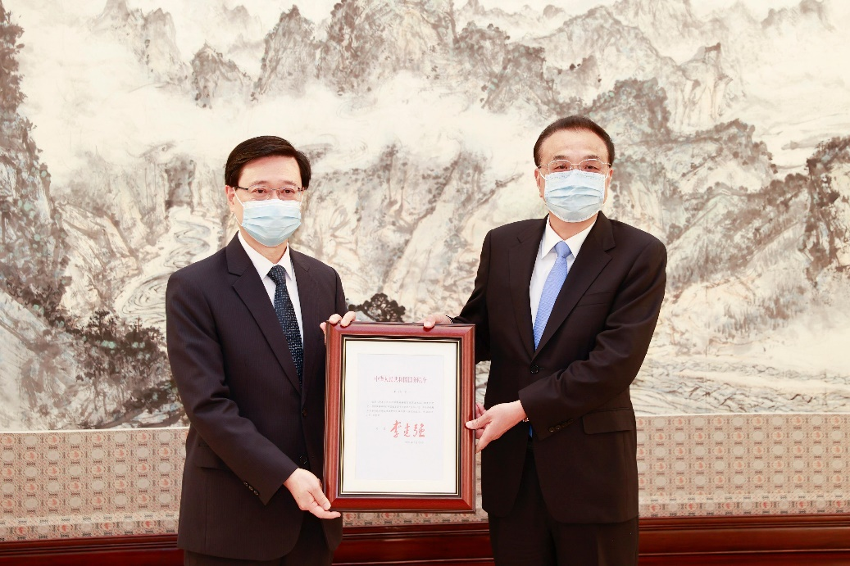

The Chief Executive-elect, Mr John Lee (left), receives from then Premier Li Keqiang (right) the instrument of appointment as the sixth-term Chief Executive of the Hong Kong Special Administrative Region of the People's Republic of China in Beijing (May 30 2022).

Source 2
Article 104 of the Basic Law of the Hong Kong Special Administrative Region of the People’s Republic of China stipulates, “When assuming office, the Chief Executive, principal officials, members of the Executive Council and of the Legislative Council, judges of the courts at all levels and other members of the judiciary in the Hong Kong Special Administrative Region must, in accordance with law, swear to uphold the Basic Law of the Hong Kong Special Administrative Region of the People’s Republic of China and swear allegiance to the Hong Kong Special Administrative Region of the People’s Republic of China.” In the light of the above, the Preparatory Committee of the Hong Kong Special Administrative Region of the National People’s Congress makes the following decision:
…
- During the inauguration ceremony, the Premier of the State Council or the representative entrusted by the Premier swears in the Chief Executive … of the Hong Kong Special Administrative Region …;
- With the exception of the Chief Executive of the Hong Kong Special Administrative Region, persons holding two positions should swear into respective positions during the inauguration ceremony.
…

Source of information: Translated from全國人民代表大會香港特別行政區籌備委員會（1997年5月23日），〈全國人民代表大會香港特別行政區籌備委員會關於香港特別行政區有關人員就職宣誓事宜的決定〉，載於《中華人民共和國國務院公報》Zhonghua Renmin Gongheguo Guowuyuan Gongbao 1997年第18號（總號870），頁777-778，http://www.gov.cn/gongbao/shuju/1997/gwyb199718.pdf

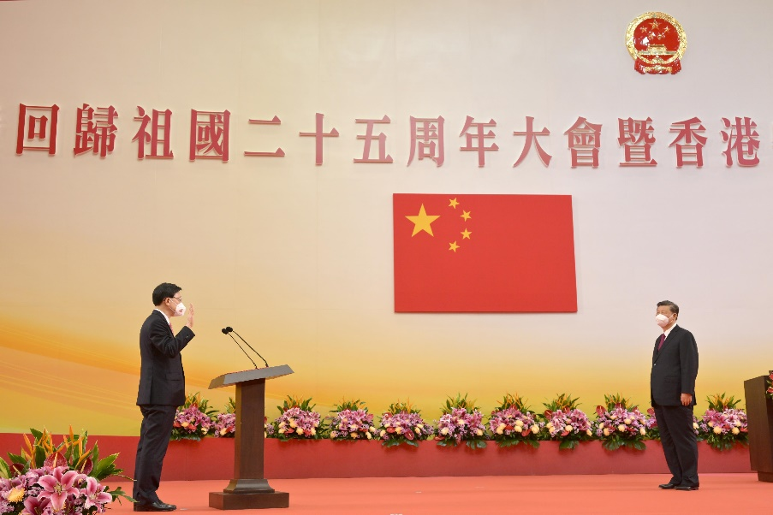

President Xi Jinping (right) swears in the Chief Executive, Mr John Lee (left), at the Inaugural Ceremony of the Sixth-term Government of the Hong Kong Special Administrative Region at the Hong Kong Convention and Exhibition Centre this morning (July 1 2022).

Source of photo: Information Services Department, HKSAR Government

Source 3
Basic Law
Chapter IV - Political Structure Section 1 The Chief Executive
Article 43
The Chief Executive of the Hong Kong Special Administrative Region shall be the head of the Hong Kong Special Administrative Region and shall represent the Region.
The Chief Executive of the Hong Kong Special Administrative Region shall be accountable to the Central People's Government and the Hong Kong Special Administrative Region in accordance with the provisions of this Law.
Article 45(1)
The Chief Executive of the Hong Kong Special Administrative Region shall be selected by election or through consultations held locally and be appointed by the Central People's Government.
Section 2 The Executive Authorities
Article 59
The Government of the Hong Kong Special Administrative Region shall be the executive authorities of the Region.
Article 60(1)
The head of the Government of the Hong Kong Special Administrative Region shall be the Chief Executive of the Region.

Source of information: Basic Law website>Basic Law>Chapter IV,
https://www.basiclaw.gov.hk/tc/basiclawtext/chapter_4.html

Source 4
Remarks by Chief Executive at a media session before the Executive Council meeting…
I must reiterate here that the Chief Executive is vested with a dual role and a dual responsibility. The Chief Executive is both the head of the executive authorities of the HKSAR and the head of the HKSAR as a whole, which is clearly specified in the Basic Law…

*The Policy Address 2020 mentioned that the Chief Executive is vested with “dual role” as head of the executive authorities of the HKSAR, that is, the HKSAR Government, and that of the HKSAR representing the whole Region. Besides, the constitutional function of “dual responsibility” is used to describe the dual accountability of the Chief Executive.

Source of information: Translated from 香港特別行政區政府新聞公報網頁，2020年6月23日，《行政長官於行政會議前會見傳媒開場發言及答問內容》，https://www.info.gov.hk/gia/general/202006/23/P2020062300464.htm

- (a) According to Source 1, who was responsible for appointing the CE of the HKSAR?
Premier of the State Council.

(b) Following the above question, which Article of the Basic Law in Source 3 is the answer to 1.(a) relevant to?
Article 45(1).

(c) According to Source 2, who was responsible for swearing in the CE of the HKSAR?
The President.

(d) Following the above question, who entrusted the person to swear in the CE of the HKSAR as mentioned in the answer to 1.(c)?
Premier of the State Council.

- (a) According to the order as shown in the articles of the Basic Law in Source 3 and Source 4, what is the order of the “dual role” of the CE?
1st Role: The head of the HKSAR.
2nd Role: The head of the Government of the HKSAR.

(b) According to Sources 3 and 4 and regarding CE’s “dual responsibility”, to whom and in what order should the CE be accountable to in accordance with the provisions of the Basic Law?
(i) Accountable to the CPG.
(ii) Accountable to the HKSAR.

- Referring to Source 6 of “Worksheet 1: Constitutional Basis of the HKSAR”, why are the provisions about the appointment, status and accountability of the CE specified in the Basic Law?
It is because the HKSAR is a local administrative region of the PRC, which
enjoys a high degree of autonomy and comes directly under the CPG.

Worksheet 13: Method of formation as well as major roles and functions of the Executive Council

Source 1
Basic Law
Chapter IV - Political Structure Section 1 The Chief Executive
Article 54
The Executive Council of the Hong Kong Special Administrative Region shall be an organ for assisting the Chief Executive in policy-making.
Article 55
Members of the Executive Council of the Hong Kong Special Administrative Region shall be appointed by the Chief Executive from among the principal officials of the executive authorities, members of the Legislative Council and public figures. Their appointment or removal shall be decided by the Chief Executive. The term of office of members of the Executive Council shall not extend beyond the expiry of the term of office of the Chief Executive who appoints them.
Members of the Executive Council of the Hong Kong Special Administrative Region shall be Chinese citizens who are permanent residents of the Region with no right of abode in any foreign country.
The Chief Executive may, as he or she deems necessary, invite other persons concerned to sit in on meetings of the Council.
Article 56
The Executive Council of the Hong Kong Special Administrative Region shall be presided over by the Chief Executive.
Except for the appointment, removal and disciplining of officials and the adoption of measures in emergencies, the Chief Executive shall consult the Executive Council before making important policy decisions, introducing bills to the Legislative Council, making subordinate legislation, or dissolving the Legislative Council.
If the Chief Executive does not accept a majority opinion of the Executive Council, he or she shall put the specific reasons on record.

Source of information: Basic Law website>Basic Law>Chapter IV,
https://www.basiclaw.gov.hk/en/basiclaw/chapter4.html

Source 2
Article 104 of the Basic Law of the Hong Kong Special Administrative Region of the People’s Republic of China stipulates, “When assuming office, the Chief Executive, principal officials, members of the Executive Council and of the Legislative Council, judges of the courts at all levels and other members of the judiciary in the Hong Kong Special Administrative Region must, in accordance with law, swear to uphold the Basic Law of the Hong Kong Special Administrative Region of the People’s Republic of China and swear allegiance to the Hong Kong Special Administrative Region of the People’s Republic of China.” In the light of the above, the Preparatory Committee of the Hong Kong Special Administrative Region of the National People’s Congress makes the following decision:
…
- During the inauguration ceremony, … the Chief Executive swears in members of the Executive Council … of the Hong Kong Special Administrative Region;
- With the exception of the Chief Executive of the Hong Kong Special Administrative Region, persons holding two positions should swear into respective positions during the inauguration ceremony.
…

Source of information: Translated from 全國人民代表大會香港特別行政區籌備委員會（1997年5月23日），〈全國人民代表大會香港特別行政區籌備委員會關於香港特別行政區有關人員就職宣誓事宜的決定〉，載於《中華人民共和國國務院公報》Zhonghua Renmin Gongheguo Guowuyuan Gongbao 1997年第18號（總號870），頁777-778，http://www.gov.cn/gongbao/shuju/1997/gwyb199718.pdf

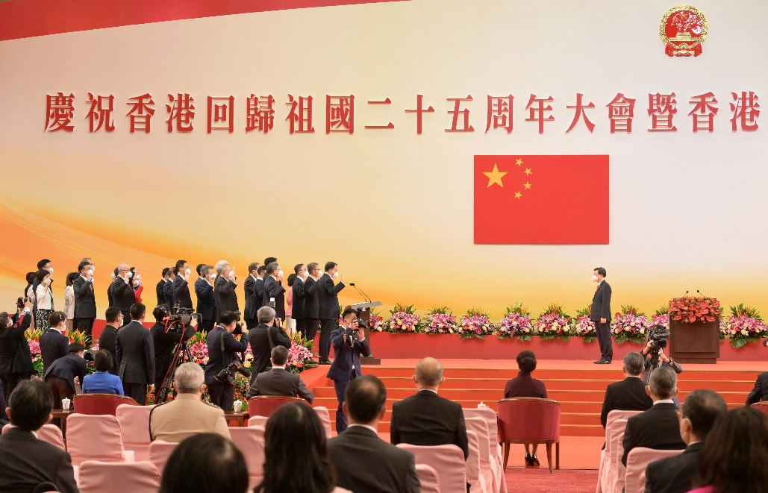

The Chief Executive, Mr John Lee (right), swears in members of the Executive Council at the Inaugural Ceremony of the Sixth-term Government of the Hong Kong Special Administrative Region (July 1 2022).

Source of photo: Information Services Department, HKSAR Government

- (a) According to Source 1, what kind of organ is the Executive Council (ExCo)?
It is the organ for assisting the CE in policy-making.

(b) According to Source 1, circle the correct answers in the table below.

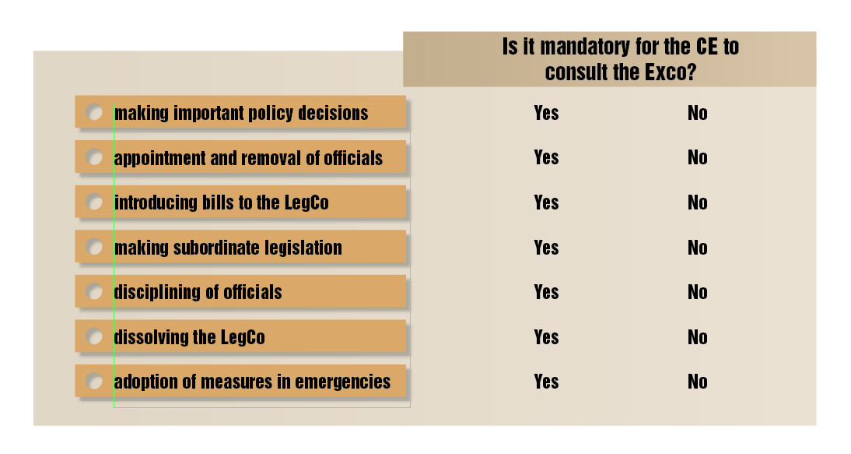

(c) According to Source 1, what should the CE do if he or she does not accept a majority opinion of the Executive Council?
He or she shall put the specific reasons on record.

- (a) According to Source 1, what is the requirement for becoming ExCo members?
Being Chinese citizens who are permanent residents of the HKSAR with
no right of abode in any foreign country.

(b) According to Source 2, who swear in members of the ExCo?
CE.

(c) Following the above question, which stipulations in Source 1 are relevant to the question of and the answer to 2.(b)?
Members of the ExCo of the HKSAR shall be appointed by the CE from
among the principal officials of the executive authorities, members of the
LegCo and public figures. Their appointment or removal shall be decided
by the CE.

Worksheet 14: Powers and functions of the executive authorities as well as the appointment and removal of principal officials
Source 1
Basic Law
Chapter IV - Political Structure Section 1 The Chief Executive
Article 48
[The Chief Executive of the Hong Kong Special Administrative Region shall exercise the following powers and functions:]
5. To nominate and to report to the Central People’s Government for appointment the following principal officials: Secretaries and Deputy Secretaries of Departments, Directors of Bureaux, Commissioner Against Corruption, Director of Audit, Commissioner of Police, Director of Immigration and Commissioner of Customs and Excise; and to recommend to the Central People's Government the removal of the above-mentioned officials;
Section 2 The Executive Authorities
Article 59
The Government of the Hong Kong Special Administrative Region shall be the executive authorities of the Region.
Article 60
The head of the Government of the Hong Kong Special Administrative Region shall be the Chief Executive of the Region.
A Department of Administration, a Department of Finance, a Department of Justice, and various bureaux, divisions and commissions shall be established in the Government of the Hong Kong Special Administrative Region.
Article 61
The principal officials of the Hong Kong Special Administrative Region shall be Chinese citizens who are permanent residents of the Region with no right of abode in any foreign country and have ordinarily resided in Hong Kong for a continuous period of not less than 15 years.
Article 62
The Government of the Hong Kong Special Administrative Region shall exercise the following powers and functions:
1. To formulate and implement policies;
2. To conduct administrative affairs;
3. To conduct external affairs as authorised by the Central People’s Government under this Law;
4. To draw up and introduce budgets and final accounts;
5. To draft and introduce bills, motions and subordinate legislation; and
6. To designate officials to sit in on the meetings of the Legislative Council and to speak on behalf of the government.

Source of information: Basic Law website>Basic Law>Chapter IV,
https://www.basiclaw.gov.hk/en/basiclaw/chapter4.html
Source 2
Article 104 of the Basic Law of the Hong Kong Special Administrative Region of the People’s Republic of China stipulates, “When assuming office, the Chief Executive, principal officials, members of the Executive Council and of the Legislative Council, judges of the courts at all levels and other members of the judiciary in the Hong Kong Special Administrative Region must, in accordance with law, swear to uphold the Basic Law of the Hong Kong Special Administrative Region of the People’s Republic of China and swear allegiance to the Hong Kong Special Administrative Region of the People’s Republic of China.” In the light of the above, the Preparatory Committee of the Hong Kong Special Administrative Region of the National People’s Congress makes the following decision:
…
- During the inauguration ceremony, the Premier of the State Council or the representative entrusted by the Premier swears in the … principal officials of the Hong Kong Special Administrative Region …;
- With the exception of the Chief Executive of the Hong Kong Special Administrative Region, persons holding two positions should swear into respective positions during the inauguration ceremony.
…

Source of information: Translated from 全國人民代表大會香港特別行政區籌備委員會（1997年5月23日），〈全國人民代表大會香港特別行政區籌備委員會關於香港特別行政區有關人員就職宣誓事宜的決定〉，載於《中華人民共和國國務院公報》Zhonghua Renmin Gongheguo Guowuyuan Gongbao 1997年第18號（總號870），頁777-778，http://www.gov.cn/gongbao/shuju/1997/gwyb199718.pdf

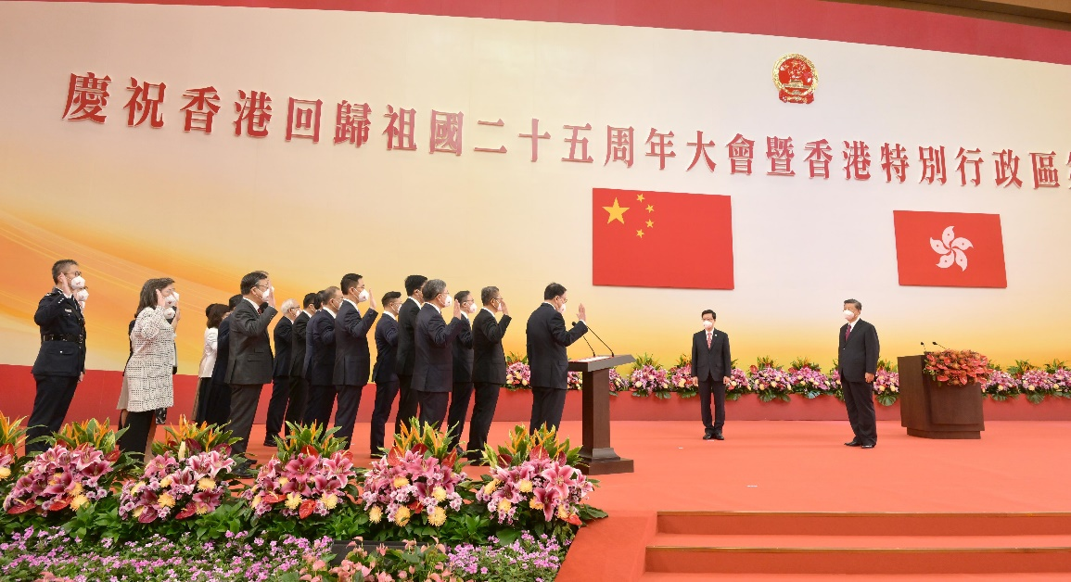
President Xi Jinping (first right) swears in Principal Officials of the sixth-term Hong Kong Special Administrative Region Government at the Inaugural Ceremony of the Sixth-term Government of the Hong Kong Special Administrative Region (July 1 2022).

Source of photo: Information Services Department, HKSAR Government
- (a) According to Source 1, what is the executive authorities of the HKSAR?
Government of the HKSAR.

(b) According to Source 1 and Source 2 of “Worksheet 5: The HKSAR enjoys executive power” - Organisation Chart of the Government of the Hong Kong Special Administrative Region, complete the following simplified diagram.
CE

Financial Secretary
Chief Secretary for Administration
Secretary for Justice

bureaux
bureaux

divisions and commissions
divisions and commissions

(c) Find out which government department is responsible for the public libraries of Hong Kong on the web site of Hong Kong Public Libraries (https://www.hkpl.gov.hk/en/index.html)? This work is most relevant to which powers and functions of the Government of the HKSAR as mentioned in Article 62 of the Basic Law in Source 1?
Leisure and Cultural Services Department.
To conduct administrative affairs.

(d) Following the above question, which bureau does the department mentioned in the answer to 1.(c) report to? [Refer to Source 2 of “Worksheet 5: The HKSAR enjoys executive power” - Organisation Chart of the Government of the Hong Kong Special Administrative Region.]
Culture, Sports and Tourism Bureau

(e) Following the above question, which secretary does the bureau mentioned in the answer to 1.(d) report to? [Refer to Source 2 of “Worksheet 5: The HKSAR enjoys executive power” - Organisation Chart of the Government of the Hong Kong Special Administrative Region.]
Chief Secretary for Administration.

- (a) According to Source 1, what is the requirement for becoming principal officials of the HKSAR?
Being Chinese citizens who are permanent residents of the HKSAR with
no right of abode in any foreign country and have ordinarily resided in
Hong Kong for a continuous period of not less than 15 years.

(b) According to Source 2, who swore in the principal officials of the HKSAR?
The President.

(c) Following the above question, which stipulations in Source 1 are relevant to the question of and the answer to 2.(b)?
The CPG is be responsible for appointing or removing principal officials
of the HKSAR.

Module 2.2: Governance of the HKSAR
(Lesson 7)
Learning and Teaching Materials

Political structure of the HKSAR (2)
Activity 7

The three main roles of the LegCo are: (1) to make laws; (2) to examine and approve public spending; (3) to monitor the work of the Government. Article 73 of the Basic Law lists 10 powers and functions of the LegCo. Try to put these powers and functions into three groups according to the three main roles above. Put a in the right box(es).

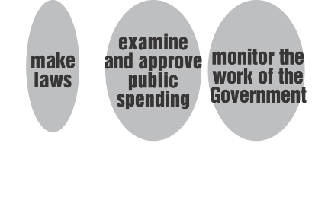

Clauses of Article 73 of the Basic Law

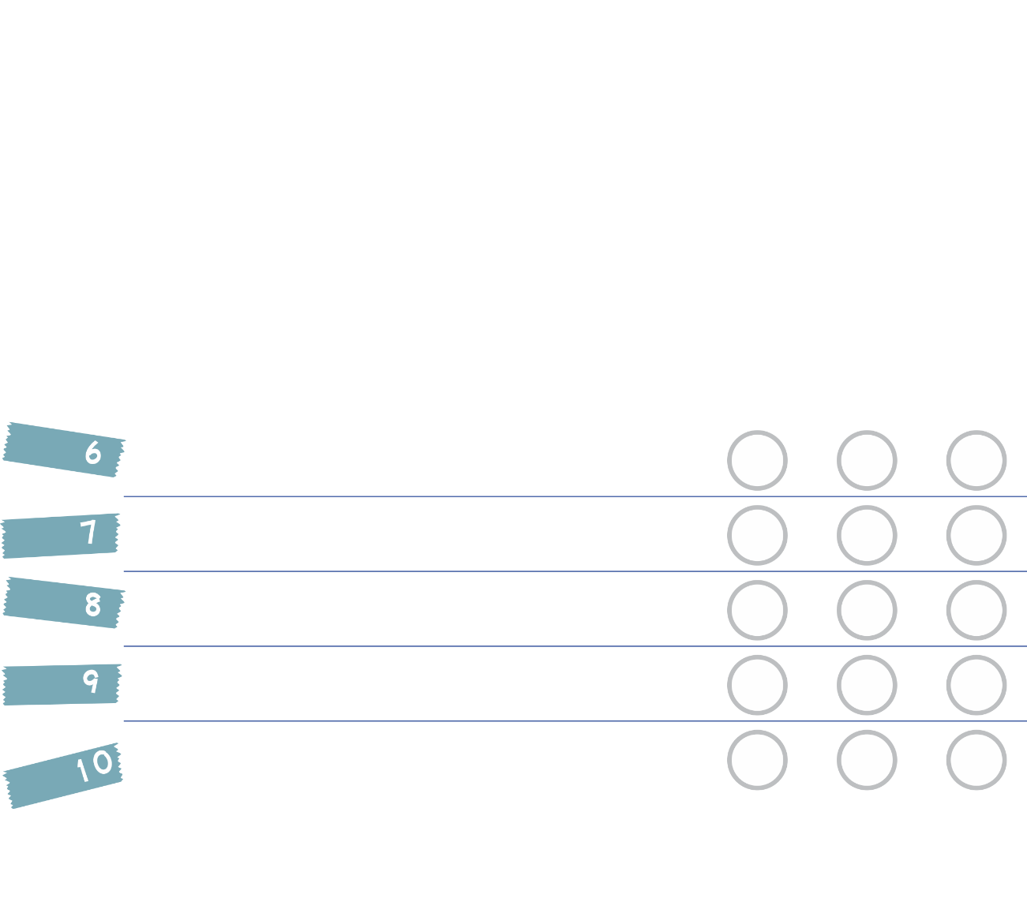

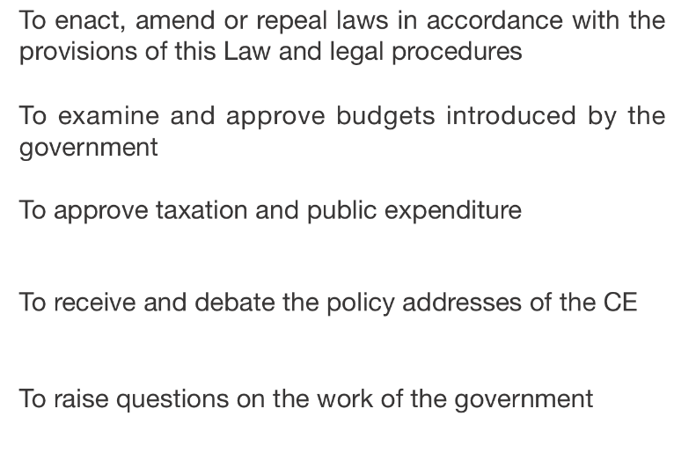

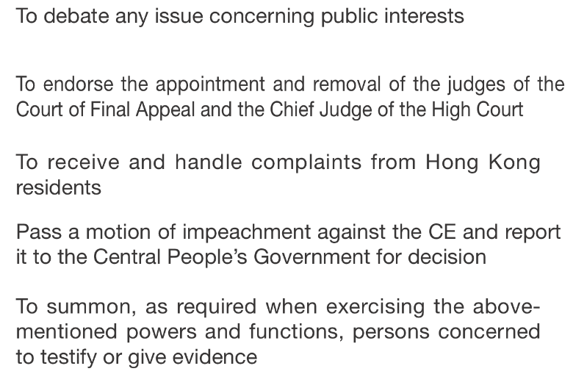

*

* In Article 73(9) of the Basic Law, there are more detailed stipulations with regard to the passing of the motion of impeachment.

Worksheet 15: Law-making process of the HKSAR

Source 1

Article 62(1) (5)
(HKSAR Government) To draft and introduce bills, motions and subordinate legislation


Article 17(2)
Laws enacted by the legislature of the HKSAR must be reported to the Standing Committee of the National People’s Congress for the record
Article 48(1) (3)
(Chief Executive) To sign bills passed by the Legislative Council and to romulgate laws
Article 73(1) (1)
(Legislative Council) To enact, amend or repeal laws in accordance with the provisions of this Law and legal procedures
Article 56(2)
The Chief Executive shall consult the Executive Council before introducing bills to the Legislative Council

Source 2
The Chief Executive (CE) considers that a bill passed by the Legislative Council (LegCo) is not compatible with the overall interests of the HKSAR

Refuses to sign the bill

May return it to the LegCo within three months for reconsideration
Article 49
Basic Law

LegCo passes the original bill again by not less than a two-thirds majority of all the members

The CE must sign and promulgate it within one month.
If the CE refuses to sign the bill passed the second time by the LegCo, and if consensus still cannot be reached after consultations, the CE may dissolve the LegCo.

Article 50
Basic Law

The CE must consult the Executive Council before dissolving the LegCo. The CE may dissolve the LegCo only once in each term of his or her office.

When the new LegCo again passes by a two-thirds majority of all the members the original bill in dispute, but the CE still refuses to sign it

Article 52
Basic Law

The CE must resign

Source 3
Basic Law
Chapter II - Relationship between the Central Authorities and the Hong Kong Special Administrative Region
Article 17(3)
If the Standing Committee of the National People’s Congress, after consulting the Committee for the Basic Law of the Hong Kong Special Administrative Region under it, considers that any law enacted by the legislature of the Region is not in conformity with the provisions of this Law regarding affairs within the responsibility of the Central Authorities or regarding the relationship between the Central Authorities and the Region, the Standing Committee may return the law in question but shall not amend it. Any law returned by the Standing Committee of the National People’s Congress shall immediately be invalidated. This invalidation shall not have retroactive effect, unless otherwise provided for in the laws of the Region.

Source of information: Basic Law website>Basic Law>Chapter II,
https://www.basiclaw.gov.hk/en/basiclaw/chapter2.html

- Complete the following flow chart according to Source 1:
Law enacted by the legislature of the HKSAR must be reported to the Standing Committee of the NPC for the record.

The Government of the HKSAR to draft bills
The flow chart of the law-making process in the Government of the HKSAR

The Chief Executive shall consult the Executive Council before introducing the bill to the LegCo.
Bills to be gazetted
To be put before & passed by the LegCo after Three Readings
The Chief Executive signs the bill passed by the LegCo.

Promulgation of the bill in Gazette by the Chief Executive and taking effect.

- (a) According to Source 2, under what circumstances can the CE return a bill passed by the LegCo to the LegCo for reconsideration?
The CE considers that the bill passed by the LegCo is not compatible with
the overall interests of the HKSAR.

(b) Following the above questions and if the situation mentioned in 2.(a) occurs, but the LegCo passes the original bill again by not less than a two-thirds majority of all the members, what else can the CE do to deal with the situation besides choosing to sign and promulgate the bill?
The CE can refuse to sign the bill, and if consensus still cannot be reached
after consultations, the CE may dissolve the LegCo.

(c) Following the above question and if the CE chooses the method mentioned in the answer to 2.(b), what procedure must be followed and what will be the constraint?
The CE must consult the ExCo before dissolving the LegCo. The CE may
dissolve the LegCo only once in each term of his or her office.

(d) If the CE chooses the method mentioned in the answer to 2. (b), what will be the consequence if the new LegCo again passes by a two-thirds majority of all the members the original bill in dispute and the CE still refuses to sign it?
The CE must resign.

- On 28 March 1990, Ji Pengfei, the then Chairman of the Drafting Committee for the Basic Law of the HKSAR of the PRC submitted the Explanations on “The Basic Law of the Hong Kong Special Administrative Region of the People’s Republic of China (Draft)” and Its Related Documents at the Third Session of the Seventh National People’s Congress. It was pointed out that “To maintain Hong Kong’s stability and administrative efficiency, the Chief Executive must have real power which, at the same time, should be subject to some restrictions.”

(a) According to Source 2, which arrangements are relevant to the real power of the CE?
Refusing to sign bills; dissolving the LegCo.

(b) According to Source 2, which arrangements are relevant to the restrictions faced by the CE?
The procedure to be followed before dissolving the LegCo and the
restriction on the number of times in dissolving the LegCo; the stipulations
that the CE must resign under specified circumstances.

- (a) According to Source 3, after consulting the Committee for the Basic Law of the HKSAR, what can the NPCSC do if it considers that any law enacted by the legislature of the HKSAR is not in conformity with the provisions of the Basic Law regarding affairs within the responsibility of the Central Authorities or regarding the relationship between the Central Authorities and the HKSAR?
The NPCSC may return the law in question but shall not amend it.

(b) Following the above question and if the situation mentioned in 4.(a) occurs, what will happen to the relevant law?
The law returned shall immediately be invalidated. This invalidation shall
not have retroactive effect, unless otherwise provided for in the laws of the
HKSAR.

Worksheet 16: HKSAR Government is accountable to the LegCo

Source 1
Basic Law
Chapter IV - Political Structure Section 2 The Executive Authorities
Article 64
The Government of the Hong Kong Special Administrative Region must abide by the law and be accountable to the Legislative Council of the Region: it shall implement laws passed by the Council and already in force; it shall present regular policy addresses to the Council; it shall answer questions raised by members of the Council; and it shall obtain approval from the Council for taxation and public expenditure.
Section 3 The Legislature
Article 73(1) (1), (1) (3), (1) (4) and (1) (5)
[The Legislative Council of the Hong Kong Special Administrative Region shall exercise the following powers and functions:]
1. To enact, amend or repeal laws in accordance with the provisions of this Law and legal procedures;
3. To approve taxation and public expenditure;
4. To receive and debate the policy addresses of the Chief Executive;
5. To raise questions on the work of the government;

Source of information: Basic Law website>Basic Law>Chapter IV,
https://www.basiclaw.gov.hk/tc/basiclawtext/chapter_4.html

Source 2
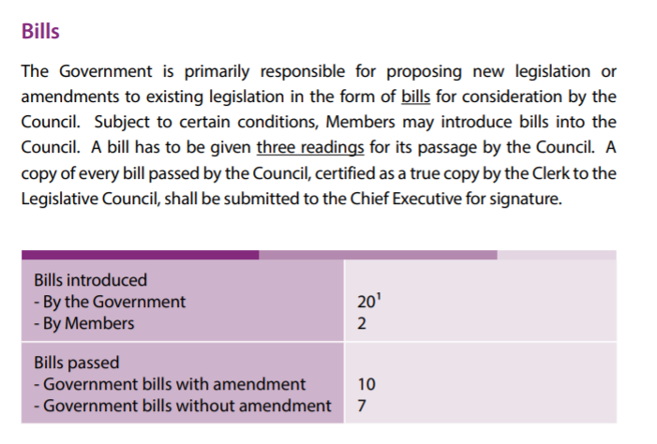
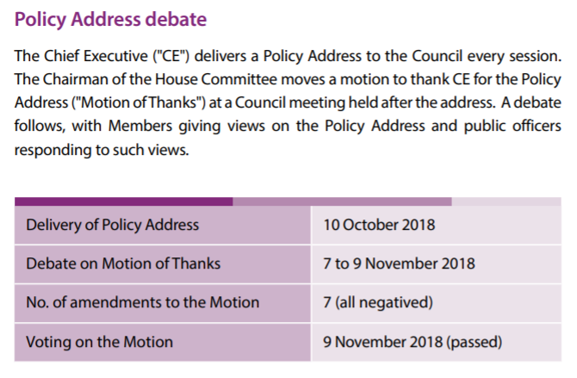
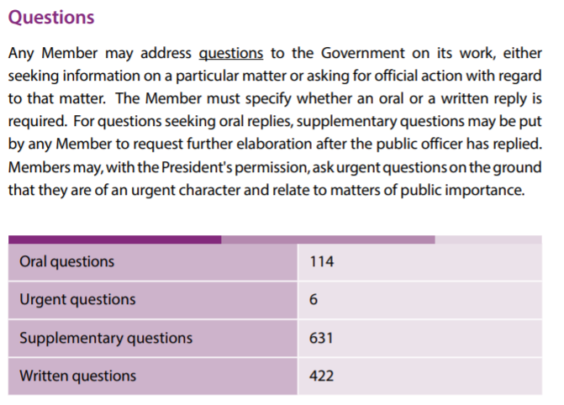
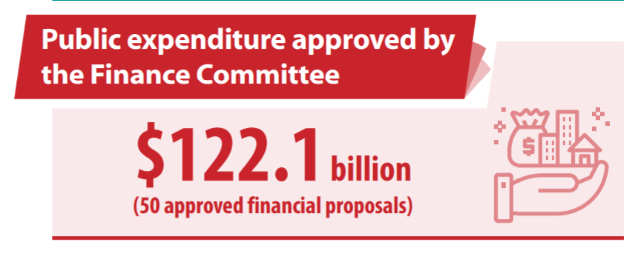

Source of information: Legislative Council Report 2018-2019, Legislative Council (2019), https://www.legco.gov.hk/general/english/sec/reports/a_1819.pdf

- (a) According to Article 64 of the Basic Law in Source 1, the Government of the HKSAR is accountable to the LegCo in four aspects. Please fill in the following table with corresponding item numbers of the powers and functions of the LegCo in Article 73(1) of the Basic Law.

The Government of the HKSAR must abide by the law and be accountable to the LegCo of the HKSAR: | Paragraph 1, Article 73 of the Basic Law
it shall implement laws passed by the Council and already in force | Item ( 1 )
it shall present regular policy addresses to the Council | Item ( 4 )
it shall answer questions raised by members of the Council | Item ( 5 )
it shall obtain approval from the Council for taxation and public expenditure | Item ( 3 )

(b) According to Source 2, how many bills were passed by the LegCo in 2018-2019? What procedures must be followed in the LegCo before they were passed?
17 government bills. The bills have to be given three readings for their
passage by the LegCo.

(c) According to Article 64 of the Basic Law in Source 1, what is the role of the CE when delivering “a policy address to the LegCo every sessoin”? [See Source 2.]
The head of the Government of the HKSAR.

(d) According to Source 2, who can address questions to the Government on its work? What is the procedure for asking urgent questions?
Any Member of the LegCo.
With the President’s permission.

(e) According to Source 2, public expenditure should be approved by which committee of the LegCo?
Finance Committee.

Module 2.2: Governance of the HKSAR
(Lesson 8)
Learning and Teaching Materials

Political structure of the HKSAR (3)
Activity 8

Source 1
Basic Law
Chapter II - Relationship between the Central Authorities and the Hong Kong Special Administrative Region
Article 19
The Hong Kong Special Administrative Region shall be vested with independent judicial power, including that of final adjudication.
The courts of the Hong Kong Special Administrative Region shall have jurisdiction over all cases in the Region, except that the restrictions on their jurisdiction imposed by the legal system and principles previously in force in Hong Kong shall be maintained.
The courts of the Hong Kong Special Administrative Region shall have no jurisdiction over acts of state such as defence and foreign affairs. The courts of the Region shall obtain a certificate from the Chief Executive on questions of fact concerning acts of state such as defence and foreign affairs whenever such questions arise in the adjudication of cases. This certificate shall be binding on the courts. Before issuing such a certificate, the Chief Executive shall obtain a certifying document from the Central People’s Government.

Source of information: Basic Law website>Basic Law>Chapter II,
https://www.basiclaw.gov.hk/en/basiclaw/chapter2.html

Source 2
The Supreme People’s Court is the highest judicial organ and the Supreme People’s Procuratorate is the highest legal oversight organ. According to the stipulations of the Basic Laws of the Special Administrative Regions (SARs), SARs shall be vested with independent judicial power, including that of final adjudication. Therefore, judiciaries and legal departments in the SARs have no affiliation with state judicial and legal oversight organs. …
According to the Basic Laws of the SARs, the judicial systems previously practised in the SARs shall be maintained and are not influenced by the judicial system on the mainland. Each SAR has its own Court of Final Appeal and the final adjudication of cases is not exercised by the Supreme People’s Court. There is no higher adjudicatory organ above the Courts of Final Appeal of the SARs and the Supreme People’s Court. So “one country, two judicial systems” has taken shape in China.

Source of information: Translated from 王振民（2017年），《 “一國兩制” 與基本法：歷史、現實與未來》，三聯書店（香港）有限公司, p.97 and p.128.

- (a) According to Source 1, the courts of the HKSAR shall have no jurisdiction over what aspects?
Acts of state such as defence and foreign affairs.

(b) Following the above question, why does the Basic Law stipulate so?
It is because the CPG is responsible for those aspects.

- (a) According to Source 2, how does the author describe the relationship between judiciaries and legal departments in the SARs and the state judicial and legal oversight organs?
The judiciaries and legal departments in the SARs have no affiliation
with state judicial and legal oversight organs.

(b) Following the above question, the situation mentioned in the answer to 2.(a) is most relevant to what content in Article 19 of the Basic Law in Source 1?
The HKSAR shall be vested with independent judicial power, including
that of final adjudication.

Worksheet 17: Judicial independence in the HKSAR

Source 1
Basic Law
Chapter I - General Principles
Article 2
The National People’s Congress authorizes the Hong Kong Special Administrative Region to exercise a high degree of autonomy and enjoy executive, legislative and independent judicial power, including that of final adjudication, in accordance with the provisions of this Law.
Chapter II - Relationship between the Central Authorities and the Hong Kong Special Administrative Region
Article 19(1)
The Hong Kong Special Administrative Region shall be vested with independent judicial power, including that of final adjudication.
Chapter IV - Political Structure Section 1 The Judiciary
Article 85
The courts of the Hong Kong Special Administrative Region shall exercise judicial power independently, free from any interference. Members of the judiciary shall be immune from legal action in the performance of their judicial functions.

Source of information: Basic Law website>Basic Law, https://www.basiclaw.gov.hk/tc/basiclawtext/index.html

Source 2
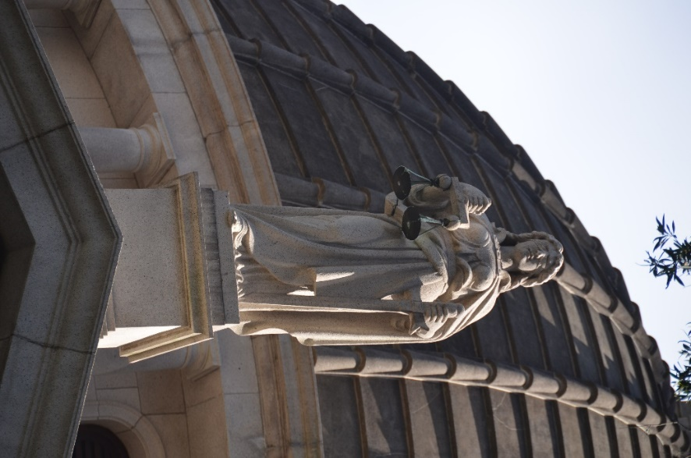
Source 3
…
An understanding of the approach of the courts is important in this discussion. The basic starting point is a facet I have already highlighted – the concept that all are equal before the law. Many take for granted the impressive statue representing justice standing at the top of the front facade of the Court of Final Appeal. This is the statue of the ancient Greek goddess Themis (in Roman mythology, she is named Justitia). Themis is blind‑folded and holds in one hand the scales of justice, a sword in the other. These are symbols of the administration of justice, which are often taken for granted …
The blindfold represents the approach of the courts in ignoring the identity of the parties who appear in them. No person or institution has any added advantage or correspondingly disadvantage in the courts by reason of who they are or what they represent. This is of course the concept of equality which I have already emphasised. …

Source of information: CJ’s speech at Ceremonial Opening of the Legal Year 2017, 9 January 2017, Press Releases, HKSAR Government, https://www.info.gov.hk/gia/general/201701/09/P2017010900457.htm?fontSize=1

Source 4
…
Independence does not mean a lack of accountability. There are built-in features in our judicial system that ensure that the Judiciary and judges are accountable to the public for their works. These include, amongst other things, the requirement that save for well-defined limited exceptions, all proceedings are open to the public, as well as the requirement that reasoned judgments which are accessible to the public on the internet be given for the decisions of the courts. Moreover, we also have a well-used system of appeals; transparent target dates for listing of cases for hearing and for delivery of judgments; a published guide to judicial conduct; an established system of complaints against judges; an annual budget that is approved by the legislature; and stringent financial control measures. There is of course further room for improvement in relation to these features, but our community should be assured that there are important features in place to ensure that whilst the Judiciary is independent in its organisation and operations, it is nonetheless fully accountable to the public in the discharge of its functions.
…

Source of information: CJ’s speech at Ceremonial Opening of the Legal Year 2021, 11 January 2021, Press Releases, HKSAR Government, https://www.info.gov.hk/gia/general/202101/11/P2021011100557.htm

- (a) According to Source 1, which organization authorises the HKSAR to enjoy independent judicial power in accordance with the provisions of the Basic Law?
NPC.

(b) According to Source 1, what are the main points related to the courts of the HKSAR exercising judicial power independently?
The courts shall be free from any interference. Members of the judiciary
shall be immune from legal action in the performance of their judicial
functions.

- (a) What is the name of the statue in the photo in Source 2? What does it represent? [Refer to Source 3.]
Its name is Themis and it represents justice.

(b) Following the above question, what is special about its eyes?
They are blind‑folded.

(c) According to Source 3, what is the meaning of the special feature described in the answer to 2. (b)?
The blindfold represents the approach of the courts in ignoring the
identity of the parties who appear in them.

(d) Following the above question, the answer to 2.(c) is relevant to which principle of the rule of law?
All are equal before the law.

- The built-in features in the judicial system have been described in Source 4. What is their main function?
To ensure that the Judiciary and judges are accountable to the public for their
works.

Worksheet 18: Appintment and removal of HKSAR judges

Source 1
Basic Law
Chapter IV - Political Structure Section 4 The Judiciary
Article 88
Judges of the courts of the Hong Kong Special Administrative Region shall be appointed by the Chief Executive on the recommendation of an independent commission composed of local judges, persons from the legal profession and eminent persons from other sectors.
Article 89
A judge of court of the Hong Kong Special Administrative Region may only be removed for inability to discharge his or her duties, or for misbehaviour, by the Chief Executive on the recommendation of a tribunal appointed by the Chief Justice of the Court of Final Appeal and consisting of not fewer than three local judges.
The Chief Justice of the Court of Final Appeal of the Hong Kong Special Administrative Region may be investigated only for inability to discharge his or her duties, or for misbehaviour, by a tribunal appointed by the Chief Executive and consisting of not fewer than five local judges and may be removed by the Chief Executive on the recommendation of the tribunal and in accordance with the procedures prescribed in this Law.
Article 90
The Chief Justice of the Court of Final Appeal and the Chief Judge of the High Court of the Hong Kong Special Administrative Region shall be Chinese citizens who are permanent residents of the Region with no right of abode in any foreign country.
In the case of the appointment or removal of judges of the Court of Final Appeal and the Chief Judge of the High Court of the Hong Kong Special Administrative Region, the Chief Executive shall, in addition to following the procedures prescribed in Articles 88 and 89 of this Law, obtain the endorsement of the Legislative Council and report such appointment or removal to the Standing Committee of the National People's Congress for the record.
Article 92
Judges and other members of the judiciary of the Hong Kong Special Administrative Region shall be chosen on the basis of their judicial and professional qualities and may be recruited from other common law jurisdictions.
Section 6 Public Servants
Article 104
When assuming office, … , judges of the courts at all levels and other members of the judiciary in the Hong Kong Special Administrative Region must, in accordance with law, swear to uphold the Basic Law of the Hong Kong Special Administrative Region of the People’s Republic of China and swear allegiance to the Hong Kong Special Administrative Region of the People’s Republic of China.

Source of information: Basic Law website>Basic Law>Chapter IV,
https://www.basiclaw.gov.hk/en/basiclaw/chapter4.html

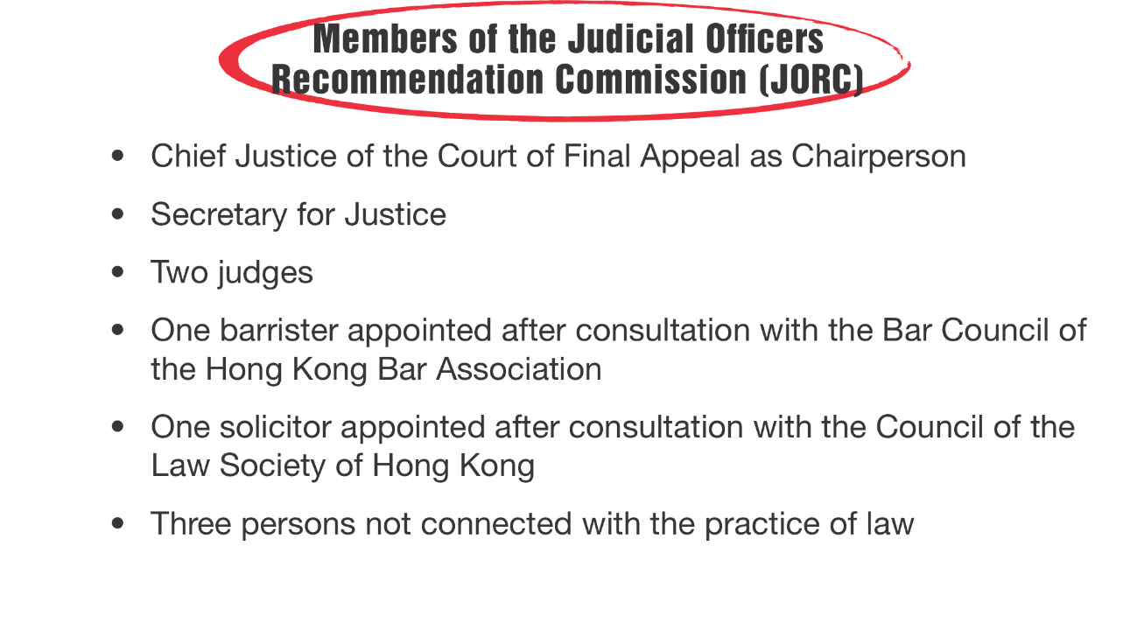
Source 2






Source of information (Reference): Cap. 92 Judicial Officers Recommendation Commission Ordinance, Hong Kong e-Legislation, https://www.elegislation.gov.hk/

Source 3
The Judicial Oath
I swear that, in the Office of a Judge/a judicial officer of the Judiciary of the Hong Kong Special Administrative Region of the People’s Republic of China, I will uphold the Basic Law of the Hong Kong Special Administrative Region of the People’s Republic of China, bear allegiance to the Hong Kong Special Administrative Region of the People’s Republic of China, serve the Hong Kong Special Administrative Region conscientiously, dutifully, in full accordance with the law, honestly and with integrity, safeguard the law and administer justice without fear or favour, self-interest or deceit.
(name of person making the oath)

Source of information: Cap. 11 Oaths and Declarations Ordinance, Hong Kong e-Legislation, https://www.elegislation.gov.hk/

Source 4
… the Judiciary must comprise judges who are upright and who are prepared to uphold rights. ... The Judicial Oath is a requirement under Article 104 of the Basic Law. It requires every judge to uphold the Basic Law, to bear allegiance to the Hong Kong Special Administrative Region, to serve Hong Kong conscientiously, dutifully, in full accordance with the law and with integrity, and to safeguard the law and administer justice without fear or favour, self-interest or deceit. It can only be fulfilled by judges who are upright; judges who are persons of integrity. It is worth repeating that judges must be impartial, free from bias or prejudice. Judges must be fearless and be prepared to make decisions in accordance with the law, regardless of whether the outcomes are popular or unpopular, or whether the outcomes would render themselves popular or unpopular. A judge must be honest and intellectually honest. Binding laws and precedents must be dispassionately applied and applicable rules and procedures faithfully observed, even if this means getting a result the judge personally might not prefer. Powers and discretions must be exercised judicially. Judgments must set out the true and entire reasons for the decisions made.
…

Source of information: CJ’s speech at Ceremonial Opening of the Legal Year 2021, 11 January 2021, Press Releases, HKSAR Government, https://www.info.gov.hk/gia/general/202101/11/P2021011100559.htm?fontSize=1

- (a) According to Article 88 of the Basic Law in Source 1, who appoints judges of the HKSAR?
CE.

(b) Following the above question, before the appointment of judges of the HKSAR by the person mentioned in the answer to 1.(a), the appointment shall be made on the recommendation of an independent commission as stipulated in Article 88 of the Basic Law. According to Source 2, what is the name of the commission?
Judicial Officers Recommendation Commission (JORC).

(c) Referring to Sources 1 and 2, put a “” in the relevant box on the sector of the Commission in the following table.

 | Article 88 of the Basic Law
 | Local judges | Persons from the legal profession | Eminent persons from other sectors
Chief Justice of the Court of Final Appeal
Secretary for Justice
Two judges
One barrister
One solicitor
Three persons not connected with the practice of law

(d) According to Article 90(2) of the Basic Law in Source 1, in addition to the requirement that “Judges of the courts of the Hong Kong Special Administrative Region shall be appointed by the Chief Executive on the recommendation of an independent commission composed of local judges, persons from the legal profession and eminent persons from other sectors”, what other procedure shall be followed for the appointment of judges of the Court of Final Appeal and the Chief Justice of the High Court of the HKSAR?
The CE shall obtain the endorsement of the LegCo and report such
appointment to the NPCSC for the record.

- (a) Complete the following chart on the steps taken to remove judges according to Article 89(1) of the Basic Law in Source 1.
If a judge is unable to discharge his or her duties or misbehaves

The Chief Justice of the Court of Final Appeal appoints a tribunal consisting of not fewer than three local judges

Recommend removal

The Chief Executive remove the judge

(b) According to Article 89(2) and Article 90(2), if the Chief Justice of the Court of Final Appeal involves in the situations mentioned in Step of 2.(a), what changes will take place in steps and ?
Step A tribunal appointed by the CE which consists of not fewer than
five local judges shall investigate and recommend removal.
Step The CE shall obtain the endorsement of the LegCo and report
such removal to the NPCSC for the record.

- (a) According to Article 92 of the Basic Law in Source 1, on what basis shall judges and other members of the judiciary of the HKSAR be chosen?
The judicial and professional qualities of relevant persons.

(b) Which Article of the Basic Law in Source 1 is relevant to “the Judicial Oath” in Source 3? [Only the relevant article number is required]
Article 104.

(c) According to Source 4, the Judicial Oath can only be fulfilled by judges with what kind of qualities?
Judges who are upright; judges who are persons of integrity.

(d) According to Source 4, why must judges be “fearless”?
It is because they must be prepared to make decisions in accordance with
the law, regardless of whether the outcomes are popular or unpopular, or
whether the outcomes would render themselves popular or unpopular.

Conclusion

Our political structure is an executive-led system headed by the Chief Executive. The executive authorities, the legislature and the judiciary perform their respective functions under the executive-led system in accordance with the Basic Law and complement each other with a view to upholding national unity and territorial integrity, maintaining the prosperity and stability of Hong Kong.

First of all, it is important to understand that China is a unitary state. According to the constitutional structure of China, power comes from the Central Authorities. The system of people’s congress is China’s political system. The HKSAR was established by a Decision made by the National People’s Congress (NPC) in accordance with the Constitution. The Basic Law was also adopted by the NPC. The HKSAR was empowered to discharge its duties by the NPC through the Basic Law. According to Articles 43 and 60 of the Basic Law, the Chief Executive shall be the head of the HKSAR and the head of the Government of the HKSAR. As head of both the HKSAR and its government, the Chief Executive shall exercise the powers and functions conferred by the Basic Law to discharge his or her duties. Article 48 states that the Chief Executive shall lead the Government of the HKSAR, sign bills, decide on government policies and etc. This fully reflects the executive-led style of governance in our structure.

Secondly, with a common goal of building a better Hong Kong, the provisions of the Basic Law set out the different powers and functions of the executive authorities, the legislature and the judiciary. In accordance with the Basic Law, the Government of the HKSAR is responsible for formulating policies and introducing bills. The Legislative Council of the HKSAR shall enact laws as required, which will be implemented or enforced by the Government. The Government is also responsible for drawing up budgets to be scrutinised by the Legislative Council. It is worth noting that members of the Legislative Council in introducing bills relating to government policies have to obtain a written consent of the Chief Executive. Clearly, under the political structure set out in the Basic Law, the executive and legislative branches are inter-related in performance of functions, but the powers of introducing bills mainly rest with the executive.

The Basic Law empowers the courts of the HKSAR to exercise judicial power independently, including that of final adjudication. Some have raised concerns over the judicial independence in the light of the political structure of the HKSAR. But these concerns are totally unfounded. Article 85 guarantees that the courts of the HKSAR shall exercise judicial power independently, free from any interference. Members of the judiciary shall be immune from legal action in the performance of their judicial functions. At the same time, the Basic Law also provides that judges of the courts of the HKSAR shall be appointed by the Chief Executive on the recommendation of an independent commission. Although the executive authorities enjoy greater power in policy making under the political structure of the HKSAR, they must abide by the law. Their decisions are also subject to judicial challenges which will be handled by the court independently based on applicable laws and evidence.

The Basic Law safeguards the exercise of judicial power by members of the judiciary without interference. … The political structure laid down in the Basic Law fully reflects the principle of rule of law and the essence of judicial independence.

A proper understanding of the political structure from the perspective of the constitutional order of the HKSAR clearly shows our system is based on an executive-led structure. We should all refrain from looking at the labelling of a concept, on the contrary, we have to appreciate its intrinsic meaning so as to avoid any unwarranted disputes.
Module 2.2: Governance of the HKSAR
(Lesson 9)
Learning and Teaching Materials

Political structure of the HKSAR (4)
Activity 9

Source 1
Decision of the National People’s Congress on Improving the Electoral System of the Hong Kong Special Administrative Region
(Adopted at the Fourth session of the Thirteenth National People’s Congress on 11 March 2021)

… The session considered that the return of Hong Kong to the motherland put the region once again under the overall governance system of the country, and the Constitution of the People’s Republic of China (PRC) and the Basic Law of the Hong Kong Special Administrative Region (HKSAR) of the PRC jointly form the constitutional basis of the HKSAR. The electoral system of the HKSAR, which includes the methods for the selection of the Chief Executive and for the formation of the Legislative Council (LegCo), is an important part of the political structure of the HKSAR. It should conform to the policy of “one country, two systems”, meet the realities in the HKSAR and serve to ensure that Hong Kong is administered by people who love the country and Hong Kong; be conducive to safeguarding national sovereignty, security, and development interests of the country and maintain the long-term prosperity and stability of Hong Kong. To improve the electoral system of the HKSAR and develop a democratic system suited to the HKSAR’s realities, the NPC has made the following decision pursuant to Articles 31 and 62(2), (14) and (16) of the Constitution of the PRC and the relevant provisions of the Basic Law of the HKSAR of the PRC and the Law of the PRC on Safeguarding National Security in the HKSAR:

1. Improving the electoral system of the HKSAR must fully and faithfully implement the policy of “one country, two systems” under which the people of Hong Kong administer Hong Kong with a high degree of autonomy, uphold the constitutional order in the HKSAR as established by the Constitution of the PRC and the Basic Law of the HKSAR of the PRC, ensure the administration of Hong Kong by Hong Kong people with patriots as the main body, effectively improve the governance efficacy of the HKSAR, and safeguard the right to vote and the right to stand for election of permanent residents of the HKSAR.
…
6. The NPC Standing Committee is authorized to, in accordance with the decision on improving the electoral system of the HKSAR, amend Annex I: Method for the Selection of the Chief Executive of the Hong Kong Special Administrative Region and Annex II: Method for the Formation of the Legislative Council of the Hong Kong Special Administrative Region and Its Voting Procedures, to the Basic Law.

7. In accordance with this decision and the Basic Law’s Annex I and Annex II amended by the NPC Standing Committee, the HKSAR shall amend relevant local laws, and organize and regulate election activities accordingly.
8. The Chief Executive of the HKSAR shall submit in a timely manner reports to the Central People’s Government on relevant important situations including the institutional arrangements for elections of the HKSAR and the organization of the elections.
…

Source of information: Basic Law website>Basic Law> Annex & Instrument, https://www.basiclaw.gov.hk/filemanager/content/en/files/basiclawtext/basiclawtext_doc31.pdf

- (a) According to Source 1, the NPC makes the Decision of the National People’s Congress on Improving the Electoral System of the Hong Kong Special Administrative Region in accordance with relevant provisions of which legal documents?
Constitution, Basic Law and and the Law of the PRC on Safeguarding
National Security in the HKSAR.

(b) According to Source 1, what is the main purpose of the NPC for making the Decision of the National People’s Congress on Improving the Electoral System of the Hong Kong Special Administrative Region?
To ensure the administration of Hong Kong by Hong Kong people with
patriots as the main body, effectively improve the governance efficacy
of the HKSAR, and safeguard the right to vote and the right to stand for
election of permanent residents of the HKSAR.

(c) Please fill in the following flow chart according to the content of Source 1:

The NPC adopted the Decision of the National People’s Congress on Improving the Electoral System of the Hong Kong Special Administrative Region
The HKSAR shall amend relevant local election laws
The NPCSC is authorized to amend Annex 1 and Annex 2 to the Basic Law

Worksheet 19: Election Committee

Source 1
Decision of the National People’s Congress on Improving the Electoral System of the Hong Kong Special Administrative Region
(Adopted at the Fourth session of the Thirteenth National People’s Congress on 11 March 2021)

…
2. The HKSAR shall establish an Election Committee which is broadly representative, suited to the HKSAR’s realities, and representative of the overall interests of its society. The Election Committee shall be responsible for electing the Chief Executive designate and part of the members of the LegCo. The Election Committee shall also be responsible for nominating candidates for the Chief Executive and LegCo members, as well as for other matters.
The Election Committee shall be composed of 1,500 members from the following five sectors: industrial, commercial and financial sectors; the professions; grassroots, labour, religious and other sectors; LegCo members and representatives of district organizations; Hong Kong deputies to the NPC, Hong Kong members of the National Committee of the Chinese People’s Political Consultative Conference and representatives of Hong Kong members of related national organizations.
…

Source of information: Basic Law website>Basic Law> Annex & Instrument, https://www.basiclaw.gov.hk/filemanager/content/en/files/basiclawtext/basiclawtext_doc31.pdf

Source 2

【On 30 March 2021, the Standing Committee of the Thirteenth National People’s Congress amended Annex I: “Method for the Selection of the Chief Executive of the Hong Kong Special Administrative Region” to the Basic Law at its Twenty-Seventh Meeting. It was promulgated by the President of the People’s Republic of China in Decree No.75.】

The Election Committee shall be composed of 1,500 members
- Members of the Election Committee must be permanent residents of the HKSAR.
- The term of office of the Election Committee shall be five years.
- Each candidate shall be nominated by 5 corporate or individual voters in the respective subsector. Each corporate or individual voter may only nominate a number of candidates not exceeding the number of seats to be elected in the respective subsectors in that election. The Election Committee Members of each subsector will be elected by secret ballot.
- The Election Committee shall establish a system of convenors. The convenors shall be responsible for convening Election Committee meetings when necessary to handle relevant matters. A Member of the Election Committee who is a state leader will become the Chief Convenor. The Chief Convenor may designate several convenors in each sector.

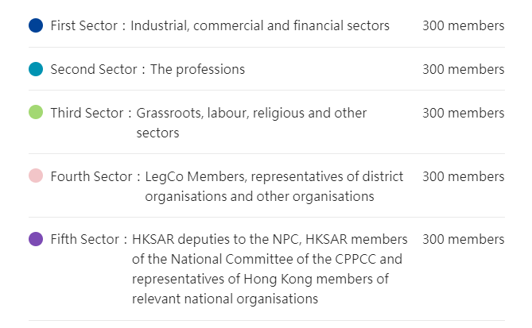

Composition, Methods for Returning Members and Electorates of Sub-sectors
Subsector | Seats | Methods for returning members | Electorates
Subsector | Seats | Methods for returning members | Individual |  | Bodies
First Sector: Industrial, commercial and financial sectors
Industrial (first) | 17 | Election
Industrial (second) | 17 | Election
Textiles and garment | 17 | Election
Commercial (first) | 17 | Election
Commercial (second) | 17 | Election
Commercial (third) | 17 | Election
Finance | 17 | Election
Financial services | 17 | Election
Insurance | 17 | Election
Real estate and construction | 17 | Election
Transport | 17 | Election
Import and export | 17 | Election
Tourism | 17 | Election
Hotel | 16 | Election
Catering | 16 | Election
Wholesale and retail | 17 | Election
Employers’ Federation of Hong Kong | 15 | Election
Small and medium enterprises | 15 | Election
Second sector: The professions
Technology and innovation | 30 | Nomination | 15
Technology and innovation | 30 | Election | 15
Engineering | 30 | Ex-officio | 15
Engineering | 30 | Election | 15
Architectural, surveying, planning and landscape | 30 | Ex-officio | 15
Architectural, surveying, planning and landscape | 30 | Election | 15
Accountancy | 30 | Nomination | 15
Accountancy | 30 | Election | 15
Legal | 30 | Ex-officio | 6
Legal | 30 | Nomination | 9
Legal | 30 | Election | 15
Education | 30 | Ex-offico | 16
Education | 30 | Election | 14
Sports, performing arts, culture and publication | 30 | Nomination | 15
Sports, performing arts, culture and publication | 30 | Election | 15
Medical and health services | 30 | Ex-officio | 15
Medical and health services | 30 | Election | 15
Chinese medicine | 30 | Nomination | 15
Chinese medicine | 30 | Election | 15
Social welfare | 30 | Ex-officio | 15
Social welfare | 30 | Election | 15
Third sector: Grassroots, labour, religious and other sectors
Agriculture and fisheries | 60 | Election
Labour | 60 | Election
Grassroots associations | 60 | Election
Associations of Chinese fellow townsmen | 60 | Election
Religious | 60 | Nomination
Fourth sector: LegCo members, representatives of district organisations and other organisations
Members of the Legislative Council | 90 | Ex-officio
Heung Yee Kuk | 27 | Election
Representatives of members of Area Committees, District Fight Crime Committees, and District Fire Safety Committees of Hong Kong and Kowloon | 76 | Election
Representatives of members of Area Committees, District Fight Crime Committees, and District Fire Safety Committees of the New Territories | 80 | Election
Representatives of associations of Hong Kong residents on the Mainland | 27 | Nomination
Fifth sector: HKSAR deputies to the NPC, HKSAR members of the National Committee of the CPPCC and representatives of Hong Kong members of relevant national organisations
HKSAR deputies to the NPC and HKSAR members of the National Committee of the CPPCC | 190 | Ex-officio
Representatives of Hong Kong members of relevant national organisations | 110 | Election
Source of information: Improve Electoral System, Constitutional and Mainland Affairs Bureau, HKSAR Government, https://www.cmab.gov.hk/improvement/en/home/index.html

- (a) According to Source 1, what are the three characteristics of the Election Committee established in the HKSAR?
It is broadly representative, suited to the HKSAR’s realities, and
representative of the overall interests of its society.

(b) According to Source 1, what are the main responsibilities of the Election Committee?
The Election Committee shall be responsible for electing the CE
designate and part of the members of the LegCo. The Election Committee
shall also be responsible for nominating candidates for the CE and
LegCo members, as well as for other matters.

- (a) According to Source 2, what is the requirement for members of the Election Committee?
They must be permanent residents of the HKSAR.

(b) According to Source 2, how many members are there in the Election Committee? It is divided into five sectors. How many people are there in each sector?
The Election Committee is composed of 1,500 members and each sector
has 300 members.

(c) According to Source 2, what are the three methods for returning members of the five sectors of the Election Committee? What are the two types of electorates?
The three methods are election, nomination and ex-officio. The two
types of electorates are individual and bodies.

(d) According to Source 2, the Election Committee shall establish a system of convenors. Who will become the Chief Convenor?
A Member of the Election Committee who is a state leader will become
the Chief Convenor.

Appendix 3
President of the PRC  Xi Jinping  Vice-president: Han Zheng | 14th NPCSC  Chairperson: Zhao Leji  Vice-chairpersons:  Li Hongzhong, Wang Dongming, Xiao Jie, Zheng Jianbang, Ding Zhongli, Hao Minjin, Cai Dafeng, He Wei, Wu Weihua, Tie Ning, Peng Qinghua, Zhang Qingwei, Losong Jamcan, Shohrat Zakir  Secretary General: Liu Qi
State Council  Premier: Li Qiang  Vice-premiers:  Ding Xuexiang, He Lifeng, Zhang Guoqing, Liu Guozhong  State Councilors:  Wang Xiaohong, Wu Zhenglong, Shen Yiqin,  Secretary General: Wu Zhenglong | 14th CPPCC National Committee  Chaiperson: Wang Huning  Vice-chairpersons:  Shi Taifeng, Hu Chunhua, Shen Yueyue, Wang Yong, Zhou Qiang, Pabala Grelanger, He Houhua, Leung Chun-ying, Bater, Su Hui, Shao Hong, Gao Yunlong, Chen Wu, Mu Hong, Xian Hui, Wang Dongfeng, Jiang Xinzhi, Jiang Zuojun, He Baoxiang, Wang Guangqian, Qin Boyong, Zhu Yongxin, Yang Zhen  Secretary General: Wang Dongfeng
Central Military Commission of the PRC
Chairperson: Xi Jinping
Vice-chairperson: Zhang Shengmin
National Commission of Supervision
Director: Liu Jinquo
Supremen People’s Court
President: Zhang Jun
Supreme People’s Procuratorate
Procurator General: Ying Yong

Sources of information: The State Council, The People’s Republic of China, 30 October 2025 https://english.www.gov.cn/

Know more: State leaders
Worksheet 20: Candidate Eligibility Review Committee, measures against acts of manipulating or undermining election, and amendment to Annex I and Annex II to the Basic Law

Source 1
Decision of the National People’s Congress on Improving the Electoral System of the Hong Kong Special Administrative Region
(Adopted at the Fourth session of the Thirteenth National People’s Congress on 11 March 2021)

…
5. A candidate qualification review committee of the HKSAR shall be established. The committee shall be responsible for reviewing and confirming the qualifications of candidates for the Election Committee members, the Chief Executive, and the LegCo members. The HKSAR shall improve the system and mechanisms related to qualification review, to ensure that the qualifications of candidates are in conformity with the Basic Law, the Law on Safeguarding National Security in the HKSAR, the NPC Standing Committee’s interpretation of Article 104 of the Basic Law, the NPC Standing Committee’s decision on the qualification of HKSAR LegCo members, and provisions of relevant local laws of the HKSAR.
6. The NPC Standing Committee is authorized to, in accordance with the decision on improving the electoral system of the HKSAR, amend Annex I: Method for the Selection of the Chief Executive of the Hong Kong Special Administrative Region and Annex II: Method for the Formation of the Legislative Council of the Hong Kong Special Administrative Region and Its Voting Procedures, to the Basic Law.
…

Source of information: Basic Law website>Basic Law> Annex & Instrument, https://www.basiclaw.gov.hk/filemanager/content/en/files/basiclawtext/basiclawtext_doc31.pdf

Source 2
Annex I to the Basic Law
Method for the Selection of the Chief Executive of the
Hong Kong Special Administrative Region
(amended at the Twenty-Seventh Meeting of the Standing Committee of the Thirteenth National People’s Congress on 30 March 2021)
…
8. The Candidate Eligibility Review Committee of the HKSAR shall be responsible for reviewing and confirming the eligibility of candidates for Election Committee members and for the office of Chief Executive. The Committee for Safeguarding National Security of the HKSAR shall, on the basis of the review by the department for safeguarding national security of the Police Force of the HKSAR, make findings as to whether a candidate for Election Committee member or for the office of Chief Executive meets the legal requirements and conditions of upholding the Basic Law of the Hong Kong Special Administrative Region of the People’s Republic of China and swearing allegiance to the Hong Kong Special Administrative Region of the People’s Republic of China, and issue an opinion to the Candidate Eligibility Review Committee of the HKSAR in respect of a candidate who fails to meet such legal requirements and conditions.
No legal proceedings may be instituted in respect of a decision made by the Candidate Eligibility Review Committee of the HKSAR on the eligibility of a candidate for Election Committee member or for the office of Chief Executive pursuant to the opinion of the Committee for Safeguarding National Security of the HKSAR.
9. The HKSAR shall, in accordance with the law, take measures against acts of manipulating or undermining election.
10. The NPC Standing Committee exercises in accordance with the law the power to amend this Method. Prior to making any amendment, the NPC Standing Committee shall solicit views of various sectors of Hong Kong by appropriate means.
…

Source of information: Full Text: Annex I to the Basic Law of the Hong Kong Special Administrative Region, 30 March 2021, Xinhuanet, http://www.xinhuanet.com/english/download/2021-3-30/AnnexI.pdf

Source 3
Annex II to the Basic Law
Method for the Formation of the Legislative Council of the
Hong Kong Special Administrative Region and Its Voting Procedures
(amended at the Twenty-Seventh Meeting of the Standing Committee of the Thirteenth National People’s Congress on 30 March 2021)
…
5. The Candidate Eligibility Review Committee of the HKSAR shall be responsible for reviewing and confirming the eligibility of candidates for members of the Legislative Council. The Committee for Safeguarding National Security of the HKSAR shall, on the basis of the review by the department for safeguarding national security of the Police Force of the HKSAR, make findings as to whether a candidate for member of the Legislative Council meets the legal requirements and conditions of upholding the Basic Law of the Hong Kong Special Administrative Region of the People’s Republic of China and swearing allegiance to the Hong Kong Special Administrative Region of the People’s Republic of China, and issue an opinion to the Candidate Eligibility Review Committee of the HKSAR in respect of a candidate who fails to meet such legal requirements and conditions.
No legal proceedings may be instituted in respect of a decision made by the Candidate Eligibility Review Committee of the HKSAR on the eligibility of a candidate for member of the Legislative Council pursuant to the opinion of the Committee for Safeguarding National Security of the HKSAR.
6. The HKSAR shall, in accordance with the law, take measures against acts of manipulating or undermining election.
…
8. The NPC Standing Committee exercises in accordance with the law the power to amend this Method and the procedures for voting on bills and motions. Prior to making any amendment, the NPC Standing Committee shall solicit views of various sectors of Hong Kong by appropriate means.
…

Source of information: Full Text: Annex II to the Basic Law of the Hong Kong Special Administrative Region, 30 March 2021, Xinhuanet, http://www.xinhuanet.com/english/download/2021-3-30/AnnexII.pdf

- (a) According to Source 1, the candidate qualification review committee of the HKSAR is mainly responsible for reviewing and confirming the qualifications of what candidates?
Candidates for the Election Committee members, the CE, and the
LegCo members.

(b) According to Source 1 regarding systems and mechanisms related to qualification review, and besides ensuring that the qualifications of candidates are in conformity with the Basic Law, the Law of the on Safeguarding National Security in the HKSAR (NSL) and provisions of relevant local laws of the HKSAR, what are the two other requirements of the NPCSC that shall be conformed to?
(i) the interpretation of Article 104 of the Basic Law
(ii) the decision on the qualification of HKSAR LegCo members

- (a) According to Sources 2 and 3, which body shall issue a review opinion to the Candidate Eligibility Review Committee of the HKSAR?
The Committee for Safeguarding National Security of the HKSAR.

(b) Following the above question, on what basis shall the body mentioned in the answer to 2.(a) make its findings?
On the basis of the review by the department for safeguarding national
security of the Police Force of the HKSAR.

- (a) According to Sources 2 and 3, which organ exercises in accordance with the law the power to amend the method for the selection of the CE of the HKSAR, the method for the formation of the LegCo of the HKSAR and the procedures for voting on bills and motions?
NPCSC.

(b) Following the above question, what will the organ mentioned in the answer to 3.(a) do prior to making any amendment to Annex I and Annex II to the Basic Law?
It shall solicit views of various sectors of Hong Kong by appropriate
means.

Think about it

According to Sources 2 and 3, the Committee for Safeguarding National Security of the HKSAR shall, on the basis of the review by the department for safeguarding national security of the Police Force of the HKSAR, make findings as to whether a candidate for Election Committee member, for the office of Chief Executive, or for members of the Legislative Council meets the legal requirements and conditions of upholding the Basic Law of the HKSAR of the PRC and swearing allegiance to the Hong Kong Special Administrative Region of the People’s Republic of China, and issue an opinion to the Candidate Eligibility Review Committee of the HKSAR in respect of a candidate who fails to meet such legal requirements and conditions. Article 6(3) of the NSL contains a corresponding stipulation: “A resident of the Region who stands for election or assumes public office shall confirm in writing or take an oath to uphold the Basic Law of the Hong Kong Special Administrative Region of the People’s Republic of China and swear allegiance to the Hong Kong Special Administrative Region of the People’s Republic of China in accordance with the law”.

Also, it is pointed out in both Sources 2 and 3 that “The HKSAR shall, in accordance with the law, take measures against acts of manipulating or undermining election”. It corresponds to the criminal act of “rigging or undermining an election in the Hong Kong Special Administrative Region, which is likely to cause serious consequences” in the offence of “Collusion with a Foreign Country or with External Elements to Endanger National Security” in Article 29(1)(3) of the NSL.

Module 2.2: Governance of the HKSAR
(Lesson 10)
Learning and Teaching Materials

Political structure of the HKSAR (5)
Activity 10

Source 1
Basic Law
Chapter II - Relationship between the Central Authorities and the Hong Kong Special Administrative Region
Article 12
The Hong Kong Special Administrative Region shall be a local administrative region of the People’s Republic of China, which shall enjoy a high degree of autonomy and come directly under the Central People's Government.
Chapter IV - Political Structure Section 1 The Chief Executive
Article 43
The Chief Executive of the Hong Kong Special Administrative Region shall be the head of the Hong Kong Special Administrative Region and shall represent the Region.
The Chief Executive of the Hong Kong Special Administrative Region shall be accountable to the Central People’s Government and the Hong Kong Special Administrative Region in accordance with the provisions of this Law.
Article 45(1)
The Chief Executive of the Hong Kong Special Administrative Region shall be selected by election or through consultations held locally and be appointed by the Central People’s Government.

Source of information: Basic Law website>Basic Law, https://www.basiclaw.gov.hk/en/basiclaw/index.html

- (a) According to Source 1, the HKSAR comes directly under which organ?
CPG.

(b) According to Source 1, as the head of the HKSAR, what are the two aspects of the relationship between the Chief Executive and the CPG?
(i) The CE is accountable to the CPG.
(ii) The CE is appointed by the CPG.

Worksheet 21: Method for selecting the CE

Source 1
Basic Law
Chapter IV - Political Structure Section 1 The Chief Executive
Article 45
The Chief Executive of the Hong Kong Special Administrative Region shall be selected by election or through consultations held locally and be appointed by the Central People’s Government.
The method for selecting the Chief Executive shall be specified in the light of the actual situation in the Hong Kong Special Administrative Region and in accordance with the principle of gradual and orderly progress. The ultimate aim is the selection of the Chief Executive by universal suffrage upon nomination by a broadly representative nominating committee in accordance with democratic procedures.
The specific method for selecting the Chief Executive is prescribed in Annex I: “Method for the Selection of the Chief Executive of the Hong Kong Special Administrative Region”.

Source of information: Basic Law website>Basic Law>Chapter IV,
https://www.basiclaw.gov.hk/tc/basiclawtext/index.html

Source 2
Annex I to the Basic Law
Method for the Selection of the Chief Executive of the
Hong Kong Special Administrative Region
(amended at the Twenty-Seventh Meeting of the Standing Committee of the Thirteenth National People’s Congress on 30 March 2021)

1. The Chief Executive shall be elected in accordance with this Law by an Election Committee which is broadly representative, suited to the actual situation of the Hong Kong Special Administrative Region (HKSAR), and represents the overall interests of society, and shall be appointed by the Central People’s Government.
…
6. A candidate for the office of Chief Executive shall be nominated by not less than 188 members of the Election Committee, with not less than 15 members from each of the five sectors. Each Election Committee member may nominate one candidate only.
7. The Election Committee shall elect the Chief Executive designate from the list of nominations by secret ballot on a one-person-one-vote basis. The Chief Executive designate must obtain more than 750 votes. The specific election method shall be prescribed by the electoral law of the HKSAR.
…

Source of information: Full Text: Annex I to the Basic Law of the Hong Kong Special Administrative Region, 30 March 2021, Xinhuanet, http://www.xinhuanet.com/english/download/2021-3-30/AnnexI.pdf

- (a) According to Source 1, by what means shall the CE be selected in the HKSAR and be appointed by the CPG?
By election or through consultations.

(b) According to Source 1, before arriving at the ultimate aim of selecting the CE by universal suffrage upon nomination by a broadly representative nominating committee in accordance with democratic procedures, the method for selecting the CE shall be specified in the light of and in accordance with what?
The actual situation in the HKSAR and the principle of gradual and
orderly progress.

(c) According to Source 1, the specific method for selecting the CE is prescribed in which document?
Annex I to the Basic Law.

- (a) According to Source 2, before appointing by the CPG, which organ elects the CE in accordance with the Basic Law?
Election Committee.

(b) According to Source 2, which two requirements must be met before a CE candidate can participate in the relevant election?
(i) Nominated by not less than 188 members of the Election
Committee
(ii) With not less than 15 members from each of the five sectors

(c) According to Source 2, how do members of the Election Committee members elect the Chief Executive designate?
By secret ballot on a one-person-one-vote basis.

Worksheet 22: Method for forming the LegCo and the voting procedures of the LegCo

Source 1
Basic Law
Chapter IV - Political Structure Section 3 The Legislature
Article 68
The Legislative Council of the Hong Kong Special Administrative Region shall be constituted by election.
The method for forming the Legislative Council shall be specified in the light of the actual situation in the Hong Kong Special Administrative Region and in accordance with the principle of gradual and orderly progress. The ultimate aim is the election of all the members of the Legislative Council by universal suffrage.
The specific method for forming the Legislative Council and its procedures for voting on bills and motions are prescribed in Annex II: “Method for the Formation of the Legislative Council of the Hong Kong Special Administrative Region and Its Voting Procedures”.

Source of information: Basic Law website>Basic Law>Chapter IV,
https://www.basiclaw.gov.hk/en/basiclaw/chapter4.html

Source 2

[On 30 March 2021, the Standing Committee of the Thirteenth National People’s Congress amended Annex II: “Method for the Formation of the Legislative Council of the Hong Kong Special Administrative Region and Its Voting Procedures” to the Basic Law at its Twenty-Seventh Meeting. It was promulgated by the President of the People’s Republic of China in Decree No.76.]

Size and Composition of LegCo


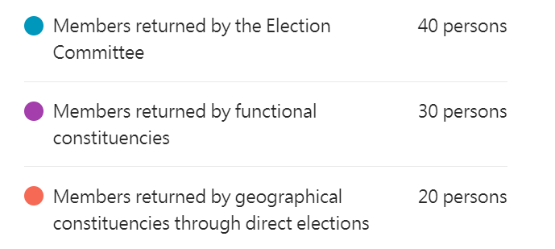

Overview of Candidature, Nomination and Voting Arrangements

Formation method | Who can run in the election? | Nomination Threshold |  | Electorate | Voting method
Formation method | Who can run in the election? | Nominations from EC / relevant FC or GC | Nominations from EC | Electorate | Voting method
Election Committee (EC) Constituency (40 seats) | All Registered Electors aged 21 or above (need not be EC Members) who have ordinarily resided in Hong Kong for 3 years immediately preceding the nomination | 10-20 | 2-4 from each of the 5 sectors | 1500 EC Members | - Block Vote (each EC member must select 40 candidates)  - The 40 candidates who obtain the greatest number of votes shall be returned in the election.
Functional Constituencies (FC)  (30 seats) | Registered Electors aged 21 or above who have ordinarily resided in Hong Kong for 3 years immediately preceding the nomination  and  Registered voters of the concerned FC or has a substantial connection with that FC | 10-20 | 2-4 from each of the 5 sectors | Eligible individual and corporate electors* | - Except the Labour FC shall continue to return 3 Members, all other constituencies shall return one member each  - First-Past-the-Post
Geographical Constituencies (GC)  (20 seats) | All Registered Electors aged 21 or above who have ordinarily resided in Hong Kong for 3 years immediately preceding the nomination | 100-200 | 2-4 from each of the 5 sectors | All registered electors | - Double Seats and Single Vote (each constituency returns 2 members, and each voter can vote for 1 candidate)  - The two candidates who obtain the greatest number of votes shall be returned in the election.
* Unless specified in the electoral law, an association or enterprise may become a corporate elector for an FC only if it has been operating for not less than three years after acquiring relevant qualifications for that FC.

Voting on bills and motions

- Unless otherwise provided for in the Basic Law, the Legislative Council shall adopt the following procedures for voting on bills and motions:
  - The passage of bills introduced by the government shall require a simple majority of votes of the members of the Legislative Council present.
  - The passage of motions, bills or amendments to government bills introduced by individual members of the Legislative Council shall require a simple majority of votes of each of the two groups of members present, i.e. members returned by the Election Committee, and those returned by functional constituencies and by geographical constituencies through direct elections.

Source of information: Improve Electoral System, Constitutional and Mainland Affairs Bureau, HKSAR Government, https://www.cmab.gov.hk/improvement/en/home/index.html

- (a) According to Source 1, how is the LegCo of the HKSAR constituted?
By election.

(b) According to Source 1, before arriving at the ultimate aim of electing all the members of the LegCo by universal suffrage, the method for forming the LegCo shall be specified in the light of and in accordance with what?
The actual situation in the HKSAR and the principle of gradual and
orderly progress.

(c) According to Source 1, the specific method for forming the LegCo and its procedures for voting on bills and motions are prescribed in which document?
Annex II to the Basic Law.

- (a) According to Source 2, what are the three methods for forming the LegCo by election?
(i) Election Committee (EC) Constituency
(ii) Functional Constituencies (FC)
(iii) Geographical Constituencies (GC)

(b) According to Source 2, which two requirements should all candidates meet?
(i) Aged 21 or above
(ii) Ordinarily resided in Hong Kong for 3 years immediately
preceding the nomination

(c) As for the nomination threshold, each candidate should meet two requirements. Try to complete the following table in accordance with Source 2:
 | Nomination threshold
EC Constituency | 10-20 nominations from the EC | 2-4 nominations from each of the five sectors of the EC
FC | 10-20 nominations from relevant FC | 2-4 nominations from each of the five sectors of the EC
GC | 100-200 nominations from relevant GC | 2-4 nominations from each of the five sectors of the EC

- Complete the following flow chart in accordance with the Voting on bills and motions in Source 2.
procedures for voting

passed by a simple majority of votes of the members of the LegCo present
bills introduced by the government

passed by a simple majority of votes of each of the two groups of members present, i.e. members returned by the Election Committee, and those returned by functional constituencies and by geographical constituencies through direct elections
motions, bills or amendments to government bills introduced by individual members of the LegCo

Appendix 4
Know More: Composition, seats allocation and electorates of 28 Functional Constituencies

Functional Constituencies |  | Seats | Electorates
 |  | Seats | Individuals | Bodies
1 | Agriculture and fisheries | 1
2 | Heung Yee Kuk | 1
3 | Industrial (first) | 1
4 | Industrial (second) | 1
5 | Textiles and garment | 1
6 | Commercial (first) | 1
7 | Commercial (second) | 1
8 | Commercial (third) | 1
9 | Finance | 1
10 | Financial services | 1
11 | Insurance | 1
12 | Real estate and construction | 1
13 | Transport | 1
14 | Import and export | 1
15 | Tourism | 1
16 | Catering | 1
17 | Wholesale and retail | 1
18 | Technology and innovation | 1
19 | Engineering | 1
20 | Architecture, surveying, planning and landscape | 1
21 | Accountancy | 1
22 | Legal | 1
23 | Education | 1
24 | Sports, performing arts, culture and publication | 1
25 | Medical and health services | 1
26 | Social welfare | 1
27 | Labour | 3
28 | HKSAR deputies to the NPC, HKSAR members of the National Committee of CPPCC, and representatives of relevant national organisations | 1
Remark: (i) Eligible corporate voters of a functional constituency shall be composed of bodies, organisations, associations or businesses which are representative and specified in relevant laws. To be eligible as a corporate voter of a functional constituency, an association or business should be in continuous operation for more than three years after acquiring qualifications for that functional constituency, unless they are specified in the electoral laws of the HKSAR.
Module 2.2: Governance of the HKSAR
(Lesson 11)
Learning and Teaching Materials

Political structure of the HKSAR (6)
Activity 11

Source 1
The Constitution and the Basic Law Established the System of Democracy in the HKSAR

—— The Constitution and the Basic Law accord the constitutional powers and duties to the central government to establish and develop democracy in the HKSAR. It is stipulated in Article 31 of China’s Constitution that “The state may establish special administrative regions when necessary. The systems instituted in special administrative regions shall, in light of specific circumstances, be prescribed by laws enacted by the National People’s Congress.” The NPC decided to set up a drafting committee for the HKSAR Basic Law on April 10, 1985. On July 1, the drafting committee, consisting of 59 mainland and Hong Kong members, was formally established. Representatives from various sectors of Hong Kong society were involved in drafting the Basic Law, a process lasting four years and eight months. The Basic Law was adopted at the Third Session of the Seventh NPC on April 4, 1990. It codifies the central government’s basic policies towards Hong Kong in the form of a national law and specifies related institutional steps. The Basic Law provides the constitutional basis for establishing and developing democracy in Hong Kong. It also accords the central government constitutional powers and duties to direct and make decisions on the development of democracy in the HKSAR.

…

—— The Basic Law provides the core components of democracy in the HKSAR and the pathway and principles for its future development. Article 45 and Article 68 of the Basic Law provide the core components of democracy in Hong Kong and the principles for implementation. The original versions of Annex I and Annex II of the Basic Law laid out the methods for selecting the Chief Executive and for forming the Legislative Council in the first decade after Hong Kong’s return to China, as well as the processes for amending these methods after 2007. The Decision of the National People’s Congress on the Method for the Formation of the First Government and the First Legislative Council of the Hong Kong Special Administrative Region was adopted on April 4, 1990 together with the Basic Law, specifying the method to be used. Hong Kong practices an executive-led system with the Chief Executive at its core. Under this system, there are checks and balances and coordination between the executive and legislative branches, and the judiciary exercises its power independently. In the Explanations on the Basic Law of the Hong Kong Special Administrative Region of the People’s Republic of China (Draft) and Its Related

Documents, the Drafting Committee for the Basic Law underlined that to ensure the prosperity and stability of Hong Kong, the political system should conform to the principle of “One Country, Two Systems” and respect the legal status and realities of the region. It should accommodate the interests of all sectors of Hong Kong society and facilitate Hong Kong’s economic growth under capitalism. The best practices of Hong Kong’s previous political system should be maintained, together with an orderly and phased development of democracy. These are the principles for developing democracy in the region.

Paragraph 2 of Article 45 of the Basic Law provides: “The method for selecting the Chief Executive shall be specified in the light of the actual situation in the Hong Kong Special Administrative Region and in accordance with the principle of gradual and orderly progress. The ultimate aim is the selection of the Chief Executive by universal suffrage upon nomination by a broadly representative nominating committee in accordance with democratic procedures.” Paragraph 2 of Article 68 provides: “The method for forming the Legislative Council shall be specified in the light of the actual situation in the Hong Kong Special Administrative Region and in accordance with the principle of gradual and orderly progress. The ultimate aim is the election of all the members of the Legislative Council by universal suffrage.” This sets dual universal suffrage as the ultimate goal in developing democracy in Hong Kong.

—— The Basic Law embodies the principle of Hong Kong people governing Hong Kong, with patriots at the core. Article 2 of the Basic Law provides: “The National People’s Congress authorizes the Hong Kong Special Administrative Region to exercise a high degree of autonomy and enjoy executive, legislative and independent judicial power, including that of final adjudication, in accordance with the provisions of this Law.” Article 3 continues: “The executive authorities and legislature of the Hong Kong Special Administrative Region shall be composed of permanent residents of Hong Kong in accordance with the relevant provisions of this Law.” Article 104 provides: “When assuming office, the Chief Executive, principal officials, members of the Executive Council and of the Legislative Council, judges of the courts at all levels and other members of the judiciary in the Hong Kong Special Administrative Region must, in accordance with law, swear to uphold the Basic Law of the Hong Kong Special Administrative Region of the People’s Republic of China and swear allegiance to the Hong Kong Special Administrative Region of the People’s Republic of China.” These provisions of the Basic Law encapsulate the principle of Hong Kong people governing Hong Kong, as expressed in the words of former Chinese leader Deng Xiaoping: “We are confident that our fellow Chinese in Hong Kong can govern Hong Kong well… Hong Kong must be governed by the people of Hong Kong, with patriots at the core.” These statements set the parameters for Hong Kong’s governance under the policy of One Country, Two Systems, which underpin full democracy in Hong Kong.

—— The Basic Law grants extensive democratic rights and freedoms to Hong Kong residents. Under the Basic Law, permanent residents of the HKSAR have the right to vote and the right to stand for election in accordance with the law, and Hong Kong residents have freedom of speech, freedom of the press and publication, freedom of association, assembly, procession and demonstration, and other rights and freedoms provided for under the Basic Law and the laws of the HKSAR. The provisions of the International Covenant on Civil and Political Rights, the International Covenant on Economic, Social and Cultural Rights, and international labor conventions as applicable to Hong Kong remain in force and shall be implemented through the laws of Hong Kong. In addition, the Basic Law stipulates that Chinese citizens who are HKSAR residents are entitled to participate in the management of state affairs in accordance with the law. Furthermore, permanent residents of the HKSAR who are not of Chinese nationality also enjoy extensive political rights, including the right to vote and the right to stand for election. By any standard, Hong Kong’s system of democracy is highly open and inclusive.

Source of information: Information Office of the State Council, The PRC (2021), Hong Kong Democratic Progress under the Framework of “One Country, Two Systems”, https://www.chinadailyhk.com/article/252582#Full-text:-White-paper-on-Hong-Kong's-democratic-development

- According to Paragraph 1 of Source 1, which documents accord the constitutional powers and duties to the central government to establish and develop democracy in the HKSAR as well as accord the central government constitutional powers and duties to direct and make decisions on the development of democracy in the HKSAR?
The Constitution and the Basic Law.

- According to Paragraph 2 of Source 1, the political system of the HKSAR should conform to the principle of “One Country, Two Systems” and respect the legal status and realities of the region so as to ensure the prosperity and stability of Hong Kong. Accordingly, what principles should be followed for developing democracy in the HKSAR?
The interests of all sectors of Hong Kong society should be accommodated
and Hong Kong’s economic growth under capitalism should be facilitated.
The best practices of Hong Kong’s previous political system should be
maintained, together with an orderly and phased development of
democracy.

- According to Article 45(2) and Article 68(2) of the Basic Law in Paragraph 3 of Source 1, the method for selecting the Chief Executive and the method for forming the Legislative Council shall be specified in the light of and in accordance with what?
They shall be specified in the light of the actual situation in the HKSAR
and in accordance with the principle of gradual and orderly progress.

- According to Paragraph 4 of Source 1, what principle has been embodied by the Basic Law?
The principle of Hong Kong people governing Hong Kong, with patriots
at the core.

- According to Paragraph 5 of Source 1, what political rights are also enjoyed by permanent residents of the HKSAR who are not of Chinese nationality?
The right to vote and the right to stand for election.

Worksheet 23: The ultimate goal of election by universal suffrage of the Chief Executive and all members of the Legislative Council is stipulated by the Basic Law

Source 1
Developing Democracy in Line with Hong Kong’s Realities

There is no single set of criteria for democracy and no single model of democracy that is universally acceptable. Democracy works only when it suits actual conditions and solves actual problems. The social and political crises and turbulence in some countries and regions in recent years are evidence that there is no perfect democracy anywhere in the world. Disregarding the reality of one’s own country and blindly copying the systems of others often causes chaos and brings disaster to the people.

The political system of the HKSAR applies locally. This is determined by the region’s constitutional status under the “One Country, Two Systems” framework and by its actual conditions. Therefore, the system of democracy in Hong Kong should not be a replica of some other model. Rather, a path to democracy in Hong Kong should be explored under the policy of “One Country, Two Systems” and the Basic Law and in keeping with its political, economic, social, cultural and historical conditions.

—— Democracy in Hong Kong should be guided by the central authorities and make steady progress in accordance with the law. The central authorities have the final say in determining the system of democracy in the HKSAR, which is a matter of national sovereignty and security, a reflection of the nature of relationship between the central authorities and the HKSAR, and one that affects the region’s long-term peace, stability and prosperity. Only under central guidance can Hong Kong expect its democracy to make healthy progress. The central authorities exercise their constitutional power by law, and the NPC and its Standing Committee revise and improve the electoral system in the HKSAR, according to a process that is fair, just, lawful and constitutional. This is the path along which democracy should progress in Hong Kong. Any system of democracy takes time to form and proceeds in stages. These stages are more than simply quantitative units; they should also be measured against quality.

—— The constitutional order must be consolidated to safeguard national security. …

—— The executive-led system should be implemented to ensure good governance. …

—— There should be balanced participation in governance, and Hong Kong should remain open and pluralistic. Under the “One Country, Two Systems” framework, Hong Kong will maintain its capitalist economic model and way of life for a long period of time. Development of democracy in Hong Kong must be conducive to economic development under capitalism, and the interests of all social groups, sectors and stakeholders should be protected by law. A broadly based mechanism of public representation should be formed to advance balanced political participation. Development of democracy in Hong Kong should help the region to integrate into the broader framework of national development, and keep it highly open, as the common home of both Chinese and foreign residents who work and live here, and a destination of opportunity for entrepreneurs and investors from around the world.

—— The rule of law will be upheld to protect personal rights and freedoms. …

—— Democracy should be promoted in many forms. Democracy comes in many forms. It cannot be reduced to the simplistic question of whether there are elections, and elections themselves cannot be defined exclusively as direct elections. Nor can progress in democracy be defined only as more representation from direct elections. What matters is whether public representation is expanding and whether the fundamental interests and the common will of the people are faithfully represented. For democracy to develop in Hong Kong, measures should be taken to improve the electoral system, and more forms of democracy – consultation, inquiry, hearing and dialogue – should be tested, to open up more channels for democracy of quality and substance.

—— The economy will be boosted for the greater benefit of the people of Hong Kong. …

The central government will continue to develop and improve democracy in Hong Kong in line with its realities and in accordance with the Constitution, the Basic Law, and the relevant decisions of the NPC and its Standing Committee. It will work with all social groups, sectors and stakeholders towards the ultimate goal of election by universal suffrage of the Chief Executive and all members of the Legislative Council. Under the framework of “One Country, Two Systems”, the prospects are bright for democracy in Hong Kong.
Source of information: Information Office of the State Council, The PRC (2021), Hong Kong Democratic Progress under the Framework of “One Country, Two Systems”, https://www.chinadailyhk.com/article/252582#Full-text:-White-paper-on-Hong-Kong's-democratic-development

- According to Paragraph 2 of Source 1, what should be followed when exploring a path to democracy in Hong Kong?
The path to democracy should be explored under the policy of “One Country,
Two Systems” and the Basic Law and in keeping with its political, economic,
social, cultural and historical conditions.

- According to Paragraph 3 of Source 1, what do the central authorities have in regarding the determination of the system of democracy in the HKSAR?
The central authorities have the final say in determining the system of
democracy in the HKSAR.

- According to Paragraph 3 of Source 1, any system of democracy takes time to form and proceeds in stages. Apart from simply quantitative units, what should these stages be measured against?
They should also be measured against quality.

- According to Paragraph 6 of Source 1, which three aspects must the development of democracy in the HKSAR be conducive to?
- It must be conducive to economic development under capitalism, and
the interests of all social groups, sectors and stakeholders should be
protected by law. A broadly based mechanism of public representation
should be formed to advance balanced political participation.
- It should help the HKSAR to integrate into the broader framework of
national development.
- It should keep the HKSAR highly open, as the common home of both
Chinese and foreign residents who work and live here, and a
destination of opportunity for entrepreneurs and investors from around
the world.

- According to Paragraph 8 of Source 1, apart from taking measures to improve the electoral system, what should be tested to open up more channels for democracy of quality and substance so as to develop democracy in the HKSAR?
More forms of democracy – consultation, inquiry, hearing and dialogue –
should be tested.

- According to Paragraph 10 of Source 1, the Central Government will continue to develop and improve democracy in Hong Kong in line with its realities and in accordance with what?
The Constitution, the Basic Law, and the relevant decisions of the NPC and
its Standing Committee.

- Following the above question, the Central Government will work with whom towards the ultimate goal of election by universal suffrage of the Chief Executive and all members of the Legislative Council?
It will work with all social groups, sectors and stakeholders.

Module 2.2: Governance of the HKSAR
(Lesson 12)
Learning and Teaching Materials

HKSAR’s duty to safeguard national security (1)

Activity 12

Source 1
Constitution
Chapter II - Fundamental Rights and Obligations of Citizens
Article 51
When exercising their freedoms and rights, citizens of the People’s Republic of China shall not undermine the interests of the state, society or collectives, or infringe upon the lawful freedoms and rights of other citizens.
Article 52
Citizens of the People's Republic of China shall have the obligation to safeguard national unity and the solidarity of all the country’s ethnic groups.
Article 53
Citizens of the People’s Republic of China must abide by the Constitution and the law, keep state secrets, protect public property, observe discipline in the workplace, observe public order, and respect social morality.
Article 54
Citizens of the People’s Republic of China shall have the obligation to safeguard the security, honor and interests of the motherland; they must not behave in any way that endangers the motherland’s security, honor or interests.
Article 55(1)
It is the sacred duty of every citizen of the People’s Republic of China to defend the motherland and resist aggression.

Source of information: Basic Law website>Constitution>Chapter II, https://www.basiclaw.gov.hk/en/constitution/chapter2.html

- According to Source 1, fill in the following table with the different obligations and duties of citizens of the People’s Republic of China to the state:

Constitution | Obligations and duties of citizens to the state
Article 51 | shall not undermine the interests of the state when exercising freedoms and rights
Article 52 | safeguard national unity and solidarity of all the country’s ethnic groups
Article 53 | keep state secrets
Article 54 | safeguard the security, honour and interests of the motherland; must not behave in any way that endangers the motherland’s security, honour, or interests
Article 55(1) | defend the motherland and resist aggression

- Which article in the Basic Law is most relevant to the answer mentioned in question 1? [It is only necessary to write the relevant article number to answer this question.]
Article 23.

Worksheet 24: The HKSAR’s constitutional duty and legislative obligation to safeguard national security

Source 1
Constitution
Chapter I - General Principles
Article 28
The state shall maintain public order, suppress treason and other criminal activities that jeopardize national security, punish criminal activities, including those that endanger public security or harm the socialist economy, and punish and reform criminals.

Source of information: Basic Law website>Constitution>Chapter I, https://www.basiclaw.gov.hk/en/constitution/chapter1.html

Source 2
National Security Law of the People’s Republic of China
Article 15(2)
The state shall prevent, frustrate, and legally punish any conduct that betrays the country, splits the country, incites rebellion, subverts or incites the subversion of the people’s democratic dictatorship; prevent, frustrate, and legally punish any conduct that compromises national security such as stealing and divulging state secrets; and prevent, frustrate, and legally punish any penetration, destruction, subversion, and secession activities of overseas forces.
Article 28
The state shall combat all forms of terrorism and extremism, strengthen the construction of capability in preventing and punishing terrorism, legally conduct the work of intelligence, investigation, prevention, punishment and funds supervision, etc., legally ban terrorist organisations and severely punish violent terrorist activities.

Source of information: Translated from新華社（2015年7月10日），中華人民共和國國家安全法，載於人大新聞網，
http://npc.people.com.cn/BIG5/n/2015/0710/c14576-27285049.html

Source 3
Basic Law
Chapter II - Relationship between the Central Authorities and the Hong Kong Special Administrative Region
Article 23
The Hong Kong Special Administrative Region shall enact laws on its own to prohibit any act of treason, secession, sedition, subversion against the Central People’s Government, or theft of state secrets, to prohibit foreign political organisations or bodies from conducting political activities in the Region, and to prohibit political organisations or bodies of the Region from establishing ties with foreign political organisations or bodies.

Source of information: Basic Law website>Basic Law>Chapter II>, https://www.basiclaw.gov.hk/en/basiclaw/chapter2.html

Source 4
- National security is a matter within the purview of the Central Authorities. Whether it is a unitary or federal state, legislation on national security is invariably carried out by the central authorities rather than local governments.
- Article 23 of the Basic Law is a provision on the relationship between the Central Authorities and the HKSAR. It stipulates that Hong Kong “shall enact laws on its own” to prohibit seven types of acts and activities that endanger national security. It is an obligatory provision rather than a clause on delegation of power. It demonstrates the confidence the Central Authorities have in the HKSAR, but this act of faith does not mean that the Central Authorities have given up their power in national security matters which are under their purview.

Source of information: Pamphlet on The Law of the People’s Republic of China on Safeguarding National Security in the Hong Kong Special Administrative Region – Preserve One Country, Two Systems, Restore Stability (2020), Information Services Department, HKSAR Government,
https://www.isd.gov.hk/nationalsecurity/eng/pdf/NSL_QnA_Book.pdf

- According to Source 1, as stipulated by the Constitution, how shall the state deal with treason and other criminal activities that jeopardize national security?
Suppress.

- According to Source 2, Article 15(2) of the National Security Law of the People’s Republic of China stipulates that the state shall prevent, stop, and punish three types of acts and activities in accordance with the law. Please fill in the three types of acts and activities in the 2nd column of the table below.

 | Article 15(2) of the National Security Law of the People’s Republic of China | Article 23 of the Basic Law
(a) | any conduct that betrays the country, splits the country, incites rebellion, subverts or incites the subversion of the people’s democratic dictatorship | any act of treason, secession, sedition, subversion against the Central People’s Government
(b) | any conduct that compromises national security such as stealing and divulging state secrets | theft of state secrets
(c) | any penetration, destruction, subversion, and secession activities of overseas forces | foreign political organisations or bodies conducting political activities in the HKSAR; political organisations or bodies of the HKSAR establishing ties with foreign political organisations or bodies

- According to Source 3, Article 23 of the Basic Law stipulates that the HKSAR shall enact laws on its own to prohibit certain acts and activities that endanger national security. Based on the answer to Question 2, please fill in the relevant acts and activities in the 3rd column of the table in Question 2.

- How is the nature of Article 23 of the Basic Law, that is, Hong Kong “shall enact laws on its own”, described in Source 4?
An obligatory provision.

- Try to use the contents of Source 1 and Article 15(2) of the National Security Law of the People’s Republic of China in Source 2 to explain why it is pointed out in Source 4 that “National security is a matter within the purview of the Central Authorities”.
While discussing matters related to national security, the two sources take
the state and the people of the state as the main bodies. Only when national
security is a matter within the purview of the Central Authorities can the
Central Authorities make overall consideration and give holistic responses.

Worksheet 25: Background and legal basis of the Decision of the National People’s Congress on Establishing and Improving the Legal System and Enforcement Mechanisms for the Hong Kong Special Administrative Region to Safeguard National Security and that the NPCSC is authorised by the NPC to enact the law

Source 1
… To safeguard national sovereignty, security and development interests, uphold and improve the “one country, two systems” regime, safeguard the long-term prosperity and stability of Hong Kong, and safeguard the legitimate rights and interests of Hong Kong residents, the NPC has made the following decision pursuant to Articles 31, 62(2), 62(14) and 62(16) of the Constitution of the People’s Republic of China (PRC) and the relevant provisions of the Basic Law of the HKSAR of the PRC.

Source of information: Decision of the National People’s Congress on Establishing and Improving the Legal System and Enforcement Mechanisms for the Hong Kong Special Administrative Region to Safeguard National Security, (Unofficial English translation) (Adopted at the Third Session of the Thirteenth National People’s Congress on 28 May 2020),
https://www.elegislation.gov.hk/hk/A301 (Accessed_15 May 2026)
---------------------------------------------------------------------------------------------------
Supplementary information
Constitution
Chapter I - General Principles
Article 31
The state may establish special administrative regions when necessary. The systems instituted in special administrative regions shall, in light of specific circumstances, be prescribed by laws enacted by the National People's Congress.
Chapter III - State Institutions Section 1 The National People’s Congress
Article 62
[The National People’s Congress shall exercise the following functions and powers:]
2. overseeing the enforcement of the Constitution
14. deciding on the establishment of special administrative regions and the systems to be instituted there
16. other functions and powers that the highest state organ of power should exercise

Source of information: Basic Law website>Constitution, https://www.basiclaw.gov.hk/en/constitution/index.html

Source 2
6. The NPC Standing Committee is entrusted to formulate relevant laws on establishing and improving the legal system and enforcement mechanisms for the HKSAR to safeguard national security, in order to effectively prevent, stop and punish acts and activities to split the country, subvert state power, organise and carry out terrorist activities and other behaviours that seriously endanger national security, as well as activities of foreign or external forces interfering in the affairs of the HKSAR. The NPC Standing Committee decides on including relevant laws into Annex III of the Basic Law of the HKSAR of the PRC to be promulgated and implemented by the HKSAR locally.

Source of information: Decision of the National People’s Congress on Establishing and Improving the Legal System and Enforcement Mechanisms for the Hong Kong Special Administrative Region to Safeguard National Security, (Unofficial English translation) (Adopted at the Third Session of the Thirteenth National People’s Congress on 28 May 2020),
https://www.elegislation.gov.hk/hk/A301 (Accessed_15 May 2026)
------------------------------------------------------------------------------------------------------
Basic Law
Chapter II - Relationship between the Central Authorities and the Hong Kong Special Administrative Region
Article 18(2) and (3)
National laws shall not be applied in the Hong Kong Special Administrative Region except for those listed in Annex III to this Law. The laws listed therein shall be applied locally by way of promulgation or legislation by the Region.
The Standing Committee of the National People’s Congress may add to or delete from the list of laws in Annex III after consulting its Committee for the Basic Law of the Hong Kong Special Administrative Region and the government of the Region. Laws listed in Annex III to this Law shall be confined to those relating to defence and foreign affairs as well as other matters outside the limits of the autonomy of the Region as specified by this Law.

Source of information: Basic Law website>Basic Law>Chapter II, https://www.basiclaw.gov.hk/en/basiclaw/chapter2.html

- (a) According to Source 1, in accordance with what legal documents did the NPC make the Decision of the National People’s Congress on Establishing and Improving the Legal System and Enforcement Mechanisms for the Hong Kong Special Administrative Region to Safeguard National Security?
The Constitution and the Basic Law.

(b) Following the above question, what is the NPC’s purpose in making the above decision?
To safeguard national sovereignty, security, and development interests,
uphold and improve the “one country, two systems” regime, safeguard
the long-term prosperity and stability of Hong Kong, and safeguard the
legitimate rights and interests of Hong Kong residents.

- (a) According to Source 2, what method does the NPC use to allow the NPCSC to formulate relevant laws?
NPCSC is entrusted by the NPC to formulate relevant laws.

(b) According to Source 2, which body may add to or delete from the list of laws in Annex III to the Basic Law?
NPCSC.

Appendix 5
Know More: Implementation of the National Security Law in the HKSAR by way of promulgation after its addition to Annex III to the Basic Law

The implementation of the National Security Law (NSL) in the HKSAR by way of promulgation after its addition to Annex III to the Basic Law is in compliance with the Basic Law

- The NPCSC has the power to add to or remove laws listed in Annex III to the Basic Law.

- Any laws listed in Annex III to the Basic Law shall be confined to those relating to defence and foreign affairs as well as other matters outside the limits of the autonomy of the HKSAR as specified by the Basic Law.

- National security is a matter within the purview of the Central Authorities.

- The NSL is a matter outside the limits of the autonomy of the HKSAR as specified by the Basic Law.

Therefore, the implementation of the NSL in the HKSAR by way of promulgation after its addition to Annex III to the Basic Law complies with the relevant stipulations of the Basic Law.

Homework 3: Implementation of the NSL by way of promulgation

Source 1
In the afternoon on 28 May, the Decision of the National People’s Congress on Establishing and Improving the Legal System and Enforcement Mechanisms for the Hong Kong Special Administrative Region to Safeguard National Security was passed by an overwhelming majority vote at the third session of the 13th NPC.

… The Decision indicates that “The NPCSC is entrusted to formulate relevant laws on establishing and improving the legal system and enforcement mechanisms for the HKSAR to safeguard national security, in order to effectively prevent, stop and punish acts and activities to split the country, subvert state power, organise and carry out terrorist activities and other behaviours that seriously endanger national security, as well as activities of foreign or external forces interfering in the affairs of the HKSAR. The NPCSC decides on including relevant laws into Annex III of the Basic Law of the HKSAR of the PRC to be promulgated and implemented by the HKSAR locally.” …

Source of information: Translated from 新華社（2020年5月28日），《全國人大高票通過關於建立健全香港特別行政區維護國家安全的法律制度和執行機制的決定》，載於中國政府網，http://www.gov.cn/xinwen/2020-05/28/content_5515608.htm

Source 2
In the morning on 30 June, the Law of the People’s Republic of China on Safeguarding National Security in the Hong Kong Special Administrative Region (National Security Law) was passed at the 20th session of the 13th NPCSC. President Xi Jinping signed a presidential order to promulgate the law, which goes into effect as of the date of promulgation. The enactment of the National Security Law was based on Decision of the National People’s Congress on Establishing and Improving the Legal System and Enforcement Mechanisms for the Hong Kong Special Administrative Region to Safeguard National Security (Decision) passed at the third session of the 13th NPC. …

After the adoption of the law, the NPCSC, in accordance with the requirements of the Decision, consulted its HKSAR Basic Law Committee and the HKSAR Government, and adopted a decision in the afternoon on 30 June to list the law in Annex III to the Basic Law. The newly-adopted decision stipulates that the National Security Law shall be applied in the HKSAR by way of promulgation by the region. …

Source of information: Translated from 新華社（2020年6月30日），《全國人大常委會通過香港特別行政區維護國家安全法並決定列入香港基本法附件三》，載於中國人大網，http://www.npc.gov.cn/npc/c30834/202006/1fcbb09024fb4bc8982a901abe15efb3.shtml
Source 3
L. N. 136 of 2020
Promulgation of National Law 2020
WHEREAS Article 18 of the Basic Law of the Hong Kong Special Administrative Region of the People’s Republic of China provides that the national laws listed in Annex III to the Basic Law shall be applied locally by way of promulgation or legislation by the Region and that the Standing Committee of the National People’s Congress may add to or delete from the list of laws in Annex III after consulting its Committee for the Basic Law of the Hong Kong Special Administrative Region and the government of the Region.

AND WHEREAS at its Twentieth meeting on 30 June 2020, the Standing Committee of the Thirteenth National People’s Congress, after consulting the Committee for the Basic Law of the Hong Kong Special Administrative Region and the Government of the Hong Kong Special Administrative Region, decided to add the law titled “《中華人民共和國香港特別行政區維護國家安全法》”*, to the list of national laws in Annex III to the Basic Law of the Hong Kong Special Administrative Region of the People’s Republic of China.

NOW, THEREFORE, I, Carrie LAM, the Chief Executive of the Hong Kong Special Administrative Region give notice that the law titled “《中華人民共和國香港特別行政區維護國家安全法》”* as set out in the Schedule applies, from 11 p.m. on 30 June 2020, in the Hong Kong Special Administrative Region.
__________________________

Note:* For reference, an English translation of the title “《中華人民共和國香港特別行政區維護國家安全法》” is “Law of the People’s Republic of China on Safeguarding National Security in the Hong Kong Special Administrative Region”.

Source of information: Promulgation of National Law 2020, https://www.elegislation.gov.hk/hk/2020/ln136!en (Access_15 May 2026)

Source 4
Law of the People’s Republic of China on Safeguarding National Security in the Hong Kong Special Administrative Region
Article 65
The power of interpretation of this Law shall be vested in the Standing Committee of the National People’s Congress.

Source of information: Law of the People’s Republic of China on Safeguarding National Security in the Hong Kong Special Administrative Region, Hong Kong e-Legislation, https://www.elegislation.gov.hk/fwddoc/hk/a302/eng_translation_(a302)_en.pdf (Accessed_15 May 2026)

- Please fill in the blanks in the following flow chart according to Sources 1-3.

The Chief Executive promulgated that “the National Security Law as set out in the Schedule applies, from 11 p.m. on 30 June 2020, in the HKSAR”
The 3rd session of the 13th NPC voted overwhelmingly to adopt the Decision of the National People’s Congress on Establishing and Improving the Legal System and Enforcement Mechanisms for the Hong Kong Special Administrative Region to Safeguard National Security.
The 20th session of the 13th NPCSC adopted the National Security Law and the President signed the decree to promulgate the law which came into effect on the same day.
After consulting the Committee for the Basic Law of the HKSAR and the HKSAR Government, the NPCSC decided to add the National Security Law to the list of national laws in Annex III to the Basic Law.

entrusted

28/5/2020
30/6/2020 p.m.
30/6/2020
night
30/6/2020 a.m.

- With reference to Sources 1 of worksheet 8 “Interpretation of the Basic Law”, explain why Article 65 of the NSL in Source 4 stipulates that “The power of interpretation of this Law shall be vested in the Standing Committee of the National People’s Congress”?
It is because the NPCSC has the power to “interpret laws” according to the
Constitution.

Module 2.2: Governance of the HKSAR
(Lesson 13)
Learning and Teaching Materials

HKSAR’s duty to safeguard national security (2)
Worksheet 26: CPG’s responsibility for national security affairs relating to the HKSAR

Source 1
1. The country unswervingly, fully and faithfully implements the principles of “one country, two systems”, “Hong Kong people administering Hong Kong” and a high degree of autonomy; upholds that Hong Kong be administered in strict accordance with the law; upholds the Constitution and the constitutional order in the HKSAR established by the Basic Law of the HKSAR; takes necessary measures to establish and improve the legal system and enforcement mechanisms for the HKSAR to safeguard national security, as well as to prevent, stop and punish in accordance with the law acts and activities endangering national security.
2. The country resolutely opposes interference in the HKSAR’s affairs by any foreign or external forces in any form, and will take necessary countermeasures to prevent, stop and punish in accordance with the law activities of secession, subversion, infiltration and sabotage carried out by foreign or external forces in Hong Kong.
…

Source of information: Decision of the National People’s Congress on Establishing and Improving the Legal System and Enforcement Mechanisms for the Hong Kong Special Administrative Region to Safeguard National Security, (Unofficial English translation) (Adopted at the Third Session of the Thirteenth National People’s Congress on 28 May 2020),
https://www.elegislation.gov.hk/hk/A301 (Accessed_15 May 2026)

Source 2
Law of the People’s Republic of China on Safeguarding National Security in the Hong Kong Special Administrative Region
Article 2
The provisions in Articles 1 and 12 of the Basic Law of the Hong Kong Special Administrative Region on the legal status of the Hong Kong Special Administrative Region are the fundamental provisions in the Basic Law. No institution, organisation or individual in the Region shall contravene these provisions in exercising their rights and freedoms.
Article 3(1)
The Central People’s Government has an overarching responsibility for national security affairs relating to the Hong Kong Special Administrative Region.

Source of information: Law of the People’s Republic of China on Safeguarding National Security in the Hong Kong Special Administrative Region, Hong Kong e-Legislation, https://www.elegislation.gov.hk/fwddoc/hk/a302/eng_translation_(a302)_en.pdf (Accessed_15 May 2026)
Source 3
Basic Law
Chapter I - General Principles
Article 1
The Hong Kong Special Administrative Region is an inalienable part of the People’s Republic of China.
Chapter II - Relationship between the Central Authorities and the Hong Kong Special Administrative Region
Article 12
The Hong Kong Special Administrative Region shall be a local administrative region of the People’s Republic of China, which shall enjoy a high degree of autonomy and come directly under the Central People’s Government.

Source of information: Basic Law website> Basic Law, https://www.basiclaw.gov.hk/en/basiclaw/index.html

- (a) According to Source 1, who will take necessary measures to establish and improve the legal system and enforcement mechanisms for the HKSAR to safeguard national security, as well as to prevent, stop and punish in accordance with the law acts and activities endangering national security?
The country.

(b) According to Source 1, what activities carried out by foreign or external forces in Hong Kong should the country prevent, stop, and punish in accordance with the law?
Secession, subversion, infiltration, and sabotage.

- (a) How does Source 2 describe the importance of Article 1 and Article 12 of the Basic Law?
They are the fundamental provisions on the legal status of the HKSAR.

(b) According to Source 2, what is the relationship between the exercise of rights and freedoms by any institution, organisation, and individual in the HKSAR and the provisions of Articles 1 and 12 of the Basic Law?
The provisions of Article 1 and Article 12 of the Basic Law shall not be
contravened.

3. (a) According to Source 2, who has an overarching responsibility for national security affairs relating to the HKSAR?
The Central People’s Government / CPG.

(b) According to Source 3, why is the institution mentioned in the answer to 3. (a) has an overarching responsibility for national security affairs relating to the HKSAR?
It is because the HKSAR is a local administrative region of the country
which enjoys a high degree of autonomy and comes directly under the
CPG.
Worksheet 27: HKSAR’s duty to safeguard national security

Source 1
National Security Law of the People’s Republic of China
Article 11(2)
The sovereignty and territorial integrity of China shall not be infringed and divided. It is the common responsibility of all the people of China, including the compatriots of Hong Kong, Macao and Taiwan, to safeguard the sovereignty, unity and territorial integrity.
Article 40(3)
The Hong Kong Special Administrative Region and the Macao Special Administrative Region shall perform their duties for safeguarding national security.

Source of information: Translated from 人民網>人大新聞網（2015年7月10日），《中華人民共和國國家安全法》，http://npc.people.com.cn/BIG5/n/2015/0710/c14576-27285049.html
------------------------------------------------------------------------------------------------------
Decision of the National People’s Congress on Establishing and Improving the Legal System and Enforcement Mechanisms for the Hong Kong Special Administrative Region to Safeguard National Security
…
3. It is the HKSAR’s constitutional responsibilities to safeguard national sovereignty, unity and territory integrity. The HKSAR must complete the national security legislation stipulated in the Basic Law of the HKSAR at an earlier date. The HKSAR’s administrative, legislative and judicial organs must, in accordance with relevant laws and regulations, effectively prevent, stop and punish acts and activities endangering national security.
…
Source of information: Decision of the National People’s Congress on Establishing and Improving the Legal System and Enforcement Mechanisms for the Hong Kong Special Administrative Region to Safeguard National Security, (Unofficial English translation) (Adopted at the Third Session of the Thirteenth National People’s Congress on 28 May 2020),
https://www.elegislation.gov.hk/hk/A301 (Accessed_15 May 2026)

Source 2
Law of the People’s Republic of China on Safeguarding National Security in the Hong Kong Special Administrative Region
Article 3(2)
It is the duty of the Hong Kong Special Administrative Region under the Constitution to safeguard national security and the Region shall perform the duty accordingly.
Article 6
It is the common responsibility of all the people of China, including the people of Hong Kong, to safeguard the sovereignty, unification and territorial integrity of the People’s Republic of China.
Any institution, organisation or individual in the Hong Kong Special Administrative Region shall abide by this Law and the laws of the Region in relation to the safeguarding of national security, and shall not engage in any act or activity which endangers national security.
A resident of the Region who stands for election or assumes public office shall confirm in writing or take in oath to uphold the Basic Law of the Hong Kong Special Administrative Region of the People’s Republic of China and swear allegiance to the Hong Kong Special Administrative Region of the People’s Republic of China in accordance with the law.

Source of information: Law of the People’s Republic of China on Safeguarding National Security in the Hong Kong Special Administrative Region, Hong Kong e-Legislation, https://www.elegislation.gov.hk/fwddoc/hk/a302/eng_translation_(a302)_en.pdf (Accessed_15 May 2026)

- (a) According to Sources 1 and 2, what responsibilities does the HKSAR have in safeguarding national sovereignty, unity, territorial integrity and national security?
Constitutional responsibilities.

(b) According to Sources 1 and 2, what is the common responsibility of all the people of China, including the compatriots of Hong Kong?
Safeguarding the sovereignty, unity and territorial integrity of China.

(c) According to Source 2, any institution, organisation or individual in the HKSAR shall not engage in any act or activity which endangers national security. What shall they abide by?
The NSL and the laws of the HKSAR in relation to the safeguarding of
national security.

Source 3
Decision of the National People’s Congress on Establishing and Improving the Legal System and Enforcement Mechanisms for the Hong Kong Special Administrative Region to Safeguard National Security
…
5. The Chief Executive of the HKSAR must regularly report to the CPG on the HKSAR’s performance of the duty to safeguard national security, carry out national security education, and forbid acts and activities of endangering national security in accordance with the law, etc.
…
Source of information: Decision of the National People’s Congress on Establishing and Improving the Legal System and Enforcement Mechanisms for the Hong Kong Special Administrative Region to Safeguard National Security, (Unofficial English translation) (Adopted at the Third Session of the Thirteenth National People’s Congress on 28 May 2020),
https://www.elegislation.gov.hk/hk/A301 (Accessed_15 May 2026)
----------------------------------------------------------------------------------------------------
Law of the People’s Republic of China on Safeguarding National Security in the Hong Kong Special Administrative Region
Article 9
The Hong Kong Special Administrative Region shall strengthen its work on safeguarding national security and prevention of terrorist activities. The Government of the Hong Kong Special Administrative Region shall take necessary measures to strengthen public communication, guidance, supervision and regulation over matters concerning national security, including those relating to schools, universities, social organisations, the media and the internet.
Article 10
The Hong Kong Special Administrative Region shall promote national security education in schools and universities and through social organisations, the media, the internet and other means to raise the awareness of Hong Kong residents of national security and of the obligation to abide by the law.
Article 11
The Chief Executive of the Hong Kong Special Administrative Region shall be accountable to the Central People’s Government for affairs relating to safeguarding national security in the Hong Kong Special Administrative Region and shall submit an annual report on the performance of duties of the Region in safeguarding national security.
The Chief Executive shall, at the request of the Central People’s Government, submit in a timely manner a report on specific matters relating to safeguarding national security.

Source of information: Law of the People’s Republic of China on Safeguarding National Security in the Hong Kong Special Administrative Region, Hong Kong e-Legislation, https://www.elegislation.gov.hk/fwddoc/hk/a302/eng_translation_(a302)_en.pdf (Accessed_15 May 2026)

- (a) According to Source 3, as stipulated in the NSL, how shall the HKSAR respond to the relevant requirement of carrying out “national security education” in the Decision of the National People’s Congress on Establishing and Improving the Legal System and Enforcement Mechanisms for the Hong Kong Special Administrative Region to Safeguard National Security?
The HKSAR shall promote national security education in schools and
universities and through social organisations, the media, the internet and
other means.

(b) Following the above question, what is the main purpose of carrying out national security education in the HKSAR?
Raise the awareness of Hong Kong residents of national security and of
the obligation to abide by the law.

(c) According to Source 3, as stipulated in the NSL, how shall the Chief Executive of the HKSAR respond to the requirement of regularly reporting to “the CPG on the HKSAR’s performance of the duty to safeguard national security” in the Decision of the National People’s Congress on Establishing and Improving the Legal System and Enforcement Mechanisms for the Hong Kong Special Administrative Region to Safeguard National Security?
Submit an annual report on the performance of duties of the HKSAR in
safeguarding national security.

(d) Why is the Chief Executive of the HKSAR required to be accountable to and submit reports to the CPG in both the Decision of the National People’s Congress on Establishing and Improving the Legal System and Enforcement Mechanisms for the Hong Kong Special Administrative Region to Safeguard National Security and the NSL? Try to find the relevant provision from Section 1, Chapter 4 of the Basic Law* to answer this question.
(Please refer to the electronic version of the Basic Law in the Basic Law website:
https://www.basiclaw.gov.hk/en/basiclaw/chapter4.html)
According to Article 43 of the Basic Law, the Chief Executive of the
HKSAR shall be accountable to the CPG in accordance with the
provisions of the Basic Law.

Source 4
Law of the People’s Republic of China on Safeguarding National Security in the Hong Kong Special Administrative Region
Article 7
The Hong Kong Special Administrative Region shall complete, as early as possible, legislation for safeguarding national security as stipulated in the Basic Law of the Hong Kong Special Administrative Region and shall refine relevant laws.

Source of information: Law of the People’s Republic of China on Safeguarding National Security in the Hong Kong Special Administrative Region, Hong Kong e-Legislation, https://www.elegislation.gov.hk/fwddoc/hk/a302/eng_translation_(a302)_en.pdf (Accessed_15 May 2026)
------------------------------------------------------------------------------------------------------
Basic Law
Chapter II - Relationship between the Central Authorities and the Hong Kong Special Administrative Region
Article 23
The Hong Kong Special Administrative Region shall enact laws on its own to prohibit any act of treason, secession, sedition, subversion against the Central People's Government, or theft of state secrets, to prohibit foreign political organizations or bodies from conducting political activities in the Region, and to prohibit political organizations or bodies of the Region from establishing ties with foreign political organizations or bodies.

Source of information: Basic Law website>Basic Law>Chapter II, https://www.basiclaw.gov.hk/en/basiclaw/chapter2.html

- (a) According to Sources 1 and 4, who shall complete, as early as possible, legislation for safeguarding national security as stipulated in the Basic Law and shall refine relevant laws in accordance with the Decision of the National People’s Congress on Establishing and Improving the Legal System and Enforcement Mechanisms for the Hong Kong Special Administrative Region to Safeguard National Security and the NSL?
HKSAR.

(b) Following the above question, which article of the Basic Law stipulates the relevant provisions?
Article 23.

Source 5

Question: Why is there a need to legislate on Article 23 of the Basic Law even with the presence of the Hong Kong National Security Law (HKNSL)?
- Enacting local legislation on Article 23 of the Basic Law and refining laws relevant to safeguarding national security are the constitutional responsibilities of the Hong Kong Special Administrative Region (HKSAR). Article 3 of the 5.28 Decision and Article 7 of the HKNSL reaffirm the need for the HKSAR to fulfill these constitutional responsibilities as soon as possible and shall refine relevant laws.
- While the Hong Kong version of “colour revolution” in 2019 subsided, substantial risks remain. In addition, international landscape is ever-changing, and risks endangering national security exist every day. To cope with constantly arising national security risks and threats, we must seize the opportunity to legislate as soon as possible.
- The four categories of offences provided for under Chapter III of the HKNSL, namely the offences of secession, subversion, terrorist activities and collusion with a foreign country or with external elements to endanger national security, are directed at the most prominent acts and activities endangering national security in the Hong Kong version of “colour revolution” in 2019. Among them, the offences of secession and subversion have dealt with two of the seven types of acts which the HKSAR shall enact laws to prohibit as prescribed in Article 23 of the Basic Law.
- The HKSAR has a duty, as well as a practical need, to complete legislation on Article 23 of the Basic Law to prohibit those acts and activities endangering national security other than the four categories of offences provided for under the HKNSL.
Source of information: Rebuttal / Frequently Asked Questions, Safeguarding National Security: Basic Law Article 23 Legislation, Security Bureau, https://www.sb.gov.hk/eng/bl23/faq.html

- With reference to Sources 4 and 5, fill in the appropriate spaces in the figure below with the crimes related to safeguarding national security listed in the Hong Kong National Security Law and Article 23 of the Basic Law.

The Hong Kong National Security Law Article 23 of the Basic Law
- Subversion

- Secession
- Terrorist activities

- Collusion with a foreign country or with external elements to endanger national security
- Treason

- Sedition

- Theft of state secrets

- To prohibit foreign political organizations or bodies fromconducting political activities in the HKSAR

- To prohibit political organizations or bodies of the HKSAR from establishing ties with foreign political organizations or bodies

- How many types of crimes endangering national security are clearly stipulated by the Hong Kong National Security Law?

A  B  C  D | Three types  Four types  Five types  Six types

Answer：B

- How many types of acts and activities endangering national security are prohibited in Article 23 of the Basic Law?

A  B  C  D | Five types  Six types  Seven types  Eight types

Answer：C

- Following the above question, do you think how the legislation on Article 23 of the Basic Law can strengthen Hong Kong Special Administrative Region’s capacity to safeguard national security? Please explain your answer.

Yes. Article 23 of the Basic Law clearly stipulates that the Hong Kong Special
Administrative Region (HKSAR) shall enact laws to prohibit seven types of acts
and activities that endanger national security. Two (i.e. secession and subversion
against the Central People’s Government) are directly covered by the Hong Kong
National Security Law (HKNSL). Completing the enactment of local legislation to
implement Article 23 to deal with offences not covered by HKNSL further
strengthens HKSAR’s work on safeguarding national security.

Source 6
Name of the source： | Basic Law Article 23 Legislation: Safeguarding National Security Ordinance | 
Source provider： | Security Bureau
Source： | https://www.sb.gov.hk/eng/bl23/doc/Pamphlet_EN.pdf

With reference to Source 6, the pamphlet on the “Safeguarding National Security Ordinance” produced by the Security Bureau, answer the following questions.
- With reference to Source 6, which of the following characteristics does the “Safeguarding National Security Ordinance” have?
(i) | Respecting and protecting human rights, and adhering to the principle of the rule of law
(ii) | Making reference to legislative experience of common law jurisdictions to align with international practice
(iii) | Incorporating the provisions of existing local laws to meet Hong Kong’s actual circumstances
A  B  C  D | (i)、(ii)  (i)、(iii)  (ii)、(iii)  (i)、(ii)、(iii)
Answer：D

- With reference to Source 6, which of the following main crimes are included in the “Safeguarding National Security Ordinance”?
(i) | The offence of “treason”
(ii) | The offence of “insurrection”, “incitement to mutiny” and “incitement to disaffection”, and the offences in connection with “seditious intention”
(iii) | Offences in connection with state secrets and espionage
(iv) | Sabotage endangering national security
(v) | External interference endangering national security and organizations engaging in activities endangering national security
A  B  C  D | (i)、(ii)、(iv)  (i)、(iii)、 (iv)  (ii)、(iii)、(v)  (i)、(ii)、(iii)、(iv)、(v)
Answer：D

Source 7
Mr President and Honourable Members of the Legislative Council (LegCo),

Today marks a historic moment for Hong Kong. It is a historic moment that Hong Kong has been waiting for 26 years, 8 months and 19 days. It is a historic moment where the Sixth-term Government and the Seventh LegCo of the Hong Kong Special Administrative Region (HKSAR) have finally accomplished a glorious mission together. It is a proud moment for all of the HKSAR in collectively making glorious history.

Today, the constitutional responsibility and historic mission of legislating for Article 23 of the Basic Law have finally been fulfilled. The Safeguarding National Security Bill has been passed after the third reading, ensuring the effective protection of national security.

This year marks the tenth anniversary of President Xi Jinping’s proposal of the holistic view of national security. On this very day, we have fulfilled our constitutional responsibility of enacting local legislation under Article 23 of the Basic Law. We have accomplished this historic mission, living up to the trust placed in us by the Central Government and the country. I will sign the Bill and promulgate the Safeguarding National Security Ordinance by publication in the Gazette on the 23rd. In other words, the Ordinance will officially take effect on March 23, 2024.

The Safeguarding National Security Ordinance enables Hong Kong to effectively prevent, suppress and punish espionage activities, conspiracies and traps from foreign intelligence agencies, and infiltration and sabotage by hostile forces. We can effectively prevent “black-clad violence” and “colour revolution”. We can effectively prevent “Hong Kong independence” and violent destruction. We no longer need to worry about saboteurs’ “mutual destruction” threats in Hong Kong and their acts of damaging public facilities, throwing petrol bombs, setting fires, assaulting citizens with differing opinions, pushing Hong Kong into an abyss, and destroying years of our city's development. From now on, the people of Hong Kong will no longer experience these harms and sorrows.
… …
Source of information: Address by CE to LegCo on passage of Safeguarding National Security Bill, 19 March 2024, Press Releases, HKSAR Government, https://www.info.gov.hk/gia/general/202403/19/P2024031900717.htm?fontSize=1

10 With reference to Source 7, in what ways has the Hong Kong Special
Administrative Region Government fulfilled its constitutional responsibility
under Article 23 of the Basic Law?

Through local legislation, the Safeguarding National Security Bill has
been passed after the third reading.

- According to Sources 1 and 4, who should complete the legislation for safeguarding national security stipulated in the "Basic Law" as soon as possible and shall refine relevant laws under the "Decision of the National People's Congress on Establishing and Improving the Legal System and Enforcement Mechanisms for the Hong Kong Special Administrative Region to Safeguard National Security" and the Hong Kong National Security Law?

The HKSAR.

12 With reference to Source 7, how can the Safeguarding National Security
Ordinance effectively safeguard national security in Hong Kong?

(i) | effectively prevent, suppress and punish espionage activities, conspiracies and traps from foreign intelligence agencies
(ii) | effectively prevent “black-clad violence” and “colour revolution”
(iii) | effectively prevent “Hong Kong independence” and violent destruction
A  B  C  D | (i)、(ii)  (i)、(iii)  (ii)、(iii)  (i)、(ii)、(iii)
Answer：D

Legal Basis of the Hong Kong National Security Law
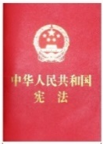
Complete the following concept map in accordance with the content learned in Lessons 1 and 2:

State institutions
Stipulations safeguarding national security, include:
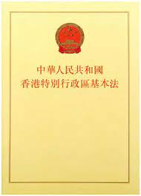
The National People’s Congress Standing Committee listed the legislation in Annex III to the Basic Law in accordance with Article 18 of the Basic Law. It applies locally by way of promulgation from the Hong Kong Special Administrative Region and stipulates four types of offences endangering national security: secession, subversion, terrorist activities, collusion with a foreign country or with external elements to endanger national security.
Hong Kong residents and other persons in Hong Kong shall have the obligation to abide by the laws in force in the Hong Kong Special Administrative Region. (Article 42, Basic Law)
The Hong Kong Special Administrative Region shall enact laws on its own to prohibit seven types of acts and activities that endanger national security. (Article 23, Basic Law)
The state may establish special administrative regions when necessary. The systems instituted in special administrative regions shall, in light of specific circumstances, be prescribed by laws enacted by the National People’s Congress. (Article 31, Constitution)
The Hong Kong Special Administrative Region is an inalienable part of the People’s Republic of China. (Article 1, Basic Law)
The Hong Kong Special Administrative Region shall be a local administrative region of the People’s Republic of China, which shall enjoy a high degree of autonomy and come directly under the Central People’s Government. (Article 12, Basic Law)
The National People’s Congress Standing Committee formulated the Hong Kong National Security Law.
entrusted
The National People's Congress shall exercise the following functions and powers, including overseeing the enforcement of the Constitution; deciding on the establishment of special administrative regions and the systems to be instituted there. (Article 62, Constitution)

The state shall maintain public order, suppress treason and other criminal activities that jeopardise national security, punish criminal activities, including those that endanger public security or harm the socialist economy, and punish and reform criminals. (Article 28, Constitution)
Fundamental rights and obligations of citizens (Chapter 2, Constitution)

Extended Reading
National security is the cornerstone of national stability and the bedrock of people’s well-being. Covering over ten fields of security, it ensures the people’s security in an all-round manner. Under the protection of the Law of the People’s Republic of China on Safeguarding National Security in the Hong Kong Special Administrative Region (National Security Law), livelihood will definitely be better than before. It is the duty of everyone to have an in-depth understanding of the holistic view of national security and to safeguard national security.

About the “National Security Education Day”
On 1 July 2015, the National Security Law of the People’s Republic of China was adopted at the 15th Session of the Standing Committee of the 12th National People’s Congress, and 15 April each year was designated as the National Security Education Day.

The National Security Education Day aims at raising public awareness of national security, creating a positive atmosphere of safeguarding national security, enhancing the capability to fend off national security risks, deepening public understanding of the Constitution, the Basic Law and national security, and fostering a sense of national identity.

We hope that on this special day of 15 April, the public will have a better understanding of the importance of national security to the country, to the Hong Kong Special Administrative Region and to every Hong Kong citizen, perform their civic duty and work together to safeguard national security.
Source of information: National Security Education Day, https://www.nsed.gov.hk/index.php?l=en

- According to the Source, what is the importance of national security to the
people?
National security is the cornerstone of national stability and the bedrock
of people’s well-being. Covering over ten fields of security, it ensures the
people’s security in an all-round manner.

(b) Following the above question, who has the duty to safeguard national security?
It is the duty of everyone to safeguard national security.

(c) According to the Source, what is the aim of the National Security Education Day?
It aims at raising public awareness of national security, creating a
positive atmosphere of safeguarding national security, enhancing the
capability to fend off national security risks, deepening public
understanding of the Constitution, the Basic Law and national security,
and fostering a sense of national identity.

Module 2.2: Governance of the HKSAR
(Lesson 14)
Learning and Teaching Materials

HKSAR’s duty to safeguard national security (3)

Worksheet 28: NSL safeguards human rights and the rule of law

Source 1
Decision of the National People’s Congress on Establishing and Improving the Legal System and Enforcement Mechanisms for the Hong Kong Special Administrative Region to Safeguard National Security
… To safeguard national sovereignty, security and development interests, uphold and improve the “one country, two systems” regime, safeguard the long-term prosperity and stability of Hong Kong, and safeguard the legitimate rights and interests of Hong Kong residents, …
1. The country unswervingly, fully and faithfully implements the principles of “one country, two systems”, “Hong Kong people administering Hong Kong” and a high degree of autonomy ; upholds that Hong Kong be administered in strict accordance with the law; upholds the Constitution and the constitutional order in the HKSAR established by the Basic Law of the HKSAR; …

Source of information: Decision of the National People’s Congress on Establishing and Improving the Legal System and Enforcement Mechanisms for the Hong Kong Special Administrative Region to Safeguard National Security, (Unofficial English translation) (Adopted at the Third Session of the Thirteenth National People’s Congress on 28 May 2020),
https://www.elegislation.gov.hk/hk/A301 (Accessed_15 May 2026)

Source 2
Law of the People’s Republic of China on Safeguarding National Security in the Hong Kong Special Administrative Region
Article 4
Human rights shall be respected and protected in safeguarding national security in the Hong Kong Special Administrative Region. The rights and freedoms, including the freedom of speech, of the press, of publication, of association, of assembly, of procession and of demonstration, which the residents of the Region enjoy under the Basic Law of the Hong Kong Special Administrative Region and the provisions of the International Covenant on Civil and Political Rights and the International Covenant on Economic, Social and Cultural Rights as applied to Hong Kong, shall be protected in accordance with the law.
Article 5
The principle of the rule of law shall be adhered to in preventing, suppressing, and imposing punishment for offences endangering national security. A person who commits an act which constitutes an offence under the law shall be convicted and punished in accordance with the law. No one shall be convicted or punished for an act which does not constitute an offence under the law.
A person is presumed innocent until convicted by a judicial body. The right to defend himself or herself and other rights in judicial proceedings that a criminal suspect, defendant, and other parties in judicial proceedings are entitled under the law shall be protected. No one shall be liable to be tried or punished again for an offence for which he or she has already been finally convicted or acquitted in judicial proceedings.

Source of information: Law of the People’s Republic of China on Safeguarding National Security in the Hong Kong Special Administrative Region, Hong Kong e-Legislation, https://www.elegislation.gov.hk/fwddoc/hk/a302/eng_translation_(a302)_en.pdf (Accessed_15 May 2026)

Source 3
Basic Law
Chapter III - Fundamental Rights and Duties of the Residents
Article 27
Hong Kong residents shall have freedom of speech, of the press and of publication; freedom of association, of assembly, of procession and of demonstration; and the right and freedom to form and join trade unions, and to strike.
Article 35(1)
Hong Kong residents shall have the right to confidential legal advice, access to the courts, choice of lawyers for timely protection of their lawful rights and interests or for representation in the courts, and to judicial remedies.
Article 39
The provisions of the International Covenant on Civil and Political Rights, the International Covenant on Economic, Social and Cultural Rights, and international labour conventions as applied to Hong Kong shall remain in force and shall be implemented through the laws of the Hong Kong Special Administrative Region.
The rights and freedoms enjoyed by Hong Kong residents shall not be restricted unless as prescribed by law. Such restrictions shall not contravene the provisions of the preceding paragraph of this Article.
Chapter IV - Political Structure Section 4 The Judiciary
Article 87
In criminal or civil proceedings in the Hong Kong Special Administrative Region, the principles previously applied in Hong Kong and the rights previously enjoyed by parties to proceedings shall be maintained.
Anyone who is lawfully arrested shall have the right to a fair trial by the judicial organs without delay and shall be presumed innocent until convicted by the judicial organs.

Source of information: Basic Law website>Basic Law, https://www.basiclaw.gov.hk/en/basiclaw/index.html

Source 4
(30 May 2020)
With regard to this, I will also take this opportunity to explain to you that in fact, human rights and freedoms are not absolute, and we all know it very well. It is clearly written in two covenants that we often talk about, the International Covenant on Civil and Political Rights (ICCPR) and the International Covenant on Economic, Social and Cultural Rights (ICESCR), that when people exercise human rights and freedoms, they cannot affect the national security of the countries concerned. Therefore, the protection of human rights and freedoms should not be regarded as absolute. Legal and international practices, including international covenants, provide for certain permissive restrictions on human rights and freedoms. These provisions are clearly written in the covenants that I have mentioned above.

(6 June 2020)
Of course, there are some differences between the civil law system on the Mainland and the common law system in Hong Kong. But now, let’s talk about some very basic and important principles, for example, national security. In fact, every country, whether it is with a civil law system or a common law system, has the same requirements for national security. Secondly, perhaps we have many concerns about whether there are differences with regard to the criminal laws. Actually, the presumption of innocence, burden of proof and the standard of proof of beyond reasonable doubt in the Criminal Law of the People’s Republic of China are consistent with those specified in Hong Kong’ criminal law, and there is no big difference. Therefore, you don’t have to worry too much. As to how to make the public understand more, I believe that if we continue to explain more, the public will gradually understand the matter objectively.

(7 July 2020)
[NSL] Article 4 stipulates that human rights shall be respected and protected in safeguarding national security in the HKSAR. The rights and freedoms, which Hong Kong residents enjoy under the Basic Law and the provisions of the ICCPR and the ICESCR as applied to Hong Kong, shall be protected in accordance with the law. Important principles of the rule of law are embodied in Article 5. They include conviction and sentencing of crimes should be well defined in the law, presumption of innocence, the right to defend himself or herself and other rights in judicial proceedings that a criminal suspect, defendant, and other parties in judicial proceedings are entitled to, and no one shall be liable to be tried or punished again for an offence for which he or she has already been finally convicted or acquitted in judicial proceedings. Apart from this, Article 39 is about non-retrospectivity (the NSL applies only to acts after its commencement).

Source of information: Translated from 律政司網頁，主頁>新聞及演辭>律政司司長，https://www.doj.gov.hk/chi/index.html

- (a) To “safeguard the legitimate rights and interests of Hong Kong residents” is mentioned in Source 1. Article 4 of the NSL in Source 2 stipulates that “the rights and freedoms, including the freedoms of speech, of the press, of publication, of association, of assembly, of procession and of demonstration”, which the residents of the Region enjoy under certain documents shall be protected in accordance with the law. What are these documents?
The Basic Law and the provisions of the ICCPR and the ICESCR as
applied to Hong Kong.

(b) According to Source 3, which article of the Basic Law mentions “freedom of speech, of the press and of publication; freedom of association, of assembly, of procession and of demonstration”?
Article 27.

(c) Source 4 indicated that “the protection of human rights and freedoms should not be regarded as absolute”. What restrictions are they subject to?
Certain permissive restrictions.

- (a) In Source 2, what are the three principles of the rule of law mentioned in Article 5 (2) of the NSL?
- A person is presumed innocent until convicted by a judicial body.
- The right to defend himself or herself and other rights in judicial
proceedings that a criminal suspect, defendant, and other parties
in judicial proceedings are entitled to under the law shall be
protected.
- No one shall be liable to be tried or punished again for an offence
for which he or she has already been finally convicted or
acquitted in judicial proceedings.

(b) Following the above question, which principle of the rule of law is mentioned in both Source 3 and Source 4?
Presumed innocent / presumption of innocence.

(c) According to Source 4, what may worry the public?
There are some differences between the civil law system on the Mainland
and the common law system in Hong Kong.

(d) According to Source 4, how can the government alleviate the public’s worries?
The government can continue to explain more that the two systems are
consistent and there is no big difference. Then the public will gradually
understand the matter objectively.

Worksheet 29: NSL stipulates four types of offences that endanger national security

Source 1
Law of the People’s Republic of China on Safeguarding National Security in the Hong Kong Special Administrative Region
Chapter III Offences and Penalties Part 1 Secession
Article 20
A person who organises, plans, commits or participates in any of the following acts, whether or not by force or threat of force, with a view to committing secession or undermining national unification shall be guilty of an offence:
(1) separating the Hong Kong Special Administrative Region or any other part of the People’s Republic of China from the People’s Republic of China;
(2) altering by unlawful means the legal status of the Hong Kong Special Administrative Region or of any other part of the People’s Republic of China; or
(3) surrendering the Hong Kong Special Administrative Region or any other part of the People’s Republic of China to a foreign country.
…
Article 21
A person who incites, assists in, abets or provides pecuniary or other financial assistance or property for the commission by other persons of the offence under Article 20 of this Law shall be guilty of an offence. …

Source of information: Law of the People’s Republic of China on Safeguarding National Security in the Hong Kong Special Administrative Region, Hong Kong e-Legislation, https://www.elegislation.gov.hk/fwddoc/hk/a302/eng_translation_(a302)_en.pdf (Accessed_15 May 2026)

Source 2
Law of the People’s Republic of China on Safeguarding National Security in the Hong Kong Special Administrative Region
Chapter III Offences and Penalties Part 2 Subversion
Article 22
A person who organises, plans, commits or participates in any of the following acts by force or threat of force or other unlawful means with a view to subverting the State power shall be guilty of an offence:
(1) overthrowing or undermining the basic system of the People’s Republic of China established by the Constitution of the People’s Republic of China;
(2) overthrowing the body of central power of the People’s Republic of China or the body of power of the Hong Kong Special Administrative Region;
(3) seriously interfering in, disrupting, or undermining the performance of duties and functions in accordance with the law by the body of central power of the People’s Republic of China or body of power of the Hong Kong Special Administrative Region; or
(4) attacking or damaging the premises and facilities used by the body of power of the Hong Kong Special Administrative Region to perform its duties and functions, rendering it incapable of performing its normal duties and functions.
…
Article 23
A person who incites, assists in, abets or provides pecuniary or other financial assistance or property for the commission by other persons of the offence under Article 22 of this Law shall be guilty of an offence. …

Source of information: Law of the People’s Republic of China on Safeguarding National Security in the Hong Kong Special Administrative Region, Hong Kong e-Legislation, https://www.elegislation.gov.hk/fwddoc/hk/a302/eng_translation_(a302)_en.pdf (Accessed_15 May 2026)

Source 3
Law of the People’s Republic of China on Safeguarding National Security in the Hong Kong Special Administrative Region
Chapter III Offences and Penalties Part 3 Terrorist Activities
Article 24
A person who organises, plans, commits, participates in or threatens to commit any of the following terrorist activities causing or intended to cause grave harm to the society with a view to coercing the Central People’s Government, the Government of the Hong Kong Special Administrative Region or an international organisation or intimidating the public in order to pursue political agenda shall be guilty of an offence:
(1) serious violence against a person or persons;
(2) explosion, arson, or dissemination of poisonous or radioactive substances, pathogens of infectious diseases or other substances;
(3) sabotage of means of transport, transport facilities, electric power or gas facilities, or other combustible or explosible facilities;
(4) serious interruption or sabotage of electronic control systems for providing and managing public services such as water, electric power, gas, transport, telecommunications and the internet; or
(5) other dangerous activities which seriously jeopardise public health, safety or security.
…
Article 25(1)
A person who organises or takes charge of a terrorist organisation shall be guilty of an offence …
Article 26(1)
A person who provides support, assistance or facility such as training, weapons, information, funds, supplies, labour, transport, technologies or venues to a terrorist organisation or a terrorist, or for the commission of a terrorist activity; or manufactures or illegally possesses substances such as explosive, poisonous or radioactive substances and pathogens of infectious diseases or uses other means to prepare for the commission of a terrorist activity, shall be guilty of an offence ...
Article 27
A person who advocates terrorism or incites the commission of a terrorist activity shall be guilty of an offence. …

Source of information: Law of the People’s Republic of China on Safeguarding National Security in the Hong Kong Special Administrative Region, Hong Kong e-Legislation, https://www.elegislation.gov.hk/fwddoc/hk/a302/eng_translation_(a302)_en.pdf (Accessed_15 May 2026)

Source 4
Law of the People’s Republic of China on Safeguarding National Security in the Hong Kong Special Administrative Region
Chapter III Offences and Penalties Part 4 Collusion with a Foreign Country or with External Elements to Endanger National Security
Article 29(1)
A person who steals, spies, obtains with payment, or unlawfully provides State secrets or intelligence concerning national security for a foreign country or an institution, organisation or individual outside the mainland, Hong Kong, and Macao of the People’s Republic of China shall be guilty of an offence; a person who requests a foreign country or an institution, organisation or individual outside the mainland, Hong Kong, and Macao of the People’s Republic of China, or conspires with a foreign country or an institution, organisation or individual outside the mainland, Hong Kong, and Macao of the People’s Republic of China, or directly or indirectly receives instructions, control, funding or other kinds of support from a foreign country or an institution, organisation or individual outside the mainland, Hong Kong, and Macao of the People’s Republic of China, to commit any of the following acts shall be guilty of an offence:
(1) waging a war against the People’s Republic of China, or using or threatening to use force to seriously undermine the sovereignty, unification and territorial integrity of the People’s Republic of China;
(2) seriously disrupting the formulation and implementation of laws or policies by the Government of the Hong Kong Special Administrative Region or by the Central People’s Government, which is likely to cause serious consequences;
(3) rigging or undermining an election in the Hong Kong Special Administrative Region, which is likely to cause serious consequences;
(4) imposing sanctions or blockade, or engaging in other hostile activities against the Hong Kong Special Administrative Region or the People’s Republic of China; or
(5) provoking by unlawful means hatred among Hong Kong residents towards the Central People’s Government or the Government of the Region, which is likely to cause serious consequences.
…

Source of information: Law of the People’s Republic of China on Safeguarding National Security in the Hong Kong Special Administrative Region, Hong Kong e-Legislation, https://www.elegislation.gov.hk/fwddoc/hk/a302/eng_translation_(a302)_en.pdf (Accessed_15 May 2026)

Source 5
Political security includes the security of the body of power, system, and ideology, etc. It is the foundation of national security. It is of fundamental and overall significance for ensuring people’s security, safeguarding national interests, continuously improving the sense of gain, happiness, and security of all citizens, and realizing the long-term stability of the country. While facing the threats of hostile activities such as infiltration, secession, and subversion, we must strengthen the leadership by the Party with firm ideals and beliefs to safeguard political security.
Homeland security includes the security of the territory, natural resources, infrastructure, etc. The core of it refers to territorial integrity, national unity, and the status of borders and frontiers, territorial airspace, maritime rights and interests, etc. are not infringed or threatened. It is a basic condition for national survival and development. While facing the provocation of separatist forces at home and abroad, we must strengthen national defence and diplomatic capacity building to safeguard homeland security.

Source of information: Translated from 中華人民共和國教育部網頁（2020年10月20日），教育部關於印發《大中小學國家安全教育指導綱要》的通知：附件《大中小學國家安全教育指導綱要》，http://www.moe.gov.cn/srcsite/A26/s8001/202010/t20201027_496805.html

- (a) What are the purposes of the three dimensions of the offence described in Source 1?
Committing secession or undermining national unification.

(b) What is the purpose of the four dimensions of the offence described in Source 2?
Subverting the State power.

(c) According to Sources 1 and 2, what are the two types of the acts of offences?
- A person who organises, plans, commits, or participates in any of
the acts of the offence.
- A person who incites, assists in, abets, or provides pecuniary or
other financial assistance or property for the commission by
other persons of the offence.

- In Source 3, what are the main differences among the offences mentioned in Articles 25 to 27 of the NSL?
The offence mentioned in Article 25 is organising or taking charge of a
terrorist organisation. The offence mentioned in Article 26 is providing
support, assistance or facility such as training, weapons, information,
funds, supplies, labour, transport, technologies or venues to a terrorist
organisation or a terrorist, or for the commission of a terrorist activity.
The offence mentioned in Article 27 is advocating terrorism or inciting
the commission of a terrorist activity.

3. (a) According to Source 4, it is an offence to steal, spy, obtain with payment, or unlawfully provide what information “for a foreign country or an institution, organisation, or individual outside the mainland, Hong Kong, and Macao of the People’s Republic of China”?
State secrets or intelligence concerning national security.

(b) According to Source 4, what are the three types of criminal acts involving the commission of the acts in items (1) to (5) under Article 29 of the NSL?
- Requests a foreign country or an institution, organisation or
individual outside the mainland, Hong Kong, and Macao of the
People’s Republic of China to commit.
- Conspires with a foreign country or an institution, organisation
or individual outside the mainland, Hong Kong, and Macao of the
People’s Republic of China to commit.
- Directly or indirectly receives instructions, control, funding, or
other kinds of support from a foreign country or an institution,
organisation or individual outside the mainland, Hong Kong, and
Macao of the People’s Republic of China to commit.

4. According to the purpose of the criminal activities that endanger national security as mentioned in the relevant provisions in Sources 1 to 4, please put a “” in the appropriate boxes in the following table to show whether the provisions are under the category of “homeland security” or “political security” as described in Source

NSL | Homeland security | Political security
Article 20
Article 22
Article 24
Article 29
Item 1
Items 2 to 5

Think about it

Items (1) to (4) in Article 24 of the NSL set out clear terrorist activities, while item (5) only mentions various illegal activities without mentioning a specific terrorist activity. The intention of this is to cover terrorist activities that cannot be accurately foreseen so as to avoid incompleteness in the provision.




Appendix 6

Know more: HKSAR and the enactment of local legislation on Article 23 of the Basic Law

• Comparing Article 23 of the Basic Law and the NSL, the scopes covered by them are different.

Article 23 of the Basic Law stipulates that the HKSAR shall enact laws on its own to prohibit seven types of acts and activities that endanger national security (any act of treason, secession, sedition, subversion against the CPG, or theft of state secrets, to prohibit foreign political organisations or bodies from conducting political activities in the HKSAR, and to prohibit political organisations or bodies of the HKSAR from establishing ties with foreign political organisations or bodies). The four offences (secession, subversion, terrorist activities, and collusion with a foreign country or with external elements to endanger national security) stipulated in the NSL only cover part of the scopes stipulated in Article 23 of the Basic Law.

• Besides, Article 7 of the NSL stipulates that: “The Hong Kong Special Administrative Region shall complete, as early as possible, legislation for safeguarding national security as stipulated in the Basic Law of the Hong Kong Special Administrative Region and shall refine relevant laws”.

• Therefore, the HKSAR has the duty to enact local legislation on Article 23 of the Basic Law.

Homework 4: Committee for Safeguarding National Security of the HKSAR and CPG Office on National Security
Source 1
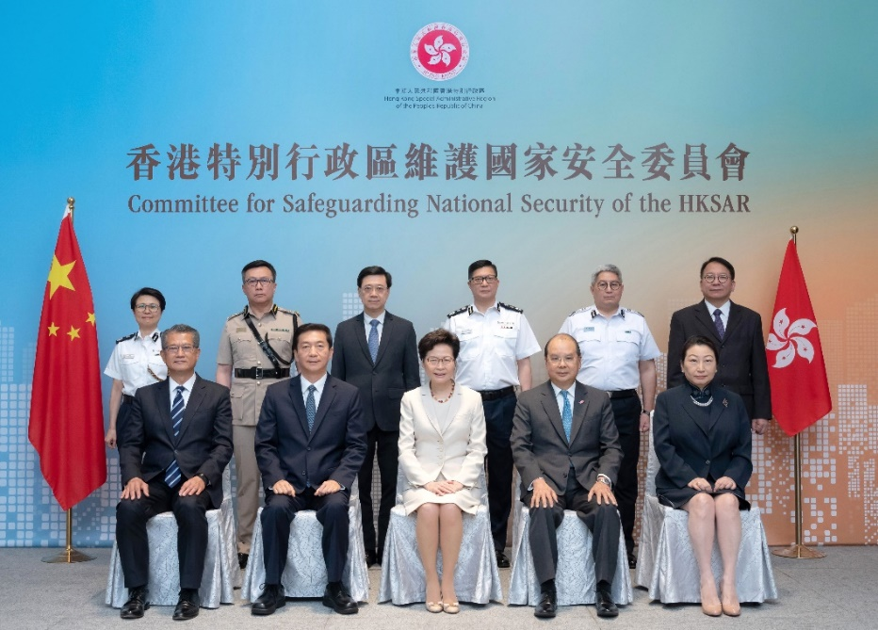

Please answer the questions with reference to the information of the following webpage:
https://www.info.gov.hk/gia/general/202007/06/P2020070600530.htm?fontSize=1

- When was the photo in Source 1 taken?
It was taken during the first meeting of the Committee for Safeguarding National
Security of the HKSAR.

- Who is the chairperson of the Committee?
The Chief Executive of the HKSAR.

- Apart from the chairperson, which officials of the HKSAR Government are members of the Committee? (Only post titles are required.)
Chief Secretary for Administration, Financial Secretary, Secretary for Justice,
Secretary for Security, Commissioner of Police, Deputy Commissioner of
Police (National Security), Director of Immigration, Commissioner of Customs
and Excise, Director of the Chief Executive’s Office (also the Secretary General
of the Committee).

Source 2
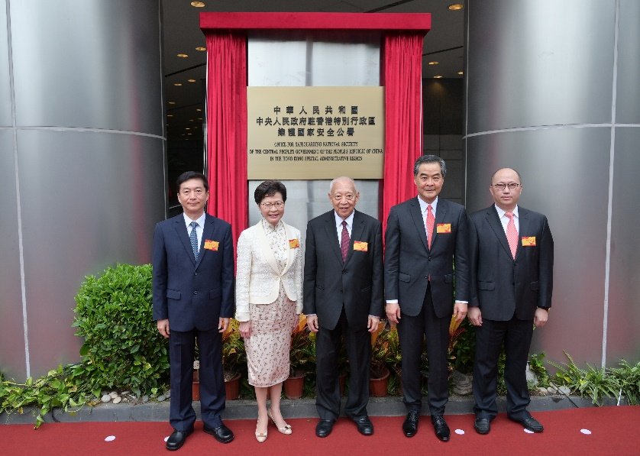

Please answer the questions with reference to the information of the following webpage: https://www.info.gov.hk/gia/general/202007/08/P2020070800238.htm

- When was the photo in Source 2 taken?
It was taken during the inauguration of the CPG Office on National Security.

- Apart from Carrie Lam, then Chief Executive of the HKSAR, who also appears in both photos of Source 1 and Source 2?
Luo Huining, the then Director of the Liaison Office of the CPG in the HKSAR
and National Security Adviser to the Committee for Safeguarding National
Security of the HKSAR.

Module 2.2: Governance of the HKSAR
(Lesson 15)
Learning and Teaching Materials

HKSAR’s duty to safeguard national security (4)

Worksheet 30: Related bodies for safeguarding national security in the HKSAR

Source 1
Decision of the National People’s Congress on Establishing and Improving the Legal System and Enforcement Mechanisms for the Hong Kong Special Administrative Region to Safeguard National Security
…
4. The HKSAR must establish and improve the institutions and enforcement mechanisms for safeguarding national security, strengthen the enforcement forces for safeguarding national security, and step up enforcement to safeguard national security. When needed, relevant national security organ of the Central People’s Government (CPG) will set up agencies in the HKSAR to fulfil relevant duties to safeguard national security in accordance with the law.
…

Source of information: Decision of the National People’s Congress on Establishing and Improving the Legal System and Enforcement Mechanisms for the Hong Kong Special Administrative Region to Safeguard National Security, (Unofficial English translation) (Adopted at the Third Session of the Thirteenth National People’s Congress on 28 May 2020),
https://www.elegislation.gov.hk/hk/A301 (Accessed_15 May 2026)

Source 2
Law of the People’s Republic of China on Safeguarding National Security in the Hong Kong Special Administrative Region
Chapter II The Duties and the Government Bodies of the Hong Kong Special Administrative Region for Safeguarding National Security
Part 2 Government Bodies
Article 12
The Hong Kong Special Administrative Region shall establish the Committee for Safeguarding National Security. The Committee shall be responsible for affairs relating to and assume primary responsibility for safeguarding national security in the Region. It shall be under the supervision of and accountable to the Central People’s Government.
Article 14
The duties and functions of the Committee for Safeguarding National Security of the Hong Kong Special Administrative Region shall be:
(1) analysing and assessing developments in relation to safeguarding national security in the Hong Kong Special Administrative Region, making work plans, and formulating policies for safeguarding national security in the Region;
(2) advancing the development of the legal system and enforcement mechanisms of the Region for safeguarding national security; and
(3) coordinating major work and significant operations for safeguarding national security in the Region.
No institution, organisation or individual in the Region shall interfere with the work of the Committee. Information relating to the work of the Committee shall not be subject to disclosure. Decisions made by the Committee shall not be amenable to judicial review.

Source of information: Law of the People’s Republic of China on Safeguarding National Security in the Hong Kong Special Administrative Region, Hong Kong e-Legislation, https://www.elegislation.gov.hk/fwddoc/hk/a302/eng_translation_(a302)_en.pdf (Accessed_15 May 2026)

Source 3
Law of the People’s Republic of China on Safeguarding National Security in the Hong Kong Special Administrative Region
Chapter II The Duties and the Government Bodies of the Hong Kong Special Administrative Region for Safeguarding National Security
Part 2 Government Bodies
Article 15
The Committee for Safeguarding National Security of the Hong Kong Special Administrative Region shall have a National Security Adviser, who shall be designated by the Central People’s Government and provide advice on matters relating to the duties and functions of the Committee. The National Security Adviser shall sit in on meetings of the Committee.

Source of information: Law of the People’s Republic of China on Safeguarding National Security in the Hong Kong Special Administrative Region, Hong Kong e-Legislation, https://www.elegislation.gov.hk/fwddoc/hk/a302/eng_translation_(a302)_en.pdf (Accessed_15 May 2026)
------------------------------------------------------------------------------------------------------
State Council’s Appointment of the National Security Adviser to the Committee for Safeguarding National Security of the Hong Kong Special Administrative Region
In accordance with the relevant provisions of the Law of the People’s Republic of China on Safeguarding National Security in the Hong Kong Special Administrative Region, the State Council decided today (3 July 2020) to appoint Mr Luo Huining as the National Security Adviser to the Committee for Safeguarding National Security of the Hong Kong Special Administrative Region.

Source of information: Translated from 國務院任命香港特別行政區維護國家安全委員會國家安全事務顧問，載於中華人民共和國中央人民政府網頁, 3 July 2020, http://www.gov.cn/xinwen/2020-07/03/content_5523874.htm

Source 4
Law of the People’s Republic of China on Safeguarding National Security in the Hong Kong Special Administrative Region
Chapter II The Duties and the Government Bodies of the Hong Kong Special Administrative Region for Safeguarding National Security
Part 2 Government Bodies
Article 16(1)
The Police Force of the Hong Kong Special Administrative Region shall establish a department for safeguarding national security with law enforcement capacity.
Article 17
The duties and functions of the department for safeguarding national security of the Hong Kong Police Force shall be:
(1) collecting and analysing intelligence and information concerning national security;
(2) planning, coordinating and enforcing measures and operations for safeguarding national security;
(3) investigating offences endangering national security;
(4) conducting counter-interference investigation and national security review;
(5) carrying out tasks of safeguarding national security assigned by the Committee for Safeguarding National Security of the Hong Kong Special Administrative Region; and
(6) performing other duties and functions necessary for the enforcement of this Law.
Article 18(1)
The Department of Justice of the Hong Kong Special Administrative Region shall establish a specialised prosecution division responsible for the prosecution of offences endangering national security and other related legal work. …

Source of information: Law of the People’s Republic of China on Safeguarding National Security in the Hong Kong Special Administrative Region, Hong Kong e-Legislation, https://www.elegislation.gov.hk/fwddoc/hk/a302/eng_translation_(a302)_en.pdf (Accessed_15 May 2026)

Think about it

NSL stipulates that “The Department of Justice of the Hong Kong Special Administrative Region shall establish a specialised prosecution division responsible for the prosecution of offences endangering national security and other related legal work.” It corresponds to Article 63 of the Basic Law which stipulates that “The Department of Justice of the Hong Kong Special Administrative Region shall control criminal prosecutions, free from any interference.”

Source 5
Law of the People’s Republic of China on Safeguarding National Security in the Hong Kong Special Administrative Region
Chapter V Office for Safeguarding National of the Central People’s Government in the Hong Kong Special Administrative Region
Article 48(1)
The Central People’s Government shall establish in the Hong Kong Special Administrative Region an office for safeguarding national security. The Office for Safeguarding National of the Central People’s Government in the Hong Kong Special Administrative Region shall perform its mandate for safeguarding national security and exercise relevant powers in accordance with the law.
Article 49
The Office for Safeguarding National of the Central People’s Government in the Hong Kong Special Administrative Region shall perform the following mandate:
(1) analysing and assessing developments in relation to safeguarding national security in the Hong Kong Special Administrative Region, and providing opinions and making proposals on major strategies and important policies for safeguarding national security;
(2) overseeing, guiding, coordinating with, and providing support to the Region in the performance of its duties for safeguarding national security;
(3) collecting and analysing intelligence and information concerning national security; and
(4) handling cases concerning offence endangering national security in accordance with the law.
Article 50
The Office for Safeguarding National of the Central People’s Government in the Hong Kong Special Administrative Region shall perform its mandate in strict compliance with the law and be subject to supervision in accordance with the law. It shall not infringe upon the lawful rights and interests of any individual or organisation.
The staff of the Office shall abide by the laws of the Hong Kong Special Administrative Region as well as national laws.
The staff of the Office shall be subject to the supervision of the national supervisory authorities in accordance with the law.

Source of information: Law of the People’s Republic of China on Safeguarding National Security in the Hong Kong Special Administrative Region, Hong Kong e-Legislation, https://www.elegislation.gov.hk/fwddoc/hk/a302/eng_translation_(a302)_en.pdf (Accessed_15 May 2026)

- (a) It is pointed out in Source 1 that “the Hong Kong Special Administrative Region must establish and improve institutions and enforcement mechanisms for safeguarding national security”. According to Sources 2 and 4, what relevant bodies have been established at different levels in the HKSAR?
The HKSAR established the Committee for Safeguarding National
Security of the HKSAR. The Police Force established a department for
safeguarding national security. The Department of Justice established a
specialised prosecution division responsible for the prosecution of
offences endangering national security.

(b) According to Source 3, who designated the National Security Adviser to the Committee for Safeguarding National Security of the HKSAR? What are the Adviser’s responsibilities?
The Adviser is designated by the CPG (i.e. the State Council). The
Adviser provides advice on matters relating to the duties and functions of
the Committee and sits in on meetings of the Committee.

(c) It is pointed out in Source 1 that “relevant national security organ of the Central People’s Government (CPG) will set up agencies in the HKSAR”. According to Source 5, what body has been established by the CPG in the HKSAR?
Office for Safeguarding National Security of the Central People's
Government in the Hong Kong Special Administrative Region /
CPG Office on National Security.

- (a) According to Source 2, who supervises the Committee for Safeguarding National Security of the HKSAR and holds it accountable?
CPG.

(b) According to Source 2, what protection does the NSL provide for the work and decisions of the Committee for Safeguarding National Security of the HKSAR in order to enable the Committee to perform its duties effectively?
No institution, organisation, or individual in the HKSAR shall interfere
with the work of the Committee. Information relating to the work of the
Committee shall not be subject to disclosure. Decisions made by the
Committee shall not be amenable to judicial review.

- Which of the duties of the Police Force described by Article 17 of the NSL in Source 4 is most relevant to the work of the Police Force mentioned in the following press releases?

Press Releases, the Government of the HKSAR | Duties
(10 August 2020)  After in-depth investigation, officers of National Security Department of Hong Kong Police conducted search operation today with a warrant issued by a Magistrate and arrested nine men and a woman, aged between 23 and 72, in various districts. They were suspected in collusion with a foreign country or with external elements to endanger national security, contravening Article 29 of the Law of the People’s Republic of China on Safeguarding National Security in the Hong Kong Special Administrative Region (National Security Law) ... | investigating offences endangering national security
(5 November 2020)  The National Security Department of Police launched the ‘National Security Department Reporting Hotline’ today with a view to facilitating members of the public to provide or report national security related information. Members of the public can report non-urgent national security related matters to National Security Department via various platforms including WeChat, SMS and email. … | collecting and analysing intelligence and information concerning national security

- (a) According to Sources 2 and 5, what are the similarities and differences between the Committee for Safeguarding National Security of the Hong Kong Special Administrative Region and the CPG Office on National Security in terms of their respective first duties?
Similarities: Both bodies shall analyse and assess developments in
relation to safeguarding national security in the HKSAR.
Differences: The Committee for Safeguarding National Security of the
HKSAR shall make work plans and formulate policies for
safeguarding national security in the HKSAR, while the
CPG Office on National Security shall provide opinions
and make proposals on major strategies and important
policies for safeguarding national security.

(b) According to Source 5, what provision in Article 50 of the NSL is related to the principle of “One Country, Two Systems”?
The staff of the Office shall abide by the laws of the HKSAR as well as
national laws.


Appendix 7
Constitution
Chapter III - State Institutions Section 7 Commissions of Supervision
Article 123
Commissions of supervision of the People’s Republic of China at all levels are the supervisory organs of the state.
Article 124
The People’s Republic of China shall establish a National Commission of Supervision and local commissions of supervision at all levels.
A commission of supervision shall be composed of the following personnel:
a chairperson,
vice chairpersons, and
members.
The chairperson of a commission of supervision shall have the same term of office as that of the people’s congress at the same level. The chairperson of the National Commission of Supervision shall serve no more than two consecutive terms.
The organization, functions and powers of the commissions of supervision shall be prescribed by law.
Article 125
The National Commission of Supervision of the People’s Republic of China is the highest supervisory organ.
The National Commission of Supervision shall direct the work of local commissions of supervision at all levels; commissions of supervision at higher levels shall direct the work of those at lower levels.
Article 126
The National Commission of Supervision shall be responsible to the National People’s Congress and the National People’s Congress Standing Committee. Local commissions of supervision at all levels shall be responsible to the state organs of power that created them and to the commissions of supervision at the next level up.
Article 127
Commissions of supervision shall, in accordance with the provisions of law, independently exercise supervisory power, and shall not be subject to interference from any administrative organ, social organization or individual.
The supervisory organs, in handling cases of duty-related malfeasance or crime, shall work together with adjudicatory organs, procuratorial organs and law enforcement departments; they shall act as a mutual check on each other.

Source of information: Basic Law website>Constitution>Chapter III, https://www.basiclaw.gov.hk/en/constitution/chapter3.html
Know More: Commissions of supervision
Worksheet 31: Jurisdiction, applicable law and procedure as stipulated in the NSL

Source 1
Opening remarks by the Secretary for Justice at the press conference on the NSL
…
Chapter IV is what I call “procedural law”. There are many provisions in “procedural law”. I would like to emphasise here that the vast majority of the cases mentioned in Article 40, except those under the circumstances specified in Article 55, will fall under the jurisdiction of Hong Kong. In other words, the prosecution and judicial proceedings of cases are conducted in Hong Kong. The proceedings mentioned in Article 45 need to be handled in accordance with the laws of Hong Kong. In other words, they will be handled in accordance with the appellate structure in the laws of Hong Kong. Of course, other special arrangements are also mentioned in Chapter IV. The Chief Executive just mentioned the designation of judges and the issuing of certificates by the Secretary for Justice on jury arrangements. These are special circumstances. Of course, this is a law to safeguard national security, so there will be some relevant special circumstances, but generally, it is carried out in accordance with procedures to which Hong Kong is familiar with.
…

Source of information: Translated from 香港特別行政區政府新聞公報網頁，2020年7月1日，《律政司司長〈中華人民共和國香港特別行政區維護國家安全法〉記者會開場發言》，https://www.info.gov.hk/gia/general/202007/01/P2020070100664.htm

Source 2
Law of the People’s Republic of China on Safeguarding National Security in the Hong Kong Special Administrative Region
Chapter IV Jurisdiction, Applicable Law and Procedure
Article 44(1)
The Chief Executive shall designate a number of judges from the magistrates, the judges of the District Court, the judges of the Court of First Instance and the Court of Appeal of the High Court, and the judges of the Court of Final Appeal, and may also designate a number of judges from deputy judges or recorders, to handle cases concerning offence endangering national security. Before making such designation, the Chief Executive may consult the Committee for Safeguarding National Security of the Hong Kong Special Administrative Region and the Chief Justice of the Court of Final Appeal. The term of office of the aforementioned designated judges shall be one year.
Article 46(1)
In criminal proceedings in the Court of First Instance of the High Court concerning offence endangering national security, the Secretary for Justice may issue a certificate directing that the case shall be tried without a jury on the grounds of, among others, the protection of State secrets, involvement of foreign factors in the case, and the protection of personal safety of jurors and their family members. Where the Secretary for Justice has issued the certificate, the case shall be tried in the Court of First Instance without a jury by a panel of three judges.

Source of information: Law of the People’s Republic of China on Safeguarding National Security in the Hong Kong Special Administrative Region, Hong Kong e-Legislation, https://www.elegislation.gov.hk/fwddoc/hk/a302/eng_translation_(a302)_en.pdf (Accessed_15 May 2026)

Source 3
Law of the People’s Republic of China on Safeguarding National Security in the Hong Kong Special Administrative Region
Chapter V Office for Safeguarding National of the Central People’s Government in the Hong Kong Special Administrative Region
Article 55
The Office for Safeguarding National of the Central People’s Government in the Hong Kong Special Administrative Region shall, upon approval by the Central People’s Government of a request made by the Government of the Hong Kong Special Administrative Region or by the Office itself, exercise jurisdiction over a case concerning offence endangering national security under this Law, if:
(1) the case is complex due to the involvement of a foreign country or external elements, thus making it difficult for the Region to exercise jurisdiction over the case;
(2) a serious situation occurs where the Government of the Region is unable to effectively enforce this Law; or
(3) a major or imminent threat to national security has occurred.
Article 56
In exercising jurisdiction over a case concerning offence endangering national security pursuant to Article 55 of this Law, the Office for Safeguarding National of the Central People’s Government in the Hong Kong Special Administrative Region shall initiate investigation into the case, the Supreme People’s Procuratorate shall designate a prosecuting body to prosecute it, and the Supreme People’s Court shall designate a court to adjudicate it.

Source of information: Law of the People’s Republic of China on Safeguarding National Security in the Hong Kong Special Administrative Region, Hong Kong e-Legislation, https://www.elegislation.gov.hk/fwddoc/hk/a302/eng_translation_(a302)_en.pdf (Accessed_15 May 2026)

- (a) According to Source 1, under the NSL, the prosecution and judicial proceedings for most cases (except the cases specified in Article 55) are carried out in accordance with what?
The laws of Hong Kong.

(b) According to Source 1, which two special arrangements are mentioned in Chapter IV of the NSL?
The designation of judges and issuing of certificates by the Secretary for
Justice on jury arrangements.

(c) According to Source 2, who can the Chief Executive consult before designating a judge?
The Committee for Safeguarding National Security of the HKSAR and the
Chief Justice of the Court of Final Appeal.

(d) According to Source 2, on what three grounds can the Secretary for Justice issue a certificate directing that the case shall be tried without a jury?
- Protection of State secrets.
- Involvement of foreign factors in the case.
- Protection of personal safety of jurors and their family members.

- (a) According to Source 3, under what three types of circumstances will the CPG Office on National Security exercise jurisdiction over a case concerning offence endangering national security as stipulated in the NSL?
- The case is complex due to the involvement of a foreign country
or external elements, thus making it difficult for the HKSAR to
exercise jurisdiction over the case.
- A serious situation occurs where the Government of the HKSAR is
unable to effectively enforce the NSL.
- A major and imminent threat to national security has occurred.

(b) Following the above question, what procedure should be followed before making such an arrangement?
Either the Government of the HKSAR or the CPG Office on National
Security makes a request and then to be approved by the CPG.

NSL: Bodies Safeguarding National Security and Jurisdiction

Complete the following concept map according to the relevant information in Worksheets 7 and 8:

Central People’s Government (CPG)

The Office shall, upon approval by the CPG of a request made by the HKSAR Government or by the Office itself, exercising jurisdiction over a case concerning offence endangering national security under the NSL, if:
(1) the case is complex due to the involvement of a foreign country or external elements, thus making it difficult for the HKSAR to exercise jurisdiction over the case;
(2) a serious situation occurs where the HKSAR Government is unable to effectively enforce this Law; or
(3) a major and imminent threat to national security has occurred.
established
under the supervision of and accountable to
designated
The Police Force
established a department for safeguarding national security with law enforcement capacity
Department of Justice established a specialised prosecution division responsible for the prosecution of offences endangering national security and other related legal work
Chief Executive designated a number of judges from the magistrates, the judges of the District Court, the judges of the Court of First Instance and the Court of Appeal of the High Court, and the judges of the Court of Final Appeal … to handle cases concerning offence endangering national security
Article 40 of the NSL stipulates that the HKSAR “shall have jurisdiction over cases concerning offences under this Law, except under the circumstances specified in Article 55 of this Law”.
HKSAR shall establish the Committee for Safeguarding National Security
- Chief Executive shall be the chairperson
- 【shall sit in on meetings of the Committee】
National Security Adviser
- Shall be responsible for affairs relating to safeguarding national security and assuming primary responsibility for safeguarding national security in the HKSAR
Office for Safeguarding National Security of the CPG in the HKSAR (Office)
- shall perform its mandate for safeguarding national security and exercise relevant powers in accordance with the law
The Office shall initiate investigation into the case, the Supreme People’s Procuratorate shall designate a prosecuting body to prosecute it, and the Supreme People’s Court shall designate a court to adjudicate it.

Extended Reading Worksheet 1: “Four Musts”

President Xi Jinping address at the meeting celebrating the 25th anniversary of Hong Kong's return to the motherland and the inaugural ceremony of the sixth-term government of the Hong Kong Special Administrative Region on July 1, 2022

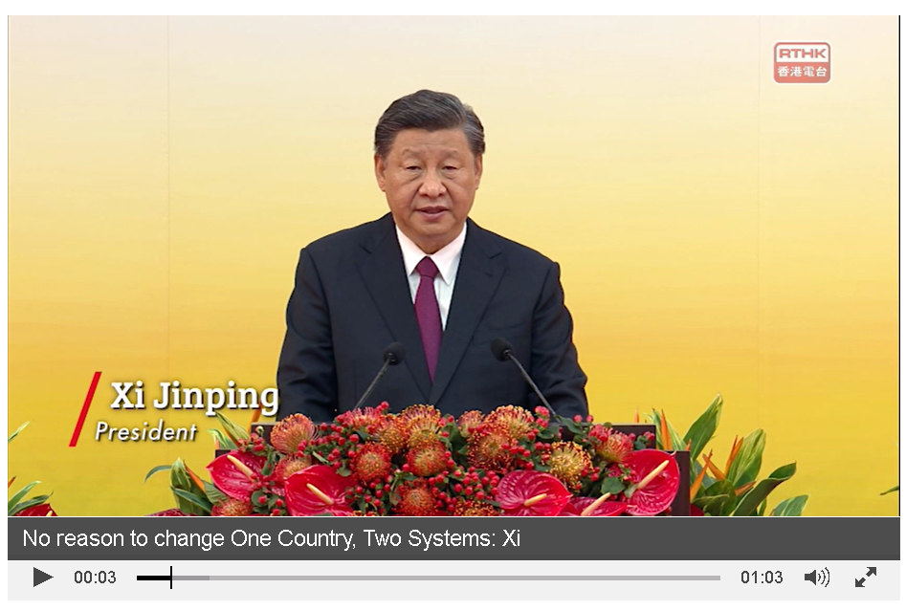

President Xi Jinping put forward “Four Musts” on “one country, two systems” at the meeting celebrating the 25th anniversary of Hong Kong's return to the motherland and the inaugural ceremony of the sixth-term government of the Hong Kong Special Administrative Region :

First, we must fully and faithfully implement the principle of “one country, two systems”. This principle embodies a complete system. Its top priority is to safeguard national sovereignty, security, and development interests. With this as a prerequisite, Hong Kong and Macao can keep the previous capitalist systems unchanged for a long time and enjoy a high degree of autonomy. Since the socialist system is the fundamental system of the People's Republic of China and leadership by the Communist Party of China is the defining feature of socialism with Chinese characteristics, all residents in the special administrative regions should willingly respect and uphold the country's fundamental system. The thorough and precise implementation of the “one country, two systems” principle will open up broader prospects for the development of Hong Kong and Macao. The more firmly the “one country” principle is upheld, the greater strength the "two systems" will be unleashed for the development of the SARs.

Second, we must uphold the central government's overall jurisdiction while securing the SARs' high degree of autonomy. Since Hong Kong's return to the motherland, it has been re-integrated into China's governance system, and a constitutional order was established with the "one country, two systems" principle as its fundamental guideline. The central government's overall jurisdiction over the SARs underpins their high degree of autonomy, and such autonomy bestowed by the law is fully respected and resolutely safeguarded by the central government. Only when the enforcement of the central government's overall jurisdiction dovetails with the fulfillment of a high degree of autonomy in the SARs, can the SARs be well governed. The SARs uphold the executive-led system. The executive, legislative, and judicial branches perform their duties in accordance with the basic laws and other relevant laws. The executive and legislative branches check and balance and cooperate with each other while the judiciary exercises its power independently.

Third, we must ensure that Hong Kong is administered by patriots. It is a universal political rule that a government must be in the hands of patriots. There is no country or region in the world where its people will allow an unpatriotic or even treasonous force or figure to take power. The government of the HKSAR must be safely kept in the hands of those who love the country. This is an essential requirement for Hong Kong's long-term prosperity and stability and must not be compromised under any circumstances. To put the governing power in the right hands is to safeguard Hong Kong's prosperity and stability as well as the immediate interests of more than 7 million people in the region.

Fourth, we must maintain Hong Kong's distinctive status and advantages. The central government has always handled Hong Kong affairs from a strategic and overall perspective, taking into consideration the fundamental and long-term interests of Hong Kong and the country as a whole. The fundamental interests of Hong Kong are in line with those of the country, and the central government and Hong Kong compatriots share the same aspirations. Hong Kong's close connection with the world market and strong support from the motherland are its distinctive advantages. Such favorable conditions are cherished by the people of Hong Kong and by the central government as well. The central government fully supports Hong Kong in its effort to maintain its distinctive status and edges, to improve its presence as an international financial, shipping, and trading center, to keep its business environment free, open, and regulated, and to maintain the common law, so as to expand and facilitate its exchanges with the world. On the country's journey toward building a modern socialist country in all respects and realizing the rejuvenation of the Chinese nation, the central government believes that Hong Kong will make great contributions.

Source of information: Full text of Xi Jinping's address at the meeting celebrating the 25th anniversary of Hong Kong's return to the motherland and the inaugural ceremony of the sixth-term government of the Hong Kong Special Administrative Region Xinhua
https://english.news.cn/20220702/74d848898c8d4201bd5140570611dc58/c.html

Questions for reflection﹕

- President Xi Jinping put forward “Four Musts” on “one country, two systems” at the meeting celebrating the 25th anniversary of Hong Kong's return to the motherland and the inaugural ceremony of the sixth-term government of the Hong Kong Special Administrative Region. What are the “Four Musts”?

The “Four Musts” refer to (1) we must fully and faithfully implement the
principle of “one country, two systems”; (2) we must uphold the central
government's overall jurisdiction while securing the SARs' high degree of
autonomy; (3) we must ensure that Hong Kong is administered by patriots, and
(4) we must maintain Hong Kong's distinctive status and advantages.

- According to President Xi Jinping, what is the top priority embodied in the principle of “one country, two systems”?

The top priority embodied in the principle of “one country, two systems” is to
safeguard national sovereignty, security, and development interests.

- According to President Xi Jinping, what is the source of the high degree of autonomy enjoyed by the HKSAR? Fill in the blanks with the correct answer.

The central government | 's overall jurisdiction over the Special
Administrative Regions underpins their high degree of autonomy, and such
autonomy bestowed by the |  | law | is fully respected and
resolutely safeguarded by the central government.

- According to President Xi Jinping, why is it important to ensure that patriots administer Hong Kong? Fill in the blanks with the correct answer.

The government of the HKSAR must be safely kept in the hands of those who
love the country |  |  | .This is an essenti al requirement for Hong
Kong's long-term |  | prosperity and stability and must not be
compromised under any circumstances. To put the governing power in the right
hands is to safeguard Hong Kong's |  |  |  | prosperity | and
stability | as well as the immediate interests of more than 7
million people in the region.

- According to President Xi Jinping, what are the distinctive status and advantages of Hong Kong? Fill in the blanks with the correct answer.

Hong Kong's close connection with the world market and strong support from
the | motherland | are its distinctive advantages. The central
government fully supports Hong Kong in its effort to maintain its distinctive
status and edges, to improve its presence as an |  |  | international financial
shipping, and trading center, to keep its business environment free, open, and
regulated, and to maintain the common law, so as to expand and facilitate its
exchanges with the world.

Extended Reading Worksheet 2: “Four Proposals”

President Xi Jinping address at the meeting celebrating the 25th anniversary of Hong Kong's return to the motherland and the inaugural ceremony of the sixth-term government of the Hong Kong Special Administrative Region on July 1, 2022

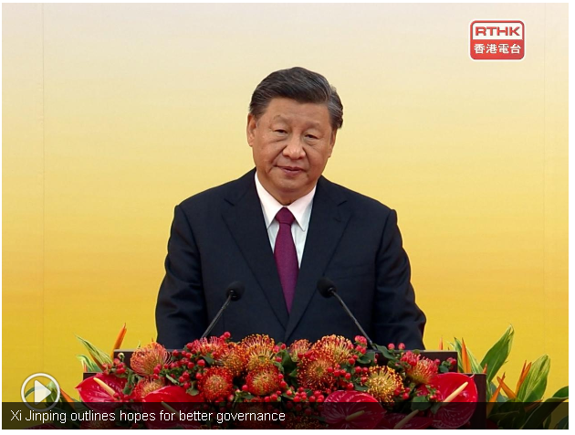

President Xi Jinping put forward “Four Proposals” on Hong Kong development at the meeting celebrating the 25th anniversary of Hong Kong's return to the motherland and the inaugural ceremony of the sixth-term government of the Hong Kong Special Administrative Region :

First, Hong Kong should further improve its governance. To promote the development of the HKSAR, it is of urgency to improve Hong Kong's governance system, governance capacity, and governance efficacy. The chief executive and the government of the HKSAR in the driver's seat are the first to be held accountable for the governance of the region. Administrators of Hong Kong should fulfill their commitments, materialize the "”one country, two systems” principle with concrete actions, uphold the authority of the Basic Law of the HKSAR and devote themselves to the development of the region. Personnel for public offices should be assessed on both ability and political integrity before they are recruited. Professionals who love both the motherland and Hong Kong with strong governance capabilities and passion for serving the public should be recruited as government staff. Administrators of Hong Kong need to have a new outlook on the motherland and have an international vision in order to make better development plans for the region from an overall and long-term perspective. They need to transform their concepts of governance to balance the relationship between the government and the market so that a capable government serves an efficient market. The HKSAR government needs to strengthen self-governance and improve its conduct to better take on its responsibilities and deliver better performance in ensuring stability and prosperity in Hong Kong.

Second, Hong Kong should continue to create strong impetus for growth. With its special status, Hong Kong enjoys good conditions and broad space for development. The central government fully supports Hong Kong in its effort to seize historic opportunities offered by China's development and actively dovetail itself with the 14th Five-Year Plan (2021-25) and other national strategies such as the development of the Guangdong-Hong Kong-Macao Greater Bay Area and high-quality Belt and Road cooperation. The central government fully supports Hong Kong in carrying out more extensive exchanges and close cooperation with the rest of the world and in attracting entrepreneurs with dreams to realize their ambitions in Hong Kong. The central government also fully supports Hong Kong in taking active yet prudent steps to advance reforms and dismantle the barriers of vested interests in order to unlock enormous creativity and development potential of Hong Kong society.

Third, Hong Kong should earnestly address people's concerns and difficulties in daily life. “Those enjoying benefits and joy of all people should also share their burdens and concerns.” As I once said, the people's aspiration for a better life is what we are striving for. Currently, the biggest aspiration of Hong Kong people is to lead a better life, in which they will have more decent housing, more opportunities for starting their own businesses, better education for their children, and better care in their twilight years. We should actively respond to such aspirations. The newly inaugurated HKSAR government should be pragmatic, live up to what the people expect of it, and consider the expectations of the whole society, particularly ordinary citizens, as what it should accomplish foremost. It should be more courageous and adopt more efficient measures to overcome difficulties and forge ahead. It should make sure that all citizens in Hong Kong share more fully and fairly in the fruits of development so that every resident will be convinced that if you work hard, you can improve the life of your own and that of your family.

Fourth, the people of Hong Kong should work together to safeguard harmony and stability. Hong Kong is the home of all its people, and harmony in a family brings success in everything. Through trials and tribulations, now we keenly feel that Hong Kong cannot withstand chaos and will not afford to have any, and we also deeply feel that the development of Hong Kong allows no delay. We must get rid of whatever interference there may be to concentrate our attention on the development of the region. Everyone in Hong Kong, regardless of profession and belief, can be a positive force and do his or her bit for the region's development as long as he or she genuinely supports the principle of “one country, two systems”, loves Hong Kong, and abides by the Basic Law and the laws of the special administrative region.

Source of information: Full text of Xi Jinping's address at the meeting celebrating the 25th anniversary of Hong Kong's return to the motherland and the inaugural ceremony of the sixth-term government of the Hong Kong Special Administrative Region Xinhua
https://english.news.cn/20220702/74d848898c8d4201bd5140570611dc58/c.html

Questions for reflection:

- President Xi Jinping put forward “Four Proposals” on Hong Kong development at the meeting celebrating the 25th anniversary of Hong Kong's return to the motherland and the inaugural ceremony of the sixth-term government of the Hong Kong Special Administrative Region. What are the “Four Proposals”?

The “Four Proposals” refer to (1) Hong Kong should further improve its
governance; (2) Hong Kong should continue to create strong impetus for
growth; (3) Hong Kong should earnestly address people's concerns and
difficulties in daily life; and (4) the people of Hong Kong should work together
to safeguard harmony and stability.

- According to President Xi Jinping, what are the three urgencies to promote the development of the HKSAR?

To promote the development of the HKSAR, it is of urgency to improve Hong
Kong's governance system, governance capacity, and governance efficacy.

- According to President Xi Jinping, what should be the role of the Chief Executive and the government of the HKSAR in governance? Please tick the correct answer box.

Administrators to make better development plans for the region
Engineers to facilitate infrastructural construction for the region
The first to be held accountable for the governance of the region
Designers to promote economic development for the region

- Column A refers to the areas for further improving governance by the Chief Executive and the government of the HKSAR. Column B refers to the content of those areas. Please match Column A and Column B correctly.

Column A Column B
Fulfill commitments |  | Professionals who love both the motherland and Hong Kong with strong governance capabilities and passion for serving the public should be recruited as government staff.
Have a new outlook on the motherland and have an international vision |  | Materialize the "one country, two systems" principle with concrete actions, uphold the authority of the Basic Law of the HKSAR and devote themselves to the development of the region.
Personnel for public offices should be assessed on both ability and political integrity before they are recruited |  | Balance the relationship between the government and the market so that a capable government serves an efficient market.
Transform concepts of governance |  | Make better development plans for the region from an overall and long-term perspective.
Strengthen self-governance |  | Improve its conduct to better take on its responsibilities and deliver better performance in ensuring stability and prosperity in Hong Kong.

- According to President Xi Jinping, how does the central government support Hong Kong continuously to create a strong impetus for growth? Please tick the correct answer box.

- The central government fully supports Hong Kong in its effort to seize historic opportunities offered by China's development
- The central government fully supports Hong Kong in carrying out more extensive exchanges and close cooperation with the rest of the world
- The central government fully supports Hong Kong in taking active yet prudent steps to advance reforms and dismantle the barriers of vested interests
- The central government fully supports Hong Kong in conducting its anti-epidemic work by providing medical experts and resources

- According to President Xi Jinping, what should be the act of the newly inaugurated government of HKSAR to address people's concerns and difficulties in daily life? Fill in the blanks with the correct answer.

The newly inaugurated HKSAR government should be |  |  |  |  | pragmatic
live up to what the people | expect |  |  | of it, and consider the
expectations of the whole society, particularly ordinary citizens, as what it
should accomplish foremost. It should be more courageous and adopt more
efficient measures to overcome difficulties and forge ahead. It should make sure
that all citizens in Hong Kong share more fully and fairly in the fruits of
development so that every resident will be convinced that if you
work hard |  | , you can improve the life of your own
and that of your family.

- According to President Xi Jinping, how can the people of Hong Kong work together to safeguard harmony and stability? Fill in the blanks with the correct answer.

Everyone in Hong Kong, regardless of profession and belief, can be a positive
force and do his or her bit for the region's development as long as he or she
genuinely supports the principle of |  | “one country, two systems”
loves Hong Kong | , and abides by the |  | Basic Law
and the laws of the special administrative region.

References

Asia-Pacific Economic Cooperation website. About APEC. Extracted from:
https://www.apec.org/About-Us/About-APEC

Basic Law website.
https://www.basiclaw.gov.hk/en/index.html

Chief Executive of the HKSAR (2021). The Chief Executive’s 2021 Policy Address. Extracted from:
https://www.policyaddress.gov.hk/2021/eng/index.html

Constitutional and Mainland Affairs Bureau, HKSAR Government. Improve Electoral System. Extracted from: https://www.cmab.gov.hk/improvement/en/home/index.html

Council for Sustainable Development (2021). Public Engagement on Control of Single-use Plastics. Extracted from:
https://www.susdev.org.hk/en/public-engagement.php

Court of Final Appeal (1 September 2017). Reasons for Determination of the Appeal Committee of the Court of Final Appeal on the Application for Leave to Appeal by Sixtus LEUNG Chung-hang and YAU Wai-ching. Extracted from:
https://legalref.judiciary.hk/lrs/common/ju/ju_frame.jsp?DIS=111120&currpage=T

Equal Opportunities Commission. Our Functions and Powers. Extracted from:
https://www.eoc.org.hk/en/

Government of the People’s Republic of China. Legislation Law of the People’s Republic of China, Gov.cn, Chinese Government’ Official Web. Extracted from:
http://english1.english.gov.cn/laws/2005-08/20/content_29724.htm

Home and Youth Affairs Bureau, HKSAR Government. Extracted from:
https://www.hyab.gov.hk/en/home/index.htm

Hong Kong e-Legislation. Cap. 11 Oaths and Declarations Ordinance. Extracted from:
https://www.elegislation.gov.hk/

Hong Kong e-Legislation. Cap. 92 Judicial Officers Recommendation Commission Ordinance. Extracted from:
https://www.elegislation.gov.hk/

Hong Kong e-Legislation. Cap. 204 Independent Commission Against Corruption Ordinance. Extracted from:
https://www.elegislation.gov.hk/

Hong Kong e-Legislation. Cap. 569 Chief Executive Election Ordinance. Extracted from:
https://www.elegislation.gov.hk/

Hong Kong e-Legislation. Law of the People’s Republic of China on Safeguarding National Security in the Hong Kong Special Administrative Region. Extracted from:
https://www.elegislation.gov.hk/fwddoc/hk/a302/eng_translation_(a302)_en.pdf

HKSAR Government (2018). Organisation Chart of the Government.
https://www.gov.hk/en/about/govdirectory/govchart/docs/chart.pdf

HKSAR Government (2020). Promulgation of National Law 2020. Gazette Extraordinary Published on Tuesday, 30/06/2020, No. 44 Vol. 24 - Legal Supplement No. 2. Extracted from:
https://www.gld.gov.hk/egazette/pdf/20202444e/es220202444136.pdf

HKSAR Government (2020). The Chief Executive 2020 Policy Address Supplement. Extracted from:
https://www.policyaddress.gov.hk/2020/eng/pdf/supplement_6.pdf

Information Office of the State Council, The PRC (2014). The Practice of the “One Country, Two Systems” Policy in the Hong Kong Special Administrative Region.
http://english.www.gov.cn/archive/white_paper/2014/08/23/content_281474982986578.htm

Information Office of the State Council, The PRC (2021) Hong Kong Democratic Progress under the Framework of “One Country, Two Systems”. https://www.chinadailyhk.com/article/252582#Full-text:-White-paper-on-Hong-Kong's-democratic-development

Information Services Department, HKSAR Government (2020). Pamphlet on The Law of the People’s Republic of China on Safeguarding National Security in the Hong Kong Special Administrative Region – Preserve One Country, Two Systems, Restore Stability. Extracted from:
https://www.isd.gov.hk/nationalsecurity/eng/pdf/NSL_QnA_Book.pdf

Legislative Council (2019). Legislative Council Report 2018-2019. Extracted from:
https://www.legco.gov.hk/general/english/sec/reports/a_1819.pdf

Legislative Council. Legislative Council Secretariat (Handling of Complaints). Extracted from:
https://www.legco.gov.hk/general/english/sec/corg_ser/redress.htm

Ministry of Foreign Affairs of the People’s Republic of China. The People’s Congress System. https://www.fmprc.gov.cn/mfa_eng/ljzg_665465/zgjk_665467/

National People’s Congress of the People’s Republic of China (1996). Law of the People’s Republic of China on Garrisoning the Hong Kong Special Administrative Region. Extracted from:
http://www.npc.gov.cn/zgrdw/englishnpc/Law/2007-12/11/content_1383602.htm

National People’s Congress (2020). Decision of the National People’s Congress on Establishing and Improving the Legal System and Enforcement Mechanisms for the Hong Kong Special Administrative Region to Safeguard National Security, (Unofficial English translation) (Adopted at the Third Session of the Thirteenth National People’s Congress on 28 May 2020). Extracted from:
https://www.elegislation.gov.hk/hk/A301 (Accessed_15 May 2026)

news.gov.hk (9 July 2019). Consultative process to be reformed. Extracted from:
https://www.news.gov.hk/eng/2019/07/20190709/20190709_105003_925.html

Office of the Commissioner of the Ministry of Foreign Affairs of the People’s Republic of China in the Hong Kong Special Administrative Region website. About Us - Main Functions. Extracted from:
http://www.fmcoprc.gov.hk/eng/zjgs/zygy/t944912.htm

Office of the Ombudsman, Hong Kong. The Ombudsman’s Role and Jurisdiction. Extracted from:
https://www.ombudsman.hk/en-us/

Press Releases, HKSAR Government (13 October 1999). LCQ6: CPG responsible for foreign affairs relating to HKSAR. Extracted from: https://www.info.gov.hk/gia/general/199910/13/1013139.htm

Press Releases, HKSAR Government (9 January 2017). CJ’s speech at Ceremonial Opening of the Legal Year 2017. Extracted from: https://www.info.gov.hk/gia/general/201701/09/P2017010900457.htm?fontSize=1

Press Releases, HKSAR Government (24 June 2020). CE appoints Chief Justice of the Court of Final Appeal. Extracted from:
https://www.info.gov.hk/gia/general/202006/24/P2020062400849.htm?fontSize=1

Press Releases, HKSAR Government (6 July 2020). Committee for Safeguarding National Security of HKSAR convenes first meeting. Extracted from:
https://www.info.gov.hk/gia/general/202007/06/P2020070600530.htm?fontSize=1

Press Releases, HKSAR Government (10 August 2020). Police arrested ten people for suspected contravention of National Security Law and conspiracy to defraud. Extracted from:
https://www.info.gov.hk/gia/general/202008/10/P2020081000870.htm?fontSize=1

Press Releases, HKSAR Government (5 November 2020). Official launch of National Security Department Reporting Hotline. Extracted from:
https://www.info.gov.hk/gia/general/202011/05/P2020110500320.htm?fontSize=1

Press Releases, HKSAR Government (11 January 2021). CJ’s speech at Ceremonial Opening of the Legal Year 2021. Extracted from:
https://www.info.gov.hk/gia/general/202101/11/P2021011100559.htm?fontSize=1

Research Office, Legislative Council Secretariat (2021). Statistically highlights: Bicycle-friendly policy in Hong Kong. Extracted from:
https://www.legco.gov.hk/research-publications/english/2021issh17-bicycle-friendly-policy-in-hong-kong-20210204-e.pdf

The State Council, The People’s Republic of China.
https://english.www.gov.cn/

Xinhua News Agency (30 March 2021). Full Text: Annex I to the Basic Law of the Hong Kong Special Administrative Region. Extracted from http://www.xinhuanet.com/english/download/2021-3-30/AnnexI.pdf

Xinhua News Agency (30 March 2021). Full Text: Annex II to the Basic Law of the Hong Kong Special Administrative Region. Extracted from http://www.xinhuanet.com/english/download/2021-3-30/AnnexII.pdf

【In Chinese only】

人民日報海外版（2016年6月24日）。《港人熱盼駐港部隊開放日》，載於中華人民共和國外交部駐香港特別行政區特派員公署網頁。擷取自網頁：
https://www.fmprc.gov.cn/ce/cohk/chn/xwdt/xjlc/t1375107.htm

人民網>人大新聞網（2015年7月10日）。《中華人民共和國國家安全法》。擷取自網頁：
http://npc.people.com.cn/BIG5/n/2015/0710/c14576-27285049.html

中央人民政府駐香港特別行政區聯絡辦公室網頁（1997年5月23日）。《全國人民代表大會香港特別行政區籌備委員會關於香港特別行政區有關人員就職宣誓事宜的決定》。擷取自網頁：
http://www.locpg.hk/flfg/1997-05/23/c_118817299.htm

中國人大網。網頁：http://www.npc.gov.cn/

中國人大網（2000年）。《哪些法律需由全國人民代表大會制定？》。擷取自網頁：
http://www.npc.gov.cn/zgrdw/npc/rdgl/rdzd/2000-11/01/content_8829.htm

中國人大網（2016年）。全國人大常委會辦公廳新聞發布會文字實錄 [全國人大常委會副秘書長兼基本法委員會主任李飛]。擷取自網頁：
http://www.npc.gov.cn/zgrdw/npc/zhibo/zzzb39/node_363.htm

中國人大網（2021年）。《全國人民代表大會關於完善香港特別行政區選舉制度的決定》。擷取自網頁：http://www.npc.gov.cn/npc/kgfb/202103/e546427083c944d484fef5482c56f9fb.shtml

中華人民共和國中央人民政府網頁（2017年3月31日）。《中華人民共和國國務院令第678號》。擷取自網頁：
http://www.gov.cn/zhengce/content/2017-04/01/content_5182820.htm

中華人民共和國中央人民政府網頁（2020年7月3日）。《國務院任命香港特別行政區維護國家安全委員會國家安全事務顧問》。擷取自網頁：
http://www.gov.cn/xinwen/2020-07/03/content_5523874.htm

中華人民共和國教育部網頁（2020年10月20日）。教育部關於印發《大中小學國家安全教育指導綱要》的通知：附件《大中小學國家安全教育指導綱要》。擷取自網頁：http://www.moe.gov.cn/srcsite/A26/s8001/202010/t20201027_496805.html

王振民（2017年）。《 “一國兩制” 與基本法：歷史、現實與未來》。三聯書店（香港）有限公司。

全國人民代表大會香港特別行政區籌備委員會（1997年5月23日）。〈全國人民代表大會香港特別行政區籌備委員會關於香港特別行政區有關人員就職宣誓事宜的決定〉，載於《中華人民共和國國務院公報》1997年第18號（總號870），頁777-778。擷取自網頁：
http://www.gov.cn/gongbao/shuju/1997/gwyb199718.pdf

香港特別行政區政府律政司網頁。網頁：https://www.doj.gov.hk/chi/index.html

香港特別行政區政府新聞公報網頁（2000年9月13日）。《奧運村內升起香港特別行政區區旗》。擷取自網頁：
https://www.info.gov.hk/gia/general/200009/13/0913169.htm

香港特別行政區政府新聞公報網頁（2020年6月23日）。《行政長官於行政會議前會見傳媒開場發言及答問內容》。擷取自網頁：https://www.info.gov.hk/gia/general/202006/23/P2020062300464.htm

香港特別行政區政府新聞公報網頁（2020年6月24日）。《行政長官任命終審法院首席法官》。擷取自網頁：
https://www.info.gov.hk/gia/general/202006/24/P2020062400779.htm

香港特別行政區政府新聞公報網頁（2020年7月1日）。《律政司司長〈中華人民共和國香港特別行政區維護國家安全法〉記者會開場發言》。擷取自網頁：
https://www.info.gov.hk/gia/general/202007/01/P2020070100664.htm

香港特別行政區政府新聞公報網頁（2020年7月8日）。《行政長官出席中央人民政府駐香港特別行政區維護國家安全公署揭牌儀式致辭》。擷取自網頁：
https://www.info.gov.hk/gia/general/202007/08/P2020070800238.htm

教育局（2020年）。「回歸事件簿」及「《憲法》和《基本法》」海報資源套。擷取自網頁：
https://www.edb.gov.hk/tc/curriculum-development/kla/pshe/basic-law-education/cble_wallcharts/index.html

新華社（2014年4月15日）。《中央國家安全委員會第一次會議召開 習近平發表重要講話》，載於中國政府網。擷取自網頁：
http://big5.gov.cn/gate/big5/www.gov.cn/xinwen/2014-04/15/content_2659641.htm

新華社（2020年5月28日）。《關於〈全國人民代表大會關於建立健全香港特別行政區維護國家安全的法律制度和執行機制的決定（草案）〉的說明——2020年5月22日在第十三屆全國人民代表大會第三次會議上全國人民代表大會常務委員會副委員長王晨》，載於中國政府網。擷取自網頁：
http://www.gov.cn/xinwen/2020-05/28/content_5515771.htm

新華社（2020年5月28日）。《全國人大關於建立健全香港特別行政區維護國家安全的法律制度和執行機制的決定》，載於中國人大網。擷取自網頁：
http://www.npc.gov.cn/npc/c30834/202005/a1d3eeecb39e40cab6edeb2a62d02b73.shtml

新華社（2020年5月28日）。《全國人大高票通過關於建立健全香港特別行政區維護國家安全的法律制度和執行機制的決定》，載於中國政府網。擷取自網頁：
http://www.gov.cn/xinwen/2020-05/28/content_5515608.htm

新華社（2020年6月30日）。《全國人大常委會通過香港特別行政區維護國家安全法並決定列入香港基本法附件三》，載於中國人大網，。擷取自網頁：
http://www.npc.gov.cn/npc/c30834/202006/1fcbb09024fb4bc8982a901abe15efb3.shtml



Translated from 教育局（2020年），《憲法》和《基本法》海報資源套 - 《憲法》和《基本法》，https://www.edb.gov.hk/tc/curriculum-development/kla/pshe/basic-law-education/cble_wallcharts/index.html
Information Office of the State Council, The PRC (2014), The Practice of the “One Country, Two Systems” Policy in the Hong Kong Special Administrative Region, http://english.www.gov.cn/archive/white_paper/2014/08/23/content_281474982986578.htm
Information Office of the State Council, The PRC (2021), Hong Kong Democratic Progress under the Framework of “One Country, Two Systems”, https://www.chinadailyhk.com/article/252582#Full-text:-White-paper-on-Hong-Kong's-democratic-development
Extracted from Department of Justice, The Government of the HKSAR > Home > Community Engagement > SJ’s Blog (5 September 2020): Division of work and complementing each other, https://www.doj.gov.hk/en/community_engagement/sj_blog/20200905_blog1.html

